# 

# TREATMENT OUTCOMES TABLE

|  |  |  |  |  |  |  |  |  |  |  |  |  |  |  |
| --- | --- | --- | --- | --- | --- | --- | --- | --- | --- | --- | --- | --- | --- | --- |
| **Agent** | **Study name** | **Intervention** | **Method** | **NAFLD activity score (NAS)** | **Resolution of NASH** | **Fibrosis Score** | **Hepatic Triglyceride content** | **Composite or Primary Outcomes** | **Weight change** | **A1C control** | **CV** | **Rate of ADR’s** | **Strengths** | **Limitations** |
| **PIOGLITAZONE** | **[Cusi et al., 2016](Treatments%20for%20NASH/Cusi%20et%20al%20Long-Term%20Pioglitazone%20Treatment%20for%20Patients%20With%20Nonalcoholic%20Steatohepatitis%20and%20Prediabetes%20or%20Type%202%20Diabetes%20Mellitus.pdf)**  Cusi K, Orsak B, Bril F, Lomonaco R, Hecht J, Ortiz-Lopez C, et al. Long-Term Pioglitazone Treatment for Patients With Nonalcoholic Steatohepatitis and Prediabetes or Type 2 Diabetes Mellitus: A Randomized, Controlled Trial. Ann Intern Med. 2016. | * Population: patients with NASH and **comorbid T2DM or prediabetes** * **All patients were placed on hypocaloric diet** (500 kcal deficit from weight-maintaining caloric intake) * 101 patients were randomized to receive either pioglitazone 45 mg/d or placebo for 72 weeks (18 m) | * Randomized, double-blind, placebo-controlled trial * Excluded patients with h/o use of TZD, vit E, other causes of liver disease, abnormal LFTs, T1DM, severe heart, hepatic, or renal disease * Patients were followed for 18 months * Randomized-blinded phase followed by an 18-m open label phase with pioglitazone? – 32 months * primary outcome was a **reduction of at least 2 points in 2 histologic categories of the NAS without worsening of fibrosis** | * Mean change in overall NAS score was significantly greater for pioglitazone (-1.7 vs -0.3, P<0.001 for individual steatosis, inflammation and ballooning scores) * Mean change in steatosis, inflammation and ballooning scores were significantly greater in the treatment group ( all P ≤0.001) | * In pioglitazone group, 51% of patients achieved resolution of NASH (treatment difference 32%, CI 13-51%, P<0.001) * Diagnosis of definite NASH was defined as zone 3 accentuation of macrovesicular steatosis (any grade), hepatocellular ballooning (any degree), and lobular inflammatory infiltrates (any amount). | * In pioglitazone group, treatment was associated with reduction of -0.5 in fibrosis score (CI, -0.9-0.0, P=0.039) where no improvement was seen the control * HOWEVER, the proportion of patients exhibiting a ≥1 stage improvement in fibrosis (39% v 25%, treatment difference -14% [-6% to -34%], was not statistically significant, p=0.130 | * In pioglitazone group, treatment was associated with reduction in hepatic triglyceride content (treatment difference -7%, CI -10%to -4%, P<0.001) * Hepatic triglyceride content was measured by magnetic resonance and proton spectroscopy (1H-MRS) | * In pioglitazone group, 58% of patients achieved ≥ 2-point reduction in NAFLD score in two histological categories without worsening fibrosis (a treatment difference of 41%, CI 23-59%, P<0.001) * Results persisted even at 36 months (3 years) * NAS was calculated as the sum of the steatosis, inflammation, and ballooning grades from the liver biopsy, and histopathologic changes were determined by using standard criteria | * Weight was significantly increased in the pioglitazone group, difference was 2.5 kg (CI 0.4 - 4.5, P=0.02) * Likewise, BMI was significantly increased difference was 0.9 (CI 0.1 – 1.6, P=0.019) * Total body fat by DXA was significantly increased in pioglitazone group, difference 2%, CI 1 – 3, P<0.001) | * A1C was significantly improved in pioglitazone group in **patients with T2DM** (mean change -0.6, CI -1.1 to -0.2, p = 0.009**) but not in patients without T2DM** * Hepatic, muscle and adipose tissue insulin sensitivity were all significantly improved in the pioglitazone group vs placebo | * No statistically significant reductions in total cholesterol or LDL * Patients in pioglitazone group experienced greater reductions in triglycerides, difference -50 mg/dL, CI -92 to -9, P=0.018) * Pioglitazone group also experienced significant improvement in HDL, difference +5 mg/dL, CI 3 to 8, P<0.001) | * Overall rate of adverse events did not differ between groups * EXCEPT, weight gain was greater in the pioglitazone group (2.5 kg difference) | * Relatively long study duration = 18 months! * Used validated metabolic and imaging techniques and serial liver biopsies | * Excluded patients with abnormal LFTs (those who progressed to active liver disease), severe hepatic, heart or renal disease * Study was not powered to assess major harms associated with pioglitazone treatment, e.g. cardiovascular events * Single center trial |
| **PIOGLITAZONE** | **[Sanyal et al., 2010](Treatments%20for%20NASH/Sanyal%20et%20al%20Pioglitazone,%20Vitamin%20E,%20or%20Placebo%20for%20Nonalcoholic%20Steatohepatitis.pdf)**  Sanyal AJ, Chalasani N, Kowdley KV, McCullough A, Diehl AM, Bass NM, et al. Pioglitazone, vitamin E, or placebo for nonalcoholic steatohepatitis. N Engl J Med. 2010;362(18):1675-85. | * Population: patients with NASH **with and without diabetes** * 247 patients were randomized to either **pioglitazone 30 mg/day or vitamin E 800 IU daily or placebo** for 96 weeks * PIVENS trial | * Phase III, multicenter, randomized controlled trial * primary composite endpoint was an improvement in histologic findings, which required **an improvement by 1 or more points in the hepatocellular ballooning score; no increase in the fibrosis score; and either a decrease in the activity score for nonalcoholic fatty liver disease to a score of 3 or less or a decrease in the activity score of at least 2 points, with at least a 1-point decrease in either the lobular inflammation or steatosis score.** | * Mean change in NAS was greater for pioglitazone (-1.9 vs -.0.5 for placebo, P<0.001) * Steatosis, hepatocyte ballooning, and lobular inflammation subscores were all significantly improved in the pioglitazone group vs placebo (P<0.001, P = 0.01, and P<0.001, respectively) | * **Resolution of NASH occurred in significantly more patients on pioglitazone than on placebo (47% v. 21%, difference 26%, P=0.001)** * **Definite or possible steatohepatitis was diagnosed with an activity score of 5 or more, or definite steatohepatitis (confirmed by two pathologists) with an activity score of 4. A score of at least 1 for hepatocellular ballooning was required in all cases.** | * Fibrosis score was not significantly improved, mean change was -0.4 vs -0.1 in placebo (P=0.10) * Percent of patients exhibiting 1 stage improvement or greater was not significant improved (44% vs 31%, P=0.12) | * Not assessed | * Primary outcome: pioglitazone therapy with placebo did not reach the prespecified 0.025 level of significance for the primary outcome (34% vs. 19%, P = 0.04; number needed to treat, 6.9) * Scores on the Medical Outcomes Study 36-Item Short-Form Health Survey (SF-36) mental and physical components did not significantly differ | * Body weight was significantly increased in pioglitazone group vs placebo (difference +4 kg, P < 0.001) * BMI was significantly increased in pioglitazone group vs placebo (difference +1.4, P<0.0001) * Fat composition was significantly increased in pioglitazone vs placebo, difference +2.7% (P<0.001) | * Fasting glucose was significantly reduced in pioglitazone group vs placebo (-3.1 mg/dL for pioglitazone vs +1.8 in placebo, P = 0.006) * Insulin resistance via HOMA-IR was significantly improved in pioglitazone group vs placebo * **A1C not reported!!!** | * No significant differences in triglycerides, total cholesterol or LDL * HDL was significantly increased in pioglitazone group vs placebo (+1.1 vs -1.9, p=0.008) | * No difference in ADR except for weight gain which was significantly greater in pioglitazone group (4 kg difference, P<0.001) | * Duration of study was relatively long: 96 weeks (2 years) * Demonstrates relative benefit of pioglitazone on altering disease progression may be greater in patients with co-morbid diabetes * Authors held themselves to more stringent P to adjust for multiple primary endpoint test (<0.025) | * Excluded patients with HCV, cirrhosis, other liver disease, or heart failure (class II-IV) * Study was not powered to assess major harms associated with pioglitazone treatment |
| **METFORMIN** | [**Loomba et al., 2008**](Treatments%20for%20NASH/Loomba%20et%20al%20Clinical%20trial%20pilot%20study%20of%20metformin%20for%20the%20treatment%20ofnon-alcoholic%20steatohepatitis.pdf)  Loomba R, Lutchman G, Kleiner DE, et al. Clinical trial: pilot study of metformin for the treatment of non-alcoholic steatohepatitis. Alimentary pharmacology & therapeutics. 2009;29:172-182. | * Population: **patients with NASH with and without diabetes** * 26 patients were prescribed to take metformin 2,000 mg/d and histological response was compared to pre-treatment | * **NOT a placebo controlled trial** * All patients were either overweight or obese * Primary endpoint was a **three-point improvement in NAS across at least two component scores with no worsening of fibrosis** | * NAS decreased from 8.2 to 5.9 at week 48 (P<0.001) * Changes in subscores for inflammation and ballooning were significantly lowered (P=0.03 and P<0.001, respectively) * Steatosis score was lowered from 2.6 to 2.0 but this difference was not statistically significant | * **Presence of NASH was decreased from 100% to 69%, a difference that was statistically significant (<0.01)** | * Fibrosis was not significantly improved (change in score from 1.7 to 1.5, P=0.43) | * Was assessed by MRI * No statistically significant difference in hepatic fat content | * Primary outcome was achieved in 8 patients (31%), all of whom has improvement in ALT | * No statistically significant reductions in weight, BMI, waist or hip circumference, or total body fat % were observed * Patients on metformin often lost weight, average of 6 kg, though this difference was not statistically significant (P=0.40) * Visceral fat as assessed by CT was significantly lowered (P=0.001) * Subcutaneous fat as assessed by CT was also significantly increased (P=0.008) | * No statistically significantly changes in fast glucose were observed with treatment * Insulin sensitivity via HOMA-IR was significantly improved at 48 weeks (P=0.04) * **A1C not reported!!!** | * No statistically significant differences in total cholesterol, LDL, HDL or triglycerides were observed | * Not reported | * Authors theorize that beneficial effect of metformin is mediated by its weight loss effect (change in weight and BMI was significantly predictive of response, P’s = 0.02, but no other parameters were associated with treatment success) * Percent weight loss was closely associated with improvement in NAS (r=0.79, P < 0.00001) * Duration of study was sufficient * Significant resolution of NASH was found | * Smaller study * No power analysis was conducted * Design was repeated measures – does not control for spontaneous remission (outcomes scores may require adjustment for comparison) |
| **LIRAGLUTIDE** | [**Armstrong et al., 2016**](Treatments%20for%20NASH/Armstrong%20et%20al%20Liraglutide%20safety%20and%20efficacy%20in%20patients%20with%20non-alcoholic%20steatohepatitis%20(LEAN).pdf)  Armstrong MJ, Gaunt P, Aithal GP, Barton D, Hull D, Parker R, et al. Liraglutide safety and efficacy in patients with non-alcoholic steatohepatitis (LEAN): a multicentre, double-blind, randomised, placebo-controlled phase 2 study. Lancet. 2016;387(10019):679-90. | * Population: patients **with NASH who are overweight** * 52 patients were randomized to receive lirglutide 1.8 mg SQ daily or placebo for 48 weeks (12 months) * LEAN trial | * Multicenter, double-blind, randomized, phase 2 trial in the UK * Primary endpoint was **resolution of definite NASH with no worsening of fibrosis** * Resolution = **disappearance of hepatocyte ballooning) without worsening of fibrosis (defined as a numerical increase in the stage of the Kleiner fibrosis classification** * Patients between the two groups were matched for features of metabolic syndrome | * There was no statistically significant difference in the change in total raw NAS between the two groups * There were no statistically significant differences in changes in the raw NAS subscores (ballooning, steatosis, and lobular inflammation) * Significantly more patients on liraglutide achieved improvement on ballooning and steatosis subscores (P = 0.05 and 0.009, respectively) but not on overall NAS or inflammation | * **Significantly higher proportion of patients in the liraglutide group experienced resolution of NASH vs placebo (39% v 9%, RR 4.3, p=0.019)** | * No statistically significant difference in the changes Kleiner fibrosis stage scores between the two groups * Lower proportion of patients in the liraglutide group experienced worsening of Kleiner fibrosis stage vs placebo (9% v 36%, RR 0.2, p=0.04) | * Not assessed | * Significantly higher proportion of patients in the liraglutide group experienced resolution of NASH vs placebo (39% v 9%, RR 4.3, p=0.019) * QOL via SF-36v2 physical subscore was significantly improved in the liraglutide group vs placebo (mean difference in change from baseline = 4.05, p=0.004) | * Weight loss was significantly greater in liraglutide group vs control, mean difference -4.39 kg ( CI -7.19 to -1.59, P =0.003) * Likewise BMI was significantly reduced, mean difference -1.59 (CI -2.66 to -0.51, P = 0.005) * Waist circumference was not significantly changed | * A1C was significantly reduced in the liraglutide group vs placebo, mean difference -0.48% (CI -0.91 to -0.05%, P = 0.03) | * No statistically significant changed in systolic or diastolic BP * No statistically significant difference in total cholesterol, LDL or triglycerides * HDL was significantly increased in liraglutide group, mean difference +0.134 (CI 0.029-0.238, P=0.01) | * Higher proportion of patients in the liraglutide group experienced **GI symptoms** (81% v 65%) * Otherwise rates of adverse events were similar between the treatment groups * As expected, A1C was significantly improved in the liraglutide group v placebo (difference -0.48%, p=0.03) and weight loss was significantly greater (difference -4.39 kg (p=0.003) | * Demonstrated positive outcomes for comorbidities as well – diabetes and weight loss | * Smaller study than the others reviewed here so far * No power analysis * No improvement seen in fibrosis 🡪 likely influenced Novo Nordisk’s decision to abandon pursuing more trials * Did not analyze whether weight loss was correlated to response 🡪 significant confounding factor |
| **VITAMIN E** | **[Sanyal et al., 2010](Treatments%20for%20NASH/Sanyal%20et%20al%20Pioglitazone,%20Vitamin%20E,%20or%20Placebo%20for%20Nonalcoholic%20Steatohepatitis.pdf)**  Sanyal AJ, Chalasani N, Kowdley KV, McCullough A, Diehl AM, Bass NM, et al. Pioglitazone, vitamin E, or placebo for nonalcoholic steatohepatitis. N Engl J Med. 2010;362(18):1675-85. | * Population: patients with NASH * 247 patients were randomized to either pioglitazone 30 mg/day or vitamin E 800 IU daily or placebo for 96 weeks * PIVENS trial | * Phase III, multicenter, randomized controlled trial * Primary composite endpoint was an improvement in histologic findings, which required **an improvement by 1 or more points in the hepatocellular ballooning score; no increase in the fibrosis score; and either a decrease in the activity score for nonalcoholic fatty liver disease to a score of 3 or less or a decrease in the activity score of at least 2 points, with at least a 1-point decrease in either the lobular inflammation or steatosis score.** | * Mean change in NAS was greater for vitamin E (-1.9 vs -.0.5 for placebo, P<0.001) | * No statistically significant increase in resolution of NASH for patients taking vitamin E v. placebo (36% vs 21%, difference 15%, P=0.05) | * Fibrosis score was not significantly improved, mean difference -0.3 vs -0.1 in placebo * Percent of patients exhibiting 1 stage improvement or greater was not significant improved (41% v 31%) | Not assessed | * Primary outcomes: Vitamin E therapy was associated with a significantly higher rate of improvement in nonalcoholic steatohepatitis (43% vs. 19%, P = 0.001; number needed to treat, 4.2), * Scores on the Medical Outcomes Study 36-Item Short-Form Health Survey (SF-36) mental and physical components did not significantly differ | * No statistically significant change in weight, BMI, waist circumference or body fat % | * No statistically significant change in fasting serum glucose or insulin resistance | * No statistically significant changes in total cholesterol, HDL, LDL, or triglycerides | * No statistically significant increase in rate of ADR associated with vitamin E | * Duration of study was relatively long: 96 weeks (2 years) |  |
| **VITAMIN E** | [**Sato et al., 2014**](Treatments%20for%20NAFLD/Sato%20et%20al%20Vitamin%20E%20has%20a%20beneficial%20effect%20on%20nonalcoholic%20fatty%20liver%20disease%20A%20meta-analysis%20of%20randomized%20controlled%20trials.pdf)  Sato, Ken, M.D., Ph.D., Gosho M, Ph.D., Yamamoto T, M.D., et al. Vitamin E has a beneficial effect on nonalcoholic fatty liver disease: A meta-analysis of randomized controlled trials. Nutrition. 2015;31:923-930. | * Population: patients with NASH * Pooled estimates are presented for effects on NAFLD and the subset of NASH specifically, including on histology | * A meta-analysis, not a randomized controlled trial * Although fibrosis improvements were significant in the pooled estimate of the 2 studies that examined NASH, fibrosis scores were not significantly improved when studies of NAFLD were included * Three studies (Dufour 2006, Lavine 2011, and Sanyal 2010) were used for NAFLD pooled estimates * Two studies (Dufour 2006, N=31, and Sanyal 2010, N=152) were used for NASH pooled estimates | * Significant reductions on steatosis, lobular inflammation, and hepatocellular ballooning in NAFLD cohort * Significant reductions in steatosis, and lobular inflammation in NASH cohort | Not reported | * In patients with NASH, there was a significant reduction in fibrosis in the pooled estimate, although neither of the studies showed a significant effect (mean pooled difference -0.30 [-0.59 to -0.01], p=0.04 * When the study of patients with NAFLD ( Lavine 2011) was included, there was no significant reduction p=0.06 * Regardless, the size of the effect is small and the proportion of patients exhibiting a clinically meaningful response (≥1 stage fibrosis reduction) was not reported |  |  | * No significant effect on BMI in either population |  |  |  |  |  |
| **PENTOXIFYLLINE** | [**Zein et al., 2011**](Treatments%20for%20NASH/Zein%20et%20al%20Pentoxifylline%20improves%20nonalcoholic%20steatohepatitis%20A%20randomized%20placebo‐controlled%20trial.pdf)  Zein CO, Yerian LM, Gogate P et al. Pentoxifylline improves  nonalcoholic steatohepatitis: a randomized placebocontrolled  trial. Hepatology 2011; 54: 1610–9. | * Population: patient with **NASH** * 55 patients were randomized to receive PTX 400 mg TID or placebo for 56 weeks | * Double blinded, randomized, placebo-controlled trial * Primary endpoint was defined as improvement in histological features of NASH as reflected by a **decrease of ≥2 points in NAS** | * Mean change in NAS was -1.6 in the PTX group vs -0.1 in the placebo group, a statistically significant improvement (P<0.001) * Specifically, steatosis and lobular inflammation subscores were improved but not ballooning | * Among patients on the PTX arm, 5 of 20 (25%) with NASH at entry had no NASH at the end of the study. Among patients on the placebo arm, 1 of 26 (3.9%) with NASH at entry had no NASH at the end of the study (P = 0.03). | * **PTX significantly improved liver fibrosis scores (mean score change -0.2 vs. +0.4 in placebo group, p=0.038)** * **Percent of patients with improvement approached significance (35% v 15.4%, p=0.17)** * **The direct estimate of treatment effect on fibrosis score was -0.5 (95% CI -1.0 to -0.04)** | Not assessed | * Primary endpoint was achieved in 38.5% of patients on PTX vs 13.8% of those on placebo (P=0.036) * Difference was even greater in per-protocol analysis versus intention-to-treat | * Change in weight was not reported * Change from baseline BMI was -0.28 in PTX group vs +0.52 in placebo group (P=0.052) * Multivariate analysis showed that treatment group AND change in BMI were significantly associated with NAS improvement (P<0.0001) 🡪 possible confounder * OR for NAS improvement with PTX was 7.1 (1.5 – 34.3, P=0.015) and with BMI it was 0.49 (0.24 – 0.99, P=0.049) | * No statistically significant changes in various measurements of insulin sensitivity or resistance * Change from baseline A1C not reported | * Change from baseline lipids or blood pressures were not reported | * No statistically significant differences in the rate of adverse events between the two groups | * Difference was greater in per-protocol vs intention to treat analysis | * Relatively small sample * Weight as possible confounder |
| **PENTOXIFYLLINE** | **[Van Wagner et al., 2011](Treatments%20for%20NASH/Van%20Wagner%20et%20al%20Pentoxifylline%20for%20the%20treatment%20of%20non-alcoholic%20steatohepatitis.pdf)**  Van Wagner LB, Koppe SW, Brunt EM et al.  Pentoxifylline for the treatment of non-alcoholic  steatohepatitis: a randomized controlled trial. Ann  Hepatol 2011; 10: 277–86. | * Population: patient with **NASH** * 30 patients were randomized in a 2:1 ratio to receive PTX 1,200 mg or placebo for 12 months | * Double blinded, randomized placebo-controlled trial * Primary endpoint was **improvement in serum ALT** * Secondary endpoint was improvement in NAS | * NAS score were lower in the PTX group but this difference was not statistically significant (-1.4 ± 0.4 vs -0.3 ± 0.4 in the control, P=0.17) * No statistically significant changes in any subscores – steatosis grade, lobular inflammation, hepatocyte ballooning * When compared to pretreatment values within-group, steatosis grade, hepatocyte ballooning and NAS score (from 5.1 ± 0.3 to 3.7 ± 0.5, p=0.002) all significantly improved in the treatment group but not control | When biopsies were given a diagnosis of either definite, borderline or not steatohepatitis, independent of the NAS, biopsy diagnosis improved as well in those that received PTX (p = 0.008). However, the proportion of subjects in the PTX vs. placebo group in whom biopsy diagnosis improved from borderline or definite steatohepatitis to not steatohepatitis was 44 vs. 28% (p = NS). | * There was no statistically significant change in fibrosis score in either the within-group and between group comparisons | Not assessed | * No statistically significant changes in ALT, AST, or percent of patients achieving normalization of these parameters in between-group comparisons * In within-group comparisons, ALT, AST, and percent of patients achieving normalization of these values were all significantly improved in the PTX group pre-treatment vs post-treatment but not in the placebo group | * No statistically significant change in weight * Although no significant decreases in weight loss were observed, ALT improvement did correlate with weight loss (Spearman correlation coefficient 0.63, p<0.001) | * No statistically significant change in BG * A1C not reported | * No statistically significant change in triglycerides | * No statistically significant differences in the rate of adverse events between the two groups | * Underscores importance of placebo-controlled trials since spontaneous resolution can occur for a proportion of patients | * Relatively small sample * Primary endpoint was change in ALT/AST not in histological features! |
| **OBETICHOLIC ACID (OCA)** | [**Neuschwander-Tetri, et al., 2015**](Treatments%20for%20NASH/Neuschwander-Tetri%20et%20al%20Farnesoid%20X%20nuclear%20receptor%20ligand%20obeticholic%20acid%20for%20noncirrhotic%20NASH.pdf)  Neuschwander-Tetri BA, Loomba R, Sanyal AJ, Lavine JE, Van Natta ML, Abdelmalek MF, et al. Farnesoid X nuclear receptor ligand obeticholic acid for non-cirrhotic, non-alcoholic steatohepatitis (FLINT): a multicentre, randomised, placebo-controlled trial. Lancet. 2015;385(9972):956-65. | * Population: patients **with NASH without cirrhosis** * 141 patients were randomized to receive either OCA 25 mg daily or placebo for 72 weeks * FLINT trial | * Multicenter, placebo-controlled, parallel group, RCT * primary endpoint was improvement in centrally scored liver histology defined as a **decrease in NAS score by at least 2 points without worsening of fibrosis from baseline to the end of treatment** | * OCA treatment resulted in a significantly greater reduction in total NAS score (-1.7 vs -0.7 for placebo, difference -0.9, P<0.0001) * Each individual subscore component of the total NAS was also significantly improved in the OCA treatment group | * **There was no statistically significant difference in the proportion of patients who exhibited resolution of NASH between the two treatment groups (22% for OCA v 13% for placebo, RR 1.7, P=0.08)** | * **OCA treatment significantly reduced fibrosis score vs placebo (-0.2 v +0.1, difference -0.3 (CI -0.6 to -0.1), P=0.01)** * A greater proportion of patients in the OCA treatment group experienced fibrosis improvement (35%) vs placebo (19%, RR 2.0, P=0.004) * **Improvement in fbrosis was defined as any numerical decrease in the stage. Fibrosis stages 1a, 1b, and 1c were considered stage 1 for the purposes of analysis.** | Not assessed | * 50 (45%) of 110 patients in the obeticholic acid group who were meant to have biopsies at baseline and 72 weeks had improved liver histology compared with 23 (21%) of 109 such patients in the placebo group (relative risk 2·2, 95% CI 1·4 to 3·3; p=0·0002) * Scores on the Medical Outcomes Study 36-Item Short-Form Health Survey (SF-36) mental and physical components did not significantly differ | * Weight was significantly reduced in OCA group vs placebo, mean difference -2.2 kg (CI -3.7 to -0.6, P=0.008) * BMI was also significantly reduced in OCA v placebo, mean difference was -0.7 (CI -1.3 to -0.2, P=0.01) * Waist circumference and waist-to-hip ratio were not significantly improved | * No significant improvement in A1C in OCA group v placebo (P=0.71) * Insulin concentrations were significantly increased in OCA group v placebo, mean difference 38 pmol/L (CI 6-69, P = 0.02) * Insulin resistence via HOMA-IR was significantly improved in OCA group v placebo, mean difference 13 (CI 3-23, P = 0.01) | * SBP was significantly improved in the OCA group v placebo, mean difference -3 mmHg (CI -7 to 0, P = 0.05) * No significant effect on DBP * Pts in OCA group demonstrated significant increases in total cholesterol (+0.38 mmol/L, CI 0.16-0.6, P=0.0009), decreases in HDL (-0.06, CI -0.10 to -0.01, P=0.01), and increases in LDL (+0.45, CI 0.26-0.65, P<0.0001) vs placebo * No significant effect on triglycerides | * **Pts in OCA group demonstrated significant increases in total cholesterol, decreases in HDL, and increases in LDL vs placebo** | * 62% of patients had comorbid HLD, 62% had comorbid HTN, and 53% had comorbid diabetes * Histological response seen with treatment with vitamin E and pioglitazone (45% OCA, 43% vitamin E, 34% in pioglitazone) and improvements in the placebo groups were similar to previous trial (21% & 19%) * mean changes in histological scores were similar in the two trials, with improvements in mean NAFLD activity scores of –1·7 (SD 1·8) for obeticholic acid, –1·9 (2·1) for vitamin E, and –1·9 (1·8) for pioglitazone, compared with –0·7 (1·8) and –0·5 (1·8) in the two placebo groups. | * Difference was significant in NAS score but not in resolution of NASH 🡪 reductions in activity score may not reflect changes in severity * **Derangements in lipids identified in interim analysis were treated aggressively to manage risks 🡪 obscures data** |
| **ELAFIBRANOR** | [**Ratziu et al., 2016**](Treatments%20for%20NASH/Ratziu%20et%20al%20Elafibranor%20Induces%20Resolution%20of%20Nonalcoholic%20Steatohepatitis%20Without%20Fibrosis%20Worsening.pdf)  Ratziu V, Harrison SA, Francque S, Bedossa P, Lehert P, Serfaty L, et al. Elafibranor, an Agonist of the Peroxisome Proliferator-Activated Receptor-alpha and -delta, Induces Resolution of Nonalcoholic Steatohepatitis Without Fibrosis Worsening. Gastroenterology. 2016;150(5):1147-59 e5. | * Population: patients **with NASH without cirrhosis** * 276 were randomized to receive either elafibranoir 80 mg, elafibranor 120 mg, or placebo for 52 weeks (12 months) * GOLDEN-505 trial | * International, randomized, double-blind, placebo controlled trial * Primary endpoint was **resolution of NASH** without fibrosis worsening * Definition of primary outcome was modified in the post hoc analysis * Original definition: score of 0 on at least 1 out of 3 of the NAS components without progression to bridging fibrosis or cirrhosis depending on baseline * Modified definition: score of 0 on ballooning, score of 0 or 1 on mild lobular inflammation, resulting in overall diagnosis of steatosis alone or steatosis with mild inflammation (more stringent) | * Treatment with elafibranor 120 mg, **but NOT 80 mg,** resulted in significantly greater reductions in NAS score (-1.1 vs -0.38 for placebo, P = 0.02) * In particular, hepatic ballooning subscores were significantly improved v placebo * Greater proportion of patients treated with elafibrinor 120 mg achieved a decrease in NAS ≥ 2 (48% v 21%, P=0.01) | * Significantly higher proportion of patients in the elafibrinor groups experienced resolution of NASH without fibrosis worsening **per modified definition (29% vs 5%, P=0.01)** | * Unclear – according to supplemental figure 2B, there were significant reductions in NAFLD fibrosis scores (P<0.001) but effect size is not reported, from graph it appears to be a mean difference of -0.23? * % of patients experiencing fibrosis improvement was not reported | Not assessed | * There were no significant differences in protocol-defined resolution of NASH without worsening of fibrosis * When new definition was implemented, treatment with elafibranor 120 mg resulted in a significantly higher proportion of NASH resolution than placebo (19% v 12%, OR = 2.31, P=0.45) * Also significantly improved primary outcomes by both definitions in post hoc analysis of patients with NAS ≥4 * Also showed significant improvements in A1C in elafibranor group | * **Not reported** | * A1C was significantly reduced on Elafibranor 120 mg from baseline vs placebo, average difference -0.46%, P=0.038 * Insulin resistance via HOMA-IR was also significantly improved, effect size not reported, P<0.05 * In diabetic patients, fasting serum glucose was also significantly improved (-0.98 +/- 0.56 mmol/L, P=0.08) | * Patients treated with both elafibranor doses displayed improvements in triglycerides, LDL, and HDL * ***Mean changes not reported, no statistical analysis was undertaken*** | * No difference in rate of ADR except for mild, transient elevations in SrCr in the elafibranor treatment groups * Patients taking both doses of elafibranor experience greater improvements in A1C, LDL, total cholesterol, and increase in HDL versus placebo | * Modified definition of primary outcome for which there was significantly different outcomes between treatment arms, reflects more stringent definition of resolution of NAS * International, multi-center trial * 21% placebo response rate is line with prior studies | * Post hoc analyses **indicated significant treatment X baseline NAS severity with patients with greater severity tended to respond better to elafibranor 120 mg 🡪 should have stratified randomization** * Duration of study was relatively shorter ( 1 year) |
| **CENICRIVIROC** | [**Friedman et al., 2017**](Treatments%20for%20NASH/Friedman%20et%20al%20A%20randomized,%20placebo‐controlled%20trial%20of%20cenicriviroc%20for%20treatment%20of%20nonalcoholic%20steatohepatitis%20with%20fibrosis.pdf)  Friedman SL, Ratziu V, Harrison SA, et al. A randomized, placebo‐controlled trial of cenicriviroc for treatment of nonalcoholic steatohepatitis with fibrosis. Hepatology. 2018;67:1754-1767 | * Population: patients with **NASH, NAS ≥ 4, and fibrosis (stages 1-3)** * 289 patients were randomized to CVC 150 mg daily or placebo for 1 year (52 weeks) * Data from two year analysis has been reported by Allergen to press but not yet published in a scientific journal, results look similar | * Randomized, double-blind, multinational phase 2b study * Primary outcome was ≥ 2 point improvement in NAS without worsening of fibrosis * Secondary outcomes were resolution of NASH, no worsening of fibrosis, **improvement in fibrosis by ≥ 1 stage** and no worsening of NASH | * Rates of NAS improvement were not significantly different |  | * Fibrosis improvement was met in more subjects on CVC than placebo (20% v 10%, OR 2.20 [95% CI 1.11-4.35] p = 0.02) |  | * No difference in primary outcome | * There were no meaningful differences in body weight or BMI (mean change [SD] from baseline to year 1) between groups (–0.24 [4.177] kg for CVC and –0.08 [4.301] for placebo for body weight; –0.13 [1.493] kg/m2 for CVC and –0.01 [1.751] kg/m2 for placebo for BMI). | * No significant differences in A1C, adipose insulin resistance, or HOMA-IR | * No significant changes in triglycerides, LDL, HDL, total cholesterol | * Incidence of adverse events were similar between the two groups |  | * Treatment benefits were greater in those with higher disease severity and fibrosis stage, and inclusion criteria for this study was less broad |
| **SELONSERTIB** | [**Loomba et al., 2018**](Treatments%20for%20NASH/Loomba%20et%20al%20The%20ASK1%20Inhibitor%20Selonsertib%20in%20Patients%20with%20Nonalcoholic%20Steatohepatitis.pdf)  Loomba R, Lawitz E, Mantry PS, et al. The ASK1 inhibitor selonsertib in patients with nonalcoholic steatohepatitis: A randomized, phase 2 trial. Hepatology. 2018;67:549-559. | * Population: patients with **NASH and stage 2 or 3 fibrosis** * 72 patients were randomized to receive selonsertib 6 or 18 mg daily, alone or in combo with simtuzumab, 125 mg SQ weekly for 24 weeks | * Multicenter, open-label, randomized phase 2 clinical trial in US and Canada * Due to lack of effect of simtuzumab on histology, **selonsertib groups with and without simtuzumab were pooled for analysis** * **Primary endpoint was improvement in fibrosis (defined as a reduction of 1 or more stage using NASH CRN Scoring System)** * **No statistical analysis for differences between treatment groups was undertaken** | * **Change in raw NAS scores not provided** * The proportion of patients with improvement of ≥ 1 point in the NAS in the 18-mg selonsertib group was 16 of 31 patients (52%); in the 6-mg selonsertib group, 11 of 27 patients (41%); and in the simtuzumab group, 6 of 10 (60%) * Improvements in subscores did not not differ substantially by treatment group. |  | The proportion of patients with at least a one-stage reduction in fibrosis after 24 weeks of treatment in the 18-mg selonsertib group was 13 of 30 (43%; 95% CI, 26-63); in the 6-mg selonsertib group, 8 of 27 (30%; 95% CI, 14-50); and in the simtuzumab-alone group, 2 of 10 (20%; 95% CI, 3-56) | Not assessed | * The proportion of patients with at least a one-stage reduction in fibrosis after 24 weeks of treatment in the 18-mg selonsertib group was 13 of 30 (43%; 95% CI, 26-63); in the 6-mg selonsertib group, 8 of 27 (30%; 95% CI, 14-50); and in the simtuzumab-alone group, 2 of 10 (20%; 95% CI, 3-56) | * **Not reported** | * Non-significant within-group reduction in A1C with selonsertib 18 mg (-0.2%, CI -0.5 to 0.2) but not with selonsertib 6 mg was reported **but no statistical analysis vs placebo was conducted** | * Non-significant within-group reductions in triglycerides (-21 mg/dL for selonsertib 18mg), total cholesterol (-10 mg/dL for selonsertib 18 mg), and LDL (-10 mg/dL for selonsertib 18 mg/dL) **were reported but no statistical analysis vs placebo was conducted** | * Higher proportions of patients in the selonsertib groups experienced headache, nausea, sinusitis, nasopharyngitis, upper abdominal pain, back pain, and fatigue | * Improvement in NAS was associated with fibrosis improvement (OR for improved/no change vs worse was 7.52 (CI 1.15-49.4, P = 0.04) | * Smaller study/no power analysis * **Statistical analysis of score changes and response changes was not undertaken 🡪 “descriptive study”** * Shorter duration of study (only 24 weeks) |
| **WEIGHT LOSS** | **[Promrat et al., 2010](Treatments%20for%20NASH/Promrat%20et%20al.,%20Randomized%20controlled%20trial%20testing%20the%20effects%20of%20weight%20loss%20on%20nonalcoholic%20steatohepatitis.pdf)**  Promrat K, Kleiner DE, Niemeier HM, et al. Randomized controlled trial testing the effects of weight loss on nonalcoholic steatohepatitis. Hepatology. 2010;51:121-129. | * Population: patient with **NASH who are overweight or obese (BMI 25-40 kg/m2)** * 31 patients were randomized in a 2:1 ratio to receive either intensive lifestyle intervention (LS) or structured education (control) for 48 weeks | * Randomized controlled trial * In intensive lifestyle intervention group, the goal weight reduction was 7%-10% of body weight * Primary endpoint was **reduction in NAS of at least 3 points or post-treatment NAS ≤2** * LS group intervention consisted of reducing caloric intake, controlled fat intake (partially through portion-control), and unsupervised exercise * Patients were not allowed to start insulin-sensitizing agents (pioglitazone and metformin) to reduce confounding variables | * NAS improved significantly more in the LS group (from 4.4 to 2.0, difference -2.4 points) vs control group (from 4.9 to 3.5, difference -1.4 ) (P=0.05) * Steatosis subscore in particular was significantly reduced in LS group (1.9 to 0.8, difference -1.1) vs control (1.9 to 1.6, difference -0.3) but not parenchymal inflammation or ballooning | * **67% of participants in the lifestyle group has a postintervention biopsy score (NAS) below 3 and no longer met minimal histological criteria for NASH, vs 20% in the control group (P=0.02)** | * **There was no statistically significant difference in reduction of fibrosis scores (P=0.62)** * **Authors contend this may be due to either weight loss not effecting fibrosis or that longer than 1 year is needed to observe changes in fibrosis** * **Participants had relatively low fibrosis scores at baseline** (mean = 1.52), 16% had stage 3 (bridging) and none had stage 4 (cirrhosis) | Not assessed | * Overall, 72% of participants in the lifestyle intervention group vs. 30% of patients in the control group achieved the primary endpoint (reduction of 3 or more points OR reduction to NAS of 2 or less) | * After 48 weeks, LS group lost an average of 9.3% of body weight vs 0.2% in control (P=0.003) * Mean weight changes were -8.7 kg in the LS group and -0.5 kg in the control group (P=0.005) * **Percent weight loss significantly correlated with improvement in NAS (r=0.497, P=0.007)** * **Patients who lost at least 7% of body weight had improvements in NA** * No significant difference in the degree of weight loss between overweight and obese * Subgroup analysis did find greater weight loss for nondiabetic and those not using metformin | * Approximately half (48%) of participants had type 2 diabetes * There was no significant difference in reduction in A1C between the LS and control groups (0.7% reduction in LS vs 0.5% reduction in control grou) * Likewise no significant difference in fasting BG reductions |  | * No adverse events related to either weight loss intervention | * Extremely good follow-up rate (97%) * Intervention was realistic and sustainable (not calorie deprivation or supervised exercise) | * Small sample size, total n = 31 * Ethically limited from providing no weight loss for control (standard medical care) * **Study was powered to detect difference in weight change, not primary endpoint itself (change in NAS)** * Did not enroll patients with more advanced fibrosis and was thus unable to show effect |
| **WEIGHT LOSS** | [**Harrison et al, 2009**](Treatments%20for%20NASH/Harrison%20et%20al%20Orlistat%20for%20overweight%20subjects%20with%20nonalcoholic%20steatohepatitis%20A%20randomized,%20prospective%20trial.pdf)  Harrison SA, Fecht W, Brunt EM, Neuschwander‐Tetri BA. Orlistat for overweight subjects with nonalcoholic steatohepatitis: A randomized, prospective trial. Hepatology. 2009;49:80-86. | * Population: patients with NASH who are overweight * 50 patients were randomized to **calorie restricted diet (<1,400 kcal/d)** **and vitamin E 800 IU QD, with or without orlistat 120 mg TID for 36 weeks** | * Open label randomized clinical trial with positive control – vitamin E & lifestyle modification * Added vitamin E to control for confounding effect of orlistat-induced vitamin E deficiency * Compliance was assessed by patient recall * The primary endpoint was **improvement in NAS, steatosis, and fibrosis scores** | * Stratified by weight loss rather than treatment group, patients who lost ≥5% of TBW vs patients who lost <5% of TBW had significant improvements in steatosis (P=0.015) * Patients who lost ≥9% of TBW vs patients who lost <9% of TBW had significant improvements in steatosis, ballooning, inflammation, and NAS score (all P < 0.05) | * **Not reported** | * **No significant change in fibrosis scores between patients who lost ≥9% of TBW vs patients who lost <9% of TBW** | Not assessed | * No statistical difference in primary endpoint between orlistat and control due to failure to lose weight | * There was no statistically significant enhancement of weight loss in the orlistat treatment group (8% TBW loss vs 6% in control) | * Patients who lost >9% of TBW experienced greater improvement in A1C than those who did not (r=0.388, P=0.01) * No significant difference between orlistat v control | * No significant difference in between group comparison of LDL and total cholesterol in orlistat v control |  |  | * Patients on orlistat did NOT attain weight loss vs control * If not enough people attained weight loss goal, there may not be enough data to tell what the effect of weight loss on fibrosis could have been * Study was not powered for analysis with stratification based on weight loss |
| **BARIATRIC SURGERY** | [**Glass et al., 2015**](Treatments%20for%20NASH/Glass%20et%20al%20Total%20Body%20Weight%20Loss%20of%2010%20percent%20Is%20Associated%20with%20Improved%20Hepatic%20Fibrosis%20in%20Patients%20with%20Nonalcoholic%20Steatohepatitis.pdf)  Glass LM, Dickson RC, Anderson JC, et al. Total Body Weight Loss of ≥10 % Is Associated with Improved Hepatic Fibrosis in Patients with Nonalcoholic Steatohepatitis. Digestive Diseases and Sciences. 2015;60:1024-1030. | * **Retrospective cohort study of 45 patients** with NASH comparing controls to patients with weight loss of ≥10% TBW and who have undergone bariatric surgery | * **NOT a placebo-controlled trial** * Only 12 patients who underwent bariatric surgery * Primary endpoint was fibrosis regression, **defined as improvement in fibrosis score ≥ 1 stage** * **Primary aim was to identify factors associated with fibrosis regression in patients with weight loss/bariatric surgery leading to weight loss >10% TBW** |  |  | * **In univariate analysis, patients who lost >10% of TBW had a significantly greater rate of fibrosis regression (63.2% v 9.1%, p=0.001) over a mean interval of 4.5 years** * Patients who underwent bariatric surgery had a significantly greater rate of fibrosis regression **(47.4% v 4.5%, p=0.003),** * HOWEVER, **fibrosis regression was independent of the mode of weight loss, with 4/6 (66.7%) of patients who attained weight loss by medical management and 100% who underwent RYGB (p=0.16) attaining the primary endpoint** | Not assessed |  | * In multivariate analysis, only weight loss of > 10% TBW predicted **fibrosis regression [OR 8.14, CI 1.08-61.17**], rather than other factors such as BMI at baseline, bariatric surgery use, or initial fibrosis stage |  |  |  | * Biopsies occurred over longer periods than RCT’s due to practical constraints (biopsies were typically performed at 5 year intervals vs 0.7-1.8 years in trials) * **Patients with improved NAS were significantly more likely to have improved fibrosis when compared to those with stable or increased NAS scores (68 v 21%, p = 0.004)** * **🡪 evidence to support use of NAS as study endpoint** * **“Our data further support that weight loss, by whatever method possible, is an essential part of NASH management”** | * Retrospective cohort design 🡪 subject to possible confounding factors * No power analysis attempted and only 45 patients included in the study in total |
| **BARIATRIC SURGERY** | [**Taitano et al, 2015**](Treatments%20for%20NAFLD/Taitano%20et%20al%20Bariatric%20Surgery%20Improves%20Histological%20Features%20of%20Nonalcoholic%20Fatty%20Liver%20Disease%20and%20Liver%20Fibrosis.pdf)  Taitano AA, Markow M, Finan JE, Wheeler DE, Gonzalvo JP, Murr MM. Bariatric Surgery Improves Histological Features of Nonalcoholic Fatty Liver Disease and Liver Fibrosis. Journal of Gastrointestinal Surgery. 2015;19:429-437 | * **Retrospective cohort study of 160 patients with NAFLD who had undergone bariatric surgery using Brunt classification** * Interval between biopsies was 31 +/- 26 months | * **NOT a placebo-controlled trial** * At baseline Grade 2–3 fibrosis was present in 27 %, * “resolved” if the post-bariatric biopsy grade score became zero or * “improved” if the post-bariatric biopsy score is less than the pre-bariatric score but greater than zero | * On postbariatric biopsy, steatosis resolved in 75%, lobular inflammation resolved in 75 %, chronic portal inflammation resolved in 49%, | * steatohepatitis resolved in 90 %. | * Fibrosis of any grade resolved in 53 % and improved in another 3 % of patients. * **Grade 2 fibrosis resolved in 58 %, improved in 3 %, and did not worsen in 11%** * **Bridging fibrosis resolved in 29 %, improved in 29 %, and did not worsen in 29 %.** * Overall, the number of patients with fibrosis on liver biopsy decreased from 102 (65%) to 58 (37 %) after bariatric surgery (p<0.0001). |  |  |  |  |  |  | * Patients who exhibited improvement in fibrosis had an average of 1013 +/- 846 between biopsies = AVERAGE 3 YEARS plus or minus 2.3 YEARS (wide range, but clearly generally >1 year ) |  |
| **BARIATRIC SURGERY** | [**Mummadi et al., 2008**](Treatments%20for%20NAFLD/Mummadi%20et%20al%20Effect%20of%20Bariatric%20Surgery%20on%20Nonalcoholic%20Fatty%20Liver%20Disease%20Systematic%20Review%20and%20Meta-Analysis.pdf)  Mummadi RR, Kasturi KS, Chennareddygari S et al. Effect of  bariatric surgery on nonalcoholic fatty liver disease: systematic  review and meta-analysis. Clin Gastroenterol Hepatol  2008; 6: 1396–402. | * **Meta-analysis of the effect of weight loss after bariatric surgery in patients with NAFLD** * Based on 15 studies published up to 2007 including 766 paired liver biopsies | * **NOT a placebo-controlled trial** * Primary outcome was improvement and/or resolution in 3 components of NAFLD (steatosis, steatohepatitis, and fibrois) | * Pooled proportion of patients with improvement or resolution of steatosis was 91.6% (95% CI, 82.4-97.6%) | * Pooled proportion of patients with improvement or resolution of steatohepatitis was 81.3% (61.9-94.9%) | * Pooled proportion of patients with improvement or resolution of fibrosis was 65.5% (38.2-88.1%) * Pooled from 5 studies (121 paired biopsies) |  |  |  |  |  |  |  |  |

American Association for the Study of Liver Diseases (AASLD) guidelines recommend that NASH patients lost >10% of their TBW

# SAFETY

## [Issa D, Wattacheril J, Sanyal AJ. Treatment options for nonalcoholic steatohepatitis - a safety evaluation. Expert opinion on drug safety. 2017;16:903.](Treatments%20for%20NASH/Issa%20et%20al%20Expert%20opinion%20on%20drug%20safety%20Treatment%20options%20for%20nonalcoholic%20steatohepatitis%20a%20safety%20evaluation.pdf)

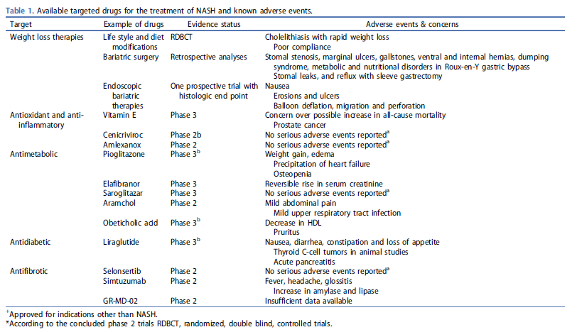

# COMPARATIVE OUTCOMES

## [Konerman MA, Jones JC, Harrison SA. Pharmacotherapy for NASH: Current and emerging. Journal of Hepatology. 2018;68:362-375.](Treatments%20for%20NASH/Reviews%20and%20Meta-analyses/Konerman%20et%20al%20Pharmacotherapy%20for%20NASH%20Current%20and%20emerging.pdf)

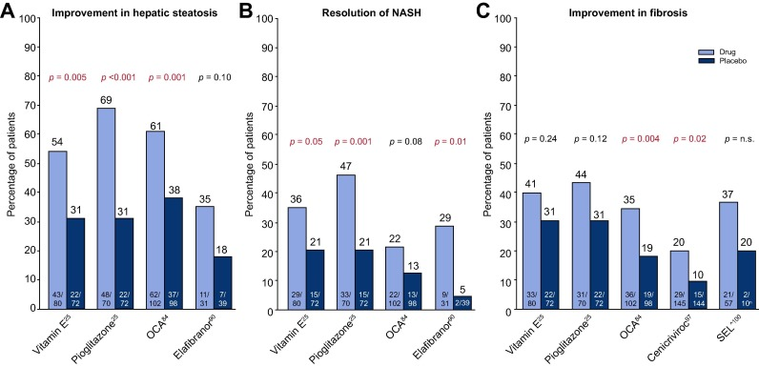

**Fig. 5** Improvement with pharmacologic agents. * (A) On hepatic steatosis (B) resolution of NASH and (C) Fibrosis. *Results are from separate studies and not a reflection of head to head direct comparison of listed agents on outcomes of interest. Trials for individual treatment agents employed different enrollment criteria and durations of therapy, and the primary endpoint definitions were not identical. ^SEL study compared SEL ± SIM to SIM alone, not placebo. Data here reflects arms with SEL compared to SIM arm alone. NASH, non-alcoholic steatohepatitis; n.s., not significant; OCA, obeticholic acid; SEL, selonsertib.

[Figure Taken from Konerman et al., 2018]

### **PHASE IIA AGENTS**

Table 1

**Pharmacologic agents in Phase IIa studies for treatment of NAFLD/NASH.**

| **Mechanism of action** | **Company (Product name)** | **Condition and stage** | **Primary endpoint(s)** | **N** | **Duration (wk)** |
| --- | --- | --- | --- | --- | --- |
| **FXR agonist non-bile acid** | | | | | |
|  | Novartis (LJN452) | NASH, stage 0–3, elevated ALT, OR  PDFF >10%, obesity, DM2 | Adverse event profile, safety, improvement in ALT | 250 | 12 |
|  | Novartis (LMB763) | NASH, stage 0–3, elevated ALT, OR  PDFF >10%, obesity, DM2 | Adverse event profile, safety, improvement in ALT | 100 | 12 |
| **FXR agonist non-bile acid + ACC inhibitor** | | | | | |
|  | Gilead (GS-9674) | MRE >2.5 kPa, PDFF >10% | Safety and tolerability | 140 | 24 |
|  | Gilead (GS-976 + GS-9674) | MRE ≥NASH 2.88 kPa, PDFF ≥10%, OR  MRE >4.67 kPa, not compensated, OR  NASH, stage 2–3 | Safety and tolerability | 110 | 12 |
| **PPAR-α/y agonist** | | | | | |
|  | Zydus (saroglitazar) | NAFLD stage 0–3, ALT >1.5 ULN | Percent change in ALT | 104 | 16 |
| **PPAR-α/δ/y agonist** | | | | | |
|  | Inventiva Pharma (IVA337) | NASH, SAF fibrosis score <4 | Improvement in SAF without worsening fibrosis | 225 | 24 |
| **GLP-1 analogue** | | | | | |
|  | Novo Nordisk (liraglutide) | NASH, fibrosis 1–4, compensated | Resolution of NASH without worsening of fibrosis | 52 | 48 |
|  | Novo Nordisk (semaglutide) | NASH, stage 2–3 fibrosis | Resolution of NASH without worsening of fibrosis | 372 | 72 |
| **ACCi** | | | | | |
|  | Gilead (GS-0976) | NAFLD OR NASH without cirrhosis | Safety and tolerability | 127 | 12 |
| Pfizer (PF-05221304) | MRE ≥2.5 kPa, PDFF ≥8%  NASH, stage 1–3 | Change in hepatic fat | 360 | 16 |
| **FGF-19 agonist** | | | | | |
|  | NGM BIO (NGM282) | NASH, stage 1–3 | Change in hepatic fat | 140 | 12 |
| **Recombinant FGF-21** | | | | | |
|  | BMS (BMS986036) | NASH, stage 1–3 | Change in hepatic fat | 74 | 16 |
| **TLR-4 antagonist** | | | | | |
|  | TAIWAN J (JKB-121) | NASH, stage 1–3 | Improvement in ALT and change in hepatic fat | 66 | 24 |
| **Thyroid hormone receptor-B agonist** | | | | | |
|  | Madrigal (MGL-3196) | NASH, stage 1–3 | Change in hepatic fat | 125 | 36 |
| **ASBT inhibitor** | | | | | |
|  | Shire (volixibat) | NASH, stage 0–3 | Improvement in NAS without fibrosis worsening | 266 | 48 |
| **mTOT modulating insulin sensitizer** | | | | | |
|  | Cirius (MSDC 0602k) | NASH, stage 1–3 | Improvement in NAS without fibrosis worsening | 380 | 48 |
| **Sodium glucose cotransporter 1 and 2 inhibitor** | | | | | |
|  | Novartis (LIK066) | NASH, stage 1–3 | Percent change in ALT | 110 | 12 |
| **AOC3 inhibitor** | | | | | |
|  | Boehringer Ingelheim (BI 1467335) | NASH stage 1–3, OR  MRE ≥3.64 kPa, PDFF ≥5% | Target enzyme activity relative to baseline in percent, 24 h post dose | 150 | Up to 16 |
| **Induction of regulatory T cells** | | | | | |
|  | IMMURON (hyperimmune bovine colostrum) | NASH, stage 0–3 | Change in hepatic fat | 130 | 24 |

**[Table taken from Konerman et al., 2018]**

### PHASE IIB AGENTS

* **ARAMCHOL – novel synthetic bile acid conjugate**
  + **Already evaluated in Phase II study examining change in hepatic steatosis in patients with NASH and NAFLD**
    - Safadi R., Konikoff F.M., Mahamid M., et al: The fatty acid-bile acid conjugate Aramchol reduces liver fat content in patients with nonalcoholic fatty liver disease. Clin Gastroenterol Hepatol 2014; 12: pp. 2085-2091
  + **Now in Phase IIb targeting overweight/obese patients with NASH and T2DM/prediabetes**
* **EMRICASAN – pan caspase inhibitor** 
  + **Already evaluated in earlier study examining portal hypertension** 
    - Barreyro F.J., Holod S., Finocchietto P.V., et al: The pan-caspase inhibitor Emricasan (IDN-6556) decreases liver injury and fibrosis in a murine model of non-alcoholic steatohepatitis. Liver Int 2015; 35: pp. 953-966
  + **Now in ENCORE-NF study with primary endpoint as improvement in fibrosis ≥1** 
    - Clinical Trials.gov. Emricasan, a Caspase Inhibitor, for Evaluation in Subjects With Non-Alcoholic Steatohepatitis (NASH) Fibrosis (ENCORE-NF).
  + **Also being studied in ENCORE-LF cirrhosis and severe portal hypertension (HVPG ≥12mmHg)**
    - Clinical Trials.gov. Emricasan, a Caspase Inhibitor, or Treatment of Subjects With Decompensated NASH Cirrhosis (ENCORE-LF).
* **GR-MD-02 – galectin-3 protein inhibitors** 
  + **Did not meet primary endpoint for Phase IIa study assessing improvement in fibrosis**
    - Clinical Trials.gov. Clinical Trial to Evaluate Efficacy of GR-MD-02 for Treatment of Liver Fibrosis in Patients With NASH With Advanced Fibrosis (NASH-FX).
  + **Now being evaluated in longer Phase IIb study specifically in patients with compensated NASH cirrhosis and portal hypertension (HVPG ≥6mmHg)**
    - Maker announced in Dec 2017 that GR-MD-02 “showed statistically significant and clinically meaningful results in reducing the primary endpoint measurement of HVPG (hepatic venous pressure gradient) in comparison to placebo in NASH cirrhosis patients without esophageal varices, which represented 50 percent of the patients enrolled in the clinical trial.”
    - <https://globenewswire.com/news-release/2017/12/05/1229091/0/en/Galectin-Therapeutics-Announces-Results-from-Phase-2b-NASH-CX-Trial.html>

### **PHASE III AGENTS**

* **OBETICHOLIC ACID (OCA) -semi-synthetic derivative of human bile acid CDCA – functions as farnesoid X receptor agonist**
  + **Previously evaluated in the** **FLINT trial** **and by** **Mudaliar et al., 2013**
    - In this study, 45% of patients in the treatment arm had at least a 2-point improvement in the NAS without worsening of fibrosis, compared to only 21% in the placebo arm ( p = 0.0002). Of note, the proportion of patients who achieved resolution of NASH (defined as either not NAFLD or NAFLD but not NASH) was not statistically different (22% for OCA vs. 13% for placebo, p = 0.08). **Interestingly, OCA did have a beneficial impact on fibrosis (35% of patients in the treatment arm vs. 19% in the placebo arm had improvements in fibrosis, p = 0.004)**
    - Major limitations: Cardiovascular risks must be further characterized due to elevations in LDL and decreases in HDL
  + **Now being assessed in a large (~2,000 patient) 6 year phase III clinical trial – REGENERATE**
    - Targeting NASH patients with **Stage 2-3 fibrosis**
    - Primary outcomes are **fibrosis improvement**, NASH resolution, progression to cirrhosis, ascites, HCC, liver transplantation
    - Treatment will last until achievement of pre-specified number of outcome events – estimated 6 years
  + **ALSO recently (December) announced the REVERSE trial** 
    - Targeting patients with **compensated cirrhosis with fibrosis score of 4**
    - primary outcome is fibrosis improvement, NASH resolution
* **ELAFIBRANOR – dual peroxisome proliferator-activated receptor (PPAR)-alpha/delta agonist** 🡪 **inducer of beta-oxidation of fatty acids** 
  + **Previously assessed in the GOLDEN-505 trial by** **Ratziu et al., 2016**
    - Elafibranor significantly decreased total cholesterol, LDL-cholesterol, triglycerides, and increased HDL-cholesterol, and significantly improved glucose homeostasis (significant reductions in HbA1c and free fatty acids in diabetic patients)
  + **Now being investigated in a large (~2,000 patient), 4 year phase III clinical trial – RESOLVE-IT**
    - Treatment will last until achievement of pre-specified number of outcomes including all-cause mortality, cirrhosis development, and liver-related clinical outcomes
* **CENICRIVIROR (CVC) – dual CCR2/CCR5 chemokine receptor antagonist**
  + **Already evaluated in phase IIb, international study of patients with NASH and diabetes/metabolic syndrome – CENTAUR trial** 
    - No difference in primary endpoint of a 2-point improvement in the NAS without worsening of fibrosis
    - However, twice as many patients in the CVC arm had improvement in fibrosis by ≥1 stage without worsening in steatohepatitis
  + **Now undergoing further investigation for impact on fibrosis in a 12-month phase III clinical trial of patients with NASH and stage 2-3 fibrosis – AURORA trial**
* **SELONSERTIB – an apoptosis signal-regulating kinase which mediates oxidative stress related cell death, inflammation, and fibrosis** 
  + **Recent Phase II trial evaluated change in fibrosis are primary endpoint**
  + **2 New phase III clinical trials – STELLAR 3 and STELLAR 4 are studying the effect on fibrosis, in patients with bridging fibrosis**

### **NOT IN THE PIPELINE: WHY?**

* **VITAMIN E**
  + **Most commonly used medication in treatment of NASH**
  + **Evaluated in PIVENS trial by Sanyal et al where subjects randomised to 800 IU/day of vitamin E for 96 weeks demonstrated improvements in steatosis ( p = 0.005), lobular inflammation ( p = 0.02) and ballooning ( p = 0.01), as well as resolution of NASH (43% vs. 19% in placebo arm, p = 0.001), but no improvement in fibrosis ( p = 0.24).**
  + **May be less effective in patients with diabetes and cirrhosis** 
    - **Bril et al., Diabetes 2018** **– Abstract only presented**
  + **Possible concerns about asociations with long term increases in all-cause mortality**
  + **Recent 2018 meta-analysis of 5 RCT’s showed Vitamin E treatment resulted in improvements in steatosis, lobular inflammation and fibrosis, as well as AST/ALT,** 
    - **Sato et al., 2018**
  + **Importantly: can’t be patented**
* **PIOGLITAZONE** 
  + **Meta-analysis showed that pioglitazone resulted in improvements in histopathologic components of NASH (ballooning RR 1.62 and OR 2.11, steatosis RR 2.03 and OR 3.39, and inflammation RR 1.71 and OR 2.58), with improvements in fibrosis (RR 1.38 and OR 1.68)**
    - **Boettcher et al., 2012**
  + **Major limitations on its use: weight gain, cardiovascular risks**
  + **Also: now generic, can’t be patented**
* **LIRAGLUTIDE** 
  + **In LEAN trial, liraglutide resulted in increases in resolution of NASH (p = 0.019) and improvement of ballooning ( p = 0.05), but fibrosis worsened ( p = 0.04).**
  + **Novo-Nordisk is pursuing alternative GLP-1, semaglutide**

### **NO LONGER STUDIED:**

* **ORLISTAT**
  + didn’t result in significant weight loss, although patients who lost weight in either treatment arm experienced significant improvement in steatosis (see table)
  + **Harrison et al., 2009**
* **BETAINE** – methyl donor
  + 12 month trial found no differences in NAS or fibrosis scores
  + **Adbelmalek et al., 2009**
* **URSODEOXYCHOLIC ACID** 
  + Recent editorial summarizing 4 clinical trials “UDCA in monotherapy has no positive effect in NASH with the usual dose, and has only marginal and perhaps clinically irrelevant effects at a higher dose.”
  + **Haedrich et al., 2011**
* **SIMVASTATIN**
  + **Austin et al., 2009**
* **ATORVASTATIN**
  + **Hyogo et al., 2007**
* **ROSIGLITAZONE**
  + **Torres et al., 2011**
* **PHYLLANTHUS URINARIA** 
  + **Wai-Sun Wong et al., 2012**
* **FISH OIL** 
  + **Argo et al., 2015**

## [Singh S, Khera R, Allen AM, Murad MH, Loomba R. Comparative effectiveness of pharmacological interventions for nonalcoholic steatohepatitis: A systematic review and network meta‐analysis. Hepatology. 2015;62:1417-1432.](Treatments%20for%20NASH/Reviews%20and%20Meta-analyses/Singh%20et%20al%20Comparative%20effectiveness%20of%20pharmacological%20interventions%20for%20nonalcoholic%20steatohepatitis%20A%20systematic%20review%20and%20network%20meta‐analysis.pdf)

* We performed a Bayesian network meta-analysis combining direct and indirect treatment comparisons to assess the comparative effectiveness of pharmacological agents for the treatment of nonalcoholic steatohepatitis (NASH). Through systematic literature review, we identified nine randomized, controlled trials (RCTs) including 964 patients with biopsy-proven NASH, comparing vitamin E, thiazolidinediones (TZDs), pentoxifylline, or obeticholic acid to one another or placebo.
  + This method involves the simultaneous analysis of direct evidence (from RCTs directly comparing treatments of interest) and indirect evidence (from RCTs comparing treatments of interest with a common comparator, such as placebo) to calculate a **mixed-effect estimate** as the **weighted average** of the two. Such a technique may improve the precision of the estimate (compared with direct evidence alone) and also allows estimation of the comparative efficacy of two active treatments, even if no studies directly compare them. For example, through a Bayesian network of three agents, A, B, and C, **if we know the relationship between A and B, and B and C, we can infer probabilistic relationship between A and C**
  + If outcomes were reported at multiple time points, we **examined results reported at 12 months.**
  + Only reported results of trials that compared treatment to another active agent or placebo
  + Excluded observational studies and trials with dietary (nonstandard) interventions
* The primary outcome was improvement in fibrosis stage
  + Direct meta-analysis: Compared to placebo**, pentoxifylline (two RCTs; RR, 0.80; 95% CI: 0.65-0.98) and OCA (one RCT; RR, 0.81; 95% CI: 0.70-0.95)** were associated with improvement in fibrosis in patients with NASH.
  + In contrast, **vitamin E and TZDs were not associated with a significant improvement in fibrosis** (Fig. 2A). In the only head-to-head trial, pioglitazone was comparable to vitamin E (RR, 0.93; 95% CI: 0.64-1.32).
  + **Improvement in fibrosis was defined as any numerical decrease in the stage. Fibrosis stages 1a, 1b, and 1c were considered stage 1 for the purposes of analysis.**
  + Network Meta-analysis: Moderate-quality evidence supports the use of **pentoxifylline (RR, 0.26; 95% CrI: 0.05-1.00**) over placebo in improving fibrosis.
  + 
* secondary outcomes were improvement in ballooning degeneration, lobular inflammation, and steatosis.
  + High-quality evidence supports the effect of vitamin E, TZDs, and obeticholic acid over placebo in improving ballooning degeneration.
  + All four interventions seemed to have at least moderate-quality evidence over placebo to improve steatosis.
  + Moderate-quality evidence supports that TZDs, pentoxifylline, and obeticholic acid decrease lobular inflammation.
  + All the head-to-head comparisons were supported by very low-quality evidence except for superiority of TZDs over vitamin E on improving steatosis and lobular inflammation, which had moderate-quality evidence.
* Conclusions: Based on direct and network meta-analysis, pentoxifylline and obeticholic acid improve fibrosis, and vitamin E, TZDs, and obeticholic acid improve ballooning degeneration in patients with NASH. Future comparative trials of combination therapies targeting distinct histological features are warranted.

# CLINCAL ENDPOINTS 🡪 CLINICAL OUTCOMES

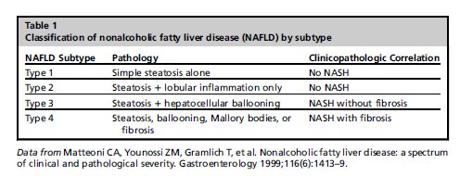

## [Younossi ZM, Stepanova M, Rafiq N, et al. Pathologic criteria for nonalcoholic steatohepatitis: Interprotocol agreement and ability to predict liver‐related mortality. Hepatology. 2011;53:1874-1882.](NASH%20natural%20history%20and%20epidemiology/Younossi%20et%20al%20Pathologic%20criteria%20for%20nonalcoholic%20steatohepatitis%20Interprotocol%20agreement%20and%20ability%20to%20predict%20liver‐related%20mortality.pdf)

* Liver biopsies for **257 NAFLD patients** with at least 5 years follow up were analyzed retrospectively using different criteria for NASH to determine which is the best predictor of long term liver-related mortality
* *After we controlled for confounders,* ***a diagnosis of NASH by the original criteria for NAFLD subtypes [adjusted hazard ratio = 9.94 (95% confidence interval = 1.28-77.08)] demonstrated the best independent association with LRM.***
  + Old system involved categorization **of NAFLD into subtypes** based on histology, **with** **subtypes 3 and 4 = NASH**
    - (1) steatosis alone (NAFLD type 1), (2) steatosis with lobular inflammation only (NAFLD type 2), (3) steatosis with **hepatocellular ballooning** (NAFLD type 3), or (4) **steatosis with Mallory-Denk bodies or fibrosis** (NAFLD type 4).
  + Subsequently **Brunt criteria** was developed
    - each liver biopsy sample with at least **fat and lobular inflammation** was further graded as **mild (grade 1), moderate (grade 2), or marked (grade 3)** as described by Brunt et al
    - For the purpose of this study, patients with **Brunt grades of 1 to 3 were combined and were considered to have NASH.**
    - **Brunt criteria was found to lack specificity for predicting LRM** 
      * **Over-identified the population at risk**
  + **Nonalcoholic Fatty Liver Disease Score (NAS)** and fibrosis scoring from Kleiner et al
    - separate scores for **steatosis (0-3), hepatocellular ballooning (0-2), lobular inflammation (0-3),** and fibrosis (0-4).
    - NAS was the sum of the first three features.
    - Fibrosis according to the NAS was scored from 0 to 4 [(0) none, (1) centrilobular/perisinusoidal, (2) centrilobular plus periportal, (3) bridging, and (4) cirrhosis].
  + Current study proposed:
    - NASH diagnosed for (1) **any degree of steatosis** along with centrilobular **ballooning and/or Mallory- Denk bodies** or (2) **any degree of steatosis** along with **centrilobular pericellular/perisinusoidal fibrosis** **or bridging fibrosis** in the absence of another identifiable cause
    - Diagnosis by these criteria was in almost complete agreement with original definition of NASH
  + **Original criteria was found to be stronger than use of NAS for predicting long term mortality** 
    - **Median follow up = 146 months**
    - **31% of patients died (9% were liver related)**
* **Among the individual pathologic features, advanced fibrosis showed the best independent association with LRM [adjusted hazard ratio = 5.68 (95% confidence interval = 1.50-21.45)].**
* ***the presence of advanced fibrosis is the only histologic lesion to be associated with liver-related mortality. Neither steatosis, inflammation, ballooning, nor Mallory hyaline was associated with liver-related mortality after adjusting for the presence of fibrosis.***
* *Although the incidence of NAFLD in the US population has been estimated to be 15% to 30%, only 2% to 3% have the potentially progressive subtype of NAFLD or NASH.3-5*
* ***A number of natural history studies have convincingly shown that among patients on the NAFLD spectrum, only those with NASH are at risk for progression***
  + 6. Rafiq N, Bai C, Fang Y, Srishord M, McCullough A, Gramlich T, et al. Long-term follow-up of patients with nonalcoholic fatty liver. Clin Gastroenterol Hepatol 2009;7:234-238.
  + 7. Soderberg C, Stal P, Askling J, Glaumann H, Lindberg G, Marmur J et al. Decreased survival of subjects with elevated liver function tests during a 28-year follow-up. HEPATOLOGY 2010;51:595-602.
  + 8. Ekstedt M, Franzen LE, Mathiesen UL, Thorelius L, Holmqvist M, Bodemar G, et al. Long-term follow-up of patients with NAFLD and elevated liver enzymes. HEPATOLOGY 2006;44:865-873.
  + 9. Musso G, Gambino R, Cassader M, Pagano G. Meta-analysis: natural history of non-alcoholic fatty liver disease (NAFLD) and diagnostic accuracy of non-invasive tests for liver disease severity. Ann Med; doi: 10.3109/07853890.2010.518623.
  + 10. Ong J, Pitts A, Younossi ZM. Increased mortality and liver-related mortality in patients with nonalcoholic fatty liver disease. J Hepatol 2008;49:608-612.
  + 11. Stepanova M, Rafiq N, Younossi ZM. Components of metabolic syndrome are independent predictors of mortality in patients with chronic liver disease: a population-based study. Gut 2010;59:1410-1415.
  + 12. Dunn W, Xu R, Wingard DL, Rogers C, Angulo P, Younossi ZM, et al Suspected nonalcoholic fatty liver disease and mortality risk in a population-based cohort study. Am J Gastroenterol 2008;103:2263-2271.
  + 13. Teli MR, James OF, Burt AD, Bennett MK, Day CP. The natural history of nonalcoholic fatty liver: a follow-up study. HEPATOLOGY 1995; 22:1714-1719.
  + 14. Starley BQ, Calcagno CJ, Harrison SA. Nonalcoholic fatty liver disease and hepatocellular carcinoma: a weighty connection. HEPATOLOGY 2010;51:1820-1832.
* Steatosis was scored as an estimate of the percentage of parenchyma replaced by fat: (0) 0%, (1) up to 5%, (2) 6% to 33%, (3) 34% to 66%, or (4) more than 66%.
* Lobular inflammation, portal inflammation, hepatocellular ballooning, pericellular/perisinusoidal fibrosis, and portal fibrosis were graded on a scale of 0 to 3: (0) none, (1) mild or few, (2) moderate, or (3) marked or many. Bridging fibrosis was scored as (0) none, (1) few bridges, or (2) many bridges.
* Cirrhosis was scored as (0) absent, (1) incomplete, or (2) established.
* Using NAS > or equal to 5 to diagnose NASH was particularly ineffective
  + Missed 40-45% of NASH patients diagnosed by original criteria
* NAS values of ≥ 3 and ≥ 4 were separately considered as definitions of NASH.
  + Better predicted LRM but still shy of statistical significance
* NASH patients were at a higher risk of LRM vs non-NASH patients when diagnosed using original criteria and current study’s protocol, but not with Brunt criteria (NAS score was shy of statistical significance)
  + 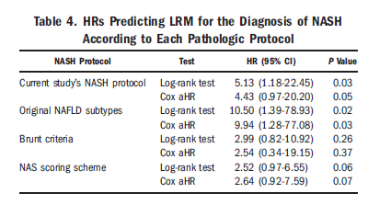
  + After we controlled for important confounders (age, gender, ethnicity, and presence of obesity and diabetes), a diagnosis of NASH made by the original criteria for NAFLD subtype [aHR = 9.94 (95% CI = 1.28-77.08)] and a diagnosis of NASH made by the current study’s criteria for subtypes [aHR = 4.43 (95% CI = 0.97-20.20)] were independent predictors of LRM (Table 4).
  + NAS threshold was optimized to NAS ≥ 4, but was still shy of statistical significance
* Additionally, histologic documentation of **advanced fibrosis grade ≥ 2 [HR = 20.4 (95% CI = 5.9-70.5), P < 0.0001] or any cirrhosis [HR = 10.6 95% CI = 4.19-26.7), P < 0.0001] was also associated with LRM. (In univariate analysis)**
* **In multivariate analysis, portal fibrosis graded as ≥3 (with the current study’s fibrosis grading, this included all patients with bridging fibrosis and cirrhosis) remained independently associated with LRM [aHR = 5.68 (95% CI = 1.50-21.45)].**
* **Similarly, pathologic features graded with NAS, advanced fibrosis (stage 4) was independently associated with LRM [aHR = 5.62 (95% CI = 1.92-6.46)]**
* **Additionally, we observed that NASH subjects dying from liver-related causes died on average 6 years earlier than subjects without NASH. Therefore, we assume that NASH, once it has progressed, could be responsible for approximately 6 fewer years of life,**
* **and the rate of its progression to liver death over 10 years is approximately 16%.**
* **Limitations**
  + Use of LRM as an outcome for validating the diagnosis of NASH is narrow in scope
  + **Any cause-specific mortality (i.e., LRM) lacks true negative controls: deaths other than liver-related deaths did not mean the absence of life-threatening liver disease, so those who had been diagnosed with NASH but eventually did not die from liver-related causes were not genuine false positives.**
  + **🡪 SUPPORTS THE CASE FOR EXAMINING CV MORTALITY AS WELL IN PE MODEL**
  + **Half of those who had NASH and might well have been on their way to a liver-related death died earlier from other causes (mostly from coronary artery disease).**

## [Brunt EM, Kleiner DE, Wilson LA, et al. Nonalcoholic fatty liver disease (NAFLD) activity score and the histopathologic diagnosis in NAFLD: distinct clinicopathologic meanings. Hepatology. 2011;53:810-820.](NASH%20natural%20history%20and%20epidemiology/Brunt%20et%20al%20Nonalcoholic%20fatty%20liver%20disease%20(NAFLD)%20activity%20score%20and%20the%20histopathologic%20diagnosis%20in%20NAFLD.pdf)

* The diagnosis of nonalcoholic steatohepatitis (NASH) is defined by the presence and pattern of specific histological abnormalities on liver biopsy. A separate system of scoring the features of nonalcoholic fatty liver disease (NAFLD) called the NAFLD Activity Score (NAS) was developed as a tool to measure changes in NAFLD during therapeutic trials. **However, some studies have used threshold values of the NAS, specifically NAS ≥5, as a surrogate for the histologic diagnosis of NASH.**
  + the dichotomous assessment of liver biopsies as either having steatohepatitis (SH) or not is less helpful in treatment trials of therapeutic agents to improve NASH **because it cannot identify patients in whom NASH significantly lessened in severity with treatment but continued to fulfill diagnostic criteria for NASH. For this reason, a scoring system was needed that included the full spectrum of nonalcoholic fatty liver disease and would be sensitive to changes in the underlying disease process independent of the diagnosis of NASH.**
  + **It is, however, increasingly apparent from ongoing and published studies that the numeric value of the composite NAS is considered by some investigators to be either ‘‘synonymous’’ with, or actually a replacement for, a microscopic diagnosis that is based on overall pattern of injury as well as the presence of additional lesions such as zonality of lesions, portal inflammation, and fibrosi**
* To evaluate whether this unintended use of the NAS is valid, biopsy and clinical data from the 976 adults in NASH Clinical Research Network (CRN) studies were reviewed. Biopsies were evaluated centrally by the NASH CRN Pathology Committee.
* Definite steatohepatitis (SH) was diagnosed in 58.1%, borderline SH in 19.5% and ‘‘not SH’’ in 22%. The NAS was ≥5 in 50% and <4 in 49%; in this cohort **only 75% of biopsies with definite SH had an NAS ≥5, whereas 28% of borderline SH and 7% of ‘‘not SH’’ biopsies had NAS ≥ 5.** Of biopsies with an NAS ≥5, 86% had SH and 3% ‘‘not SH’’. **NAS <4 did not indicate benign histology; 29% had SH and only 42% had ‘‘not SH.’’**
  + NAS scoring both underdiagnoses by missing 29% of patients with SH and overdiagnoses by 7-28%?
  + not all biopsies with NAS **≥**5 have findings that meet diagnostic criteria of definite SH, and that some cases of NAS <4 do, indicating that the threshold value of an NAS > 5 cannot be used reliably to establish the presence or absence of NASH.
  + 
* Higher values of the NAS were associated with higher levels of alanine aminotransferase and aspartate aminotransferase, whereas the diagnosis of SH was associated with features of the metabolic syndrome.
  + NAS is more reflective of acute liver inflammatory and apoptosis rather than chronic outcomes (since SH is being defined as a cohort with elevated LRM)
  + SH diagnosis is therefore more associated with metabolic syndrome, the main driver of mortality in this population
* Risk factors associated with dx of SH confirmed by blinded analysis in this trial
  + Elevated serum ALT
  + Elevated serum triglycerides
  + Elevated serum insulin
  + High calculated HOMA-IR
  + Low QUICKI
  + Dx of diabetes
  + Female gender
  + **Importantly, BMI was NOT independently associated with Dx of SH**
* To better understand the clinical characteristics of patients with low NAS but a definite SH diagnosis, or conversely, a high NAS but not a definite SH diagnosis, the biopsies with low and high NAS were analyzed separately.
  + For those with low NAS but definite SH, the only correlate was elevated ALT
  + For those with high NAS AND definite SH, several features correlated
    - Diabetes was the strongest association
    - Other factors were Hispanic ethnicity, higher fasting insulin levels, HOMA-IR, and lower QUICKI
* Conclusion: The diagnosis of definite SH or the absence of SH based on evaluation of patterns as well as individual lesions on liver biopsies does not always correlate with threshold values of the semiquantitative NAS. *Clinical trials and observational studies should take these different performance characteristics into account.*
  + Must go back and assess how SH was defined in clinical protocols to determine whether this statistic can be used for further PE extrapolation
* NAS
  + Developed because the dichotomous assessment of NASH was not sensitive to the value of potential reductions in the severity of the NASH in patients who still fulfilled the diagnosis
    - But diagnosis is totally oriented around stratifying LRM risk so how can short term histological changes even be valued in a PE model??
  + active and potentially reversible injury (‘‘grade’’) in the NAFLD Activity Score (NAS) and those potentially less reversible and characterized by collagen deposition and architectural alterations that may evolve toward more permanent parenchymal remodeling (‘‘stage’’)
  + The histologic feature of the NAS that appears to be most significant in the determination of the diagnosis of SH is ballooning. Regardless of the final NAS, >99% of 543 cases with a diagnosis of definite SH had ballooning.
    - A recent study highlighted the loss of K8/18 detectable by immunohistochemistry as a more sensitive indicator of ballooning. This technique is useful in detecting more subtle ballooning, and it is available in most diagnostic pathology laboratories.
* *The fundamental dilemma of NASH* 
  + The diagnosis is oriented toward the goal of identifying a high-risk population for liver related mortality
    - (presumably to develop treatments for these people that can justify their inevitable risks)
  + The actual assessment of the diagnosis is based on histological findings
    - “microscopic diagnosis that is based on overall pattern of injury as well as the presence of additional lesions such as zonality of lesions, portal inflammation, and fibrosis.”
  + There is a fundamental assumption that a snapshot of acute histological findings is the best method to identify a subpopulation at a high risk of LRM
    - Fibrosis is an acute histological change, THE ONLY acute histological change that can predict LRM
    - Diagnosis of NASH by original criteria had a greater aHR than fibrosis (9.9 vs 5.6) but a MUCH wider confidence interval
    - Possible composite diagnosis with consideration of long term underlying metabolic and lifestyle risk factors could offer better description of the high-risk population, since mortality is still greatly driven by underlying CV risk
* “Review as ‘‘cirrhosis with or without features of NAFLD or NASH’’ were excluded from this analysis, as it is well recognized that the active lesions of SH may not be retained in cirrhosis”
  + DX OF SH MAY RESOLVE CONCURRENTLY WITH PROGRESSION TO CIRRHOSIS!!!!!
  + *Dx of SH is likely not appropriate for long term PE extrapolation*
* Limitations
  + No adjustment for multiple comparators were made
* *Although the qualitative recognition of a pattern of injury may at first seem to be less precise and more subjective than a numerical score, our regression analysis indicated that it is a powerful result. Scores, on the other hand, are quite useful in comparative analyses, such as interventional studies, for objective measures of change of specific lesions. The exercises of diagnosis and scoring, while leading to interrelated results, are thus distinct and separate, and, when done properly, serve distinct, separate, and important purposes.*

## [Pagadala MR, MD, McCullough AJ, MD. The Relevance of Liver Histology to Predicting Clinically Meaningful Outcomes in Nonalcoholic Steatohepatitis. Clinics in Liver Disease. 2012;16:487-504.](NASH%20natural%20history%20and%20epidemiology/Pagadala%20and%20McCullough%20The%20Relevance%20of%20Liver%20Histology%20to%20Predicting%20Clinically%20Meaningful%20Outcomes%20in%20Nonalcoholic%20Steatohepatitis.pdf)

* Based on the data available and review of the current literature, particularly in general population studies, it appears that **NAFLD, including nonalcoholic steatohepatitis (NASH) but not simple steatosis, is associated with worse outcomes compared with the general population**. However, despite these observations, **the differences in all-cause mortality between no NASH and NASH are not significant.**
* Epidemiology
  + NAFLD prevalence is between 17-30% **1,2**
    - * **1. Browning JD, Szczepaniak LS, Dobbins R, et al. Prevalence of hepatic steatosis in an urban population in the United States: impact of ethnicity. Hepatology 2004; 40(6):1387–95.**
      * **2. Luyckx FH, Desaive C, Thiry A, et al. Liver abnormalities in severely obese subjects: effect of drastic weight loss after gastroplasty. Int J Obes Relat Metab Disord 1998;22(3):222–6.**
    - Of NAFLD patients, 34% remain stable, 37% progress to fibrosis, and 29% have regression of fibrosis over 3-6 years, **23**
      * **23. Adams LA, Sanderson S, Lindor KD, et al. The histological course of nonalcoholic fatty liver disease: a longitudinal study of 103 patients with sequential liver biopsies. J Hepatol 2005;42(1):132–8.**
    - 47% of NAFLD patients without fibrosis at baseline develop fibrosis on follow up, **14.**
      * **14. Ekstedt M, Franzen LE, Mathiesen UL, et al. Long-term follow-up of patients with NAFLD and elevated liver enzymes. Hepatology 2006;44(4):865–73.**
    - Approximately 37-41% of NAFLD subjects have fibrosis progression over 3 to 10 years, **14, 23**
      * **14. Ekstedt M, Franzen LE, Mathiesen UL, et al. Long-term follow-up of patients with NAFLD and elevated liver enzymes. Hepatology 2006;44(4):865–73.**
      * **23. Adams LA, Sanderson S, Lindor KD, et al. The histological course of nonalcoholic fatty liver disease: a longitudinal study of 103 patients with sequential liver biopsies. J Hepatol 2005;42(1):132–8**
  + NASH prevalence is between 12-17%
    - Of NASH patients, **25-50% develop progressive fibrosis over a period of 4-6 years, 14, 15, 19-22**
      * **14. Ekstedt M, Franzen LE, Mathiesen UL, et al. Long-term follow-up of patients with NAFLD and elevated liver enzymes. Hepatology 2006;44(4):865–73.**
      * **15. Matteoni CA, Younossi ZM, Gramlich T, et al. Nonalcoholic fatty liver disease: a spectrum of c**
      * **19. Jepsen P, Vilstrup H, Mellemkjaer L, et al. Prognosis of patients with a diagnosis of fatty liver—a registry-based cohort study. Hepatogastroenterology 2003; 50(54):2101–4.linical and pathological severity. Gastroenterology 1999;116(6): 1413–9**
      * **20. Dam-Larsen S, Becker U, Franzmann MB, et al. Final results of a long-term, clinical follow-up in fatty liver patients. Scand J Gastroenterol 2009;44(10):1236–43.**
      * **21. Musso G, Gambino R, Cassader M, et al. Meta-analysis: natural history of nonalcoholic fatty liver disease (NAFLD) and diagnostic accuracy of non-invasive tests for liver disease severity. Ann Med 2011;43(8):617–49.**
      * **22. Angulo P, Keach JC, Batts KP, et al. Independent predictors of liver fibrosis in patients with nonalcoholic steatohepatitis. Hepatology 1999;30(6):1356–62.**
    - **15-25% of individuals with NASH progress to cirrhosis, 5**
      * **5. McCullough AJ. Pathophysiology of nonalcoholic steatohepatitis. J Clin Gastroenterol 2006;40(Suppl 1):S17–29.**
    - Stratified by fibrosis
      * 13.3% of NASH patients with mild-moderate fibrosis (stages 1 and 2) develop cirrhosis
      * 50% of patients with stage 3 fibrosis develop cirrhosis, **14**
        + **14. Ekstedt M, Franzen LE, Mathiesen UL, et al. Long-term follow-up of patients with NAFLD and elevated liver enzymes. Hepatology 2006;44(4):865–73.**
* **Ballooning** 
  + **ballooning degeneration (> or equal to 2) was associated with an increased liver-related mortality (hazard ratio [HR] 5.32; P = 0.0015)**
    - **Younossi ZM, Stepanova M, Rafiq N, et al. Pathologic criteria for nonalcoholic steatohepatitis: interprotocol agreement and ability to predict liver-related mortality. Hepatology 2011;53(6):1874–82**
  + However, the findings of ballooning may be subtle and difficult to diagnose consistently even by a trained pathologist, as noted in a study that reported a poor to fair reliability among pathologists to diagnose inflammation, balloon degeneration, and MDBs. In addition, the irregularity in distribution of ballooning degeneration and MDBs could lead to underreporting of NASH
* Mallory-Denk Bodies
  + MDBs, also known as Mallory bodies, are cytoplasmic inclusion bodies in the hepatocyte of patients with chronic liver disease containing an abnormal keratin protein that has been ubiquinated. Both ballooning degeneration and the presence of MDBs can trigger the development of apoptosis.
  + Apoptosis has been validated as an accurate marker for diagnosis of NASH based on immunochemistry in liver tissue. This aspect is of particular interest because serum level of CK-18, a biomarker of apoptosis, has been validated to differentiate NASH from no NASH.
* **Fibrosis** 
  + Although fibrosis predicts clinical outcomes in NASH, it is not included in all the currently published scoring systems.
  + ***Assessment of individual components of pathologic features found that advanced fibrosis of grade 3 or more (stage 3 fibrosis and cirrhosis), but not grades of steatosis, lobular inflammation, or ballooning degeneration, predicted an increased risk of LRM in NASH***
    - **17. Younossi ZM, Stepanova M, Rafiq N, et al. Pathologic criteria for nonalcoholic steatohepatitis: interprotocol agreement and ability to predict liver-related mortality. Hepatology 2011;53(6):1874–82.**
  + **It appears with disease progression over time, there is a decrease in in NAS simultaneously with a worsening of fibrosis, thereby decreasing the accuracy of diagnosing NASH based on NAS CRN score**
    - **This issue was illustrated in a recent study by Soderberg and colleagues, who reported no differences in survival between NASH and no NASH, based on the NAS.**
      * **45. Soderberg C, Stal P, Askling J, et al. Decreased survival of subjects with elevated liver function tests during a 28-year follow-up. Hepatology 2010;51(2):595–602**
    - An increased presence of fibrosis (72%) was noted even in the group classified as no NASH/borderline, and additionally the presence of fibrosis (stage 1–4) was more common in NAFLD patients who died than in those who survived (90% vs 75%, respectively).
  + **The inclusion of fibrosis could explain, in part, why the classifications for NASH used by Younossi and Matteoni, and not the NAS, independently correlated with liver-related mortality Furthermore, fibrosis is the histologic feature in NASH with the best inter- and intra-agreements among pathologists, 33**
    - **33. Fukusato T, Fukushima J, Shiga J, et al. Interobserver variation in the histopathological assessment of nonalcoholic steatohepatitis. Hepatol Res 2005;33(2): 122–7.**
  + **Besides NASH, the presence of NASH-related fibrosis including both mild fibrosis (F1–F2) and advanced fibrosis (F3–F4) have significantly higher liver-related mortality rates than simple steatosis, 21**
    - **21. Musso G, Gambino R, Cassader M, et al. Meta-analysis: natural history of nonalcoholic fatty liver disease (NAFLD) and diagnostic accuracy of non-invasive tests for liver disease severity. Ann Med 2011;43(8):617–49.**
* **A higher body mass index (BMI), the presence of diabetes, and a low initial fibrosis stage are associated with higher rates of fibrosis progression, 23.**
  + **23. Adams LA, Sanderson S, Lindor KD, et al. The histological course of nonalcoholic fatty liver disease: a longitudinal study of 103 patients with sequential liver biopsies. J Hepatol 2005;42(1):132–8.**
* NAFLD and All-cause mortality
  + A study of **NAFLD patients and the general population had higher all-cause mortality in the former group** (standardized mortality ratio [SMR] = 1.34; P = .03). **46**
    - **46. Adams LA, Lymp JF, St Sauver J, et al. The natural history of nonalcoholic fatty liver disease: a population-based cohort study. Gastroenterology 2005;129(1): 113–21.**
  + Another study with a 15-year follow up found Fatty Liver Index (FLI) was independently associated with increased all-cause mortality compared with the general population, **48**
    - **48. Calori G, Lattuada G, Ragogna F, et al. Fatty liver index and mortality: the Cremona study in the 15th year of follow-up. Hepatology 2011;54(1):145–52.**
  + Another recent study by Soderberg and colleagues validated these observations with **higher all-cause mortality in NAFLD patients followed for at least 21 years compared with the general population (SMR = 1.7; 95% confidence interval [CI] 1.24–2.25).** **45**
    - **45. Soderberg C, Stal P, Askling J, et al. Decreased survival of subjects with elevated liver function tests during a 28-year follow-up. Hepatology 2010;51(2):595–602.**
  + NAFLD patients with metabolic syndrome, particularly those with diabetes mellitus and insulin resistance, have more advanced fibrosis and are prone to a more rapid progression of their fibrosis. **23,50**
    - **23. Adams LA, Sanderson S, Lindor KD, et al. The histological course of nonalcoholic fatty liver disease: a longitudinal study of 103 patients with sequential liver biopsies. J Hepatol 2005;42(1):132–8.**
    - **50. Angulo P, Alba LM, Petrovic LM, et al. Leptin, insulin resistance, and liver fibrosis in human nonalcoholic fatty liver disease. J Hepatol 2004;41(6):943–9.**
  + NAFLD patients with type 2 diabetes can double the risk of overall mortality in comparison with the general population who have diabetes without NAFLD (HR = 2.2). **51**
    - **51. Adams LA, Harmsen S, St Sauver JL, et al. Nonalcoholic fatty liver disease increases risk of death among patients with diabetes: a community-based cohort study. Am J Gastroenterol 2010;105(7):1567–73.**

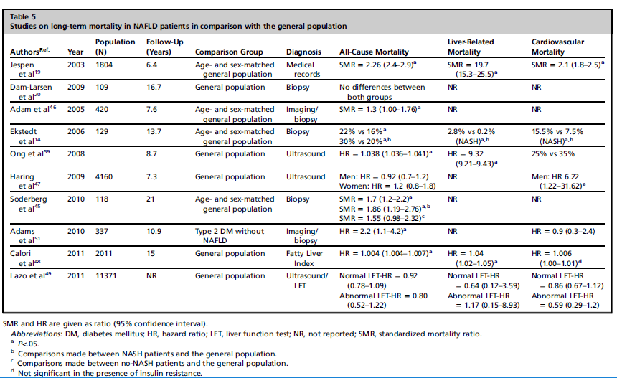

* NASH and All-cause mortality
  + In a national registry–based cohort of 129 patients with elevated liver enzymes and biopsy-proven NAFLD followed for 13 years, *Ekstedt and colleagues* found a **significant increase in all-cause mortality in patients with NASH compared with the reference population**. The overall survival of patients with NASH was significantly lower (70% vs 80%, respectively, P = .01). **14**
    - The poor outcomes in this cohort were attributed to the presence of increased cardiovascular morbidity and, to a lesser degree, liver-related mortality.
    - **14. Ekstedt M, Franzen LE, Mathiesen UL, et al. Long-term follow-up of patients with NAFLD and elevated liver enzymes. Hepatology 2006;44(4):865–73.**
  + Similarly, in another study with a 28-year follow-up, the overall mortality was higher in NASH patients compared with the general population (SMR = 1.9; 95% CI 1.19–2.76; P 5 .007), **45.**
    - **45. Soderberg C, Stal P, Askling J, et al. Decreased survival of subjects with elevated liver function tests during a 28-year follow-up. Hepatology 2010;51(2):595–602**
* Non-NASH NAFLD vs NASH and All-cause mortality
  + Matteoni and colleagues directly compared outcomes of NASH vs non-NASH NAFLD , **15**
    - **15. Matteoni CA, Younossi ZM, Gramlich T, et al. Nonalcoholic fatty liver disease: a spectrum of clinical and pathological severity. Gastroenterology 1999;116(6): 1413–9.**
  + In a mean follow-up of 18 years**, those with type 3 & 4 histology (NASH)** **had higher rates of cirrhosis and liver-related mortalities (30.8% vs 5.6%) compared with type 1 & 2 histology (no NASH)**, **but the overall survival was not different between the two groups, 15.**
    - **15. Matteoni CA, Younossi ZM, Gramlich T, et al. Nonalcoholic fatty liver disease: a spectrum of clinical and pathological severity. Gastroenterology 1999;116(6): 1413–9.**
  + In the studies described in the table below, there were no difference in all-cause mortality between NASH and non-NASH groups,
  + HOWEVER, in the study by Soderberg et al., **the presence of** **any fibrosis in NAFLD** was associated with **increased all-cause mortality** compared to patients without fibrosis, **45**
    - **45. Soderberg C, Stal P, Askling J, et al. Decreased survival of subjects with elevated liver function tests during a 28-year follow-up. Hepatology 2010;51(2):595–602**

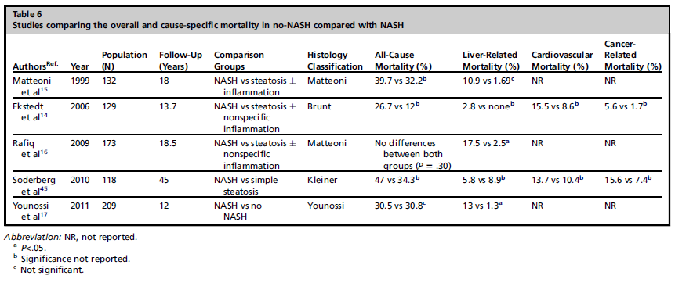

* NAFLD and CV mortality
  + NAFLD patients have a higher risk of CV mortality and morbidity compared to general population controlled for age and gender, **57.**
    - **57. Treeprasertsuk S, Leverage S, Adams LA, et al. The Framingham risk score and heart disease in nonalcoholic fatty liver disease. Liver Int 2012;32(6):945–50.**
  + Both hospital-based and community-based studies have established cardiovascular complications as one of the leading causes of death in the NAFLD cohort. **14–16,19,46,58**
    - **14. Ekstedt M, Franzen LE, Mathiesen UL, et al. Long-term follow-up of patients with NAFLD and elevated liver enzymes. Hepatology 2006;44(4):865–73.**
    - **15. Matteoni CA, Younossi ZM, Gramlich T, et al. Nonalcoholic fatty liver disease: a spectrum of clinical and pathological severity. Gastroenterology 1999;116(6): 1413–9.**
    - **16. Rafiq N, Bai C, Fang Y, et al. Long-term follow-up of patients with nonalcoholic fatty liver. Clin Gastroenterol Hepatol 2009;7(2):234–8.**
    - **19. Jepsen P, Vilstrup H, Mellemkjaer L, et al. Prognosis of patients with a diagnosis of fatty liver—a registry-based cohort study. Hepatogastroenterology 2003; 50(54):2101–4.**
    - **46. Adams LA, Lymp JF, St Sauver J, et al. The natural history of nonalcoholic fatty liver disease: a population-based cohort study. Gastroenterology 2005;129(1): 113–21.**
    - **58. Stepanova M, Younossi ZM. Independent association between nonalcoholic fatty liver disease and cardiovascular disease in the US population. Clin Gastroenterol Hepatol 2012;10(6):646–50.**
  + **Death from CV range in NAFLD range 13-30%, and is the most common cause of mortality, followed by malignancy (6-28%) and liver related deaths (2.8-19%), 14, 15, 45, 46, 59**
    - **14. Ekstedt M, Franzen LE, Mathiesen UL, et al. Long-term follow-up of patients with NAFLD and elevated liver enzymes. Hepatology 2006;44(4):865–73.**
    - **15. Matteoni CA, Younossi ZM, Gramlich T, et al. Nonalcoholic fatty liver disease: a spectrum of clinical and pathological severity. Gastroenterology 1999;116(6): 1413–9.**
    - **45. Soderberg C, Stal P, Askling J, et al. Decreased survival of subjects with elevated liver function tests during a 28-year follow-up. Hepatology 2010;51(2):595–602**
    - **46. Adams LA, Lymp JF, St Sauver J, et al. The natural history of nonalcoholic fatty liver disease: a population-based cohort study. Gastroenterology 2005;129(1): 113–21.**
    - **59. Ong JP, Pitts A, Younossi ZM. Increased overall mortality and liver-related mortality in non-alcoholic fatty liver disease. J Hepatol 2008;49(4):608–12.**
  + Ekstedt and colleagues reported higher death rates from cardiovascular disease in patients with NASH compared with the general population (15.5% vs 7.5%, P 5 .04) as well as those with no NASH (15.5% vs 8.6%); a similar but nonsignificant trend was noted in a Swedish cohort, **14, 45**
    - **14. Ekstedt M, Franzen LE, Mathiesen UL, et al. Long-term follow-up of patients with NAFLD and elevated liver enzymes. Hepatology 2006;44(4):865–73.**
    - **45. Soderberg C, Stal P, Askling J, et al. Decreased survival of subjects with elevated liver function tests during a 28-year follow-up. Hepatology 2010;51(2):595–602**
  + **However, more recent data suggest that patients with NASH do not have an increased risk of cardiovascular disease in comparison with no-NASH patients. 62**
    - **62. Domanski JP, Park SJ, Harrison SA. Cardiovascular disease and nonalcoholic Fatty liver disease: does histologic severity matter? J Clin Gastroenterol 2012; 46(5):427–30.**
  + **Several large population-based studies using non-histological diagnosis have reported no difference in cardiovascular mortality among patients with NAFLD compared to general population, 48, 49, 51**
    - **48. Calori G, Lattuada G, Ragogna F, et al. Fatty liver index and mortality: the Cremona study in the 15th year of follow-up. Hepatology 2011;54(1):145–52.**
    - **49. Lazo M, Hernaez R, Bonekamp S, et al. Non-alcoholic fatty liver disease and mortality among US adults: prospective cohort study. BMJ 2011;343:d6891**
    - **51. Adams LA, Harmsen S, St Sauver JL, et al. Nonalcoholic fatty liver disease increases risk of death among patients with diabetes: a community-based cohort study. Am J Gastroenterol 2010;105(7):1567–73.**
* NASH and Liver-related mortality
  + **Liver-related deaths are significantly higher in patients with NASH (13%–17.5%) than in those with simple steatosis and no NASH (1.3%–2.5%**), **16, 17**
    - **16. Rafiq N, Bai C, Fang Y, et al. Long-term follow-up of patients with nonalcoholic fatty liver. Clin Gastroenterol Hepatol 2009;7(2):234–8.**
    - **17. Younossi ZM, Stepanova M, Rafiq N, et al. Pathologic criteria for nonalcoholic steatohepatitis: interprotocol agreement and ability to predict liver-related mortality. Hepatology 2011;53(6):1874–82.**
  + Hepatocellular carcinoma was the most common occurrence, **14, 16, 45**
    - **14. Ekstedt M, Franzen LE, Mathiesen UL, et al. Long-term follow-up of patients with NAFLD and elevated liver enzymes. Hepatology 2006;44(4):865–73.**
    - **16. Rafiq N, Bai C, Fang Y, et al. Long-term follow-up of patients with nonalcoholic fatty liver. Clin Gastroenterol Hepatol 2009;7(2):234–8.**
    - **45. Soderberg C, Stal P, Askling J, et al. Decreased survival of subjects with elevated liver function tests during a 28-year follow-up. Hepatology 2010;51(2):595–602**
  + Besides NASH, the presence of NASH-related fibrosis including both mild fibrosis (F1-F2) and advanced fibrosis (F3-F4) have significantly higher liver-related mortality rates than simple steatosis, **21.**
    - **21. Musso G, Gambino R, Cassader M, et al. Meta-analysis: natural history of nonalcoholic fatty liver disease (NAFLD) and diagnostic accuracy of non-invasive tests for liver disease severity. Ann Med 2011;43(8):617–49.**
  + NASH subtype predicts LRM, **17**
    - **17. Younossi ZM, Stepanova M, Rafiq N, et al. Pathologic criteria for nonalcoholic steatohepatitis: interprotocol agreement and ability to predict liver-related mortality. Hepatology 2011;53(6):1874–82.**
  + Advanced fibrosis of grade 3 or more, but not grades of steatosis, lobular inflammation or ballooning degeneration predicted increased risk of LRM, **17**
    - **17. Younossi ZM, Stepanova M, Rafiq N, et al. Pathologic criteria for nonalcoholic steatohepatitis: interprotocol agreement and ability to predict liver-related mortality. Hepatology 2011;53(6):1874–82.**
  + More recently, a large study with a mean follow-up of 85.6 months comparing outcomes between NAFLD and hep C cirrhosis showed fewer liver-related complications, deaths, and transplant rates in the NAFLD group, **56**
    - **56. Bhala N, Angulo P, van der Poorten D, et al. The natural history of nonalcoholic fatty liver disease with advanced fibrosis or cirrhosis: an international collaborative study. Hepatology 2011;54(4):1208–16.**
* NASH and liver transplantation
  + Percent of patients undergoing a liver transplant for NAH in the last decade has increased from 1.2% to 9.7%
  + NASH is now the third most common indication for liver transplant, behind hep C and alcoholic liver disease, **6**
    - **6. Charlton MR, Burns JM, Pedersen RA, et al. Frequency and outcomes of liver transplantation for nonalcoholic steatohepatitis in the United States. Gastroenterology 2011;141(4):1249–53.**
* Histologic Features and Clinical Outcomes
  + **NAFLD diagnosis is associated with increased all-cause and liver-related mortalities**
  + **All-cause mortality increased by 50% in the first 10 years and peaked to 70% in the second decade, 14, 45, 46, 51**
    - **14. Ekstedt M, Franzen LE, Mathiesen UL, et al. Long-term follow-up of patients with NAFLD and elevated liver enzymes. Hepatology 2006;44(4):865–73.**
    - **45. Soderberg C, Stal P, Askling J, et al. Decreased survival of subjects with elevated liver function tests during a 28-year follow-up. Hepatology 2010;51(2):595–602**
    - **46. Adams LA, Lymp JF, St Sauver J, et al. The natural history of nonalcoholic fatty liver disease: a population-based cohort study. Gastroenterology 2005;129(1): 113–21**
  + **HOWEVER, the subset of patients with simple steatosis in the absence of ballooning degeneration or fibrosis are associated with similar outcomes to the general population**
  + **Within the spectrum of NAFLD, there is no difference between NASH and non-NASH subtypes in all-cause mortality, 16, 17, 45**
    - **16. Rafiq N, Bai C, Fang Y, et al. Long-term follow-up of patients with nonalcoholic fatty liver. Clin Gastroenterol Hepatol 2009;7(2):234–8.**
    - **17. Younossi ZM, Stepanova M, Rafiq N, et al. Pathologic criteria for nonalcoholic steatohepatitis: interprotocol agreement and ability to predict liver-related mortality. Hepatology 2011;53(6):1874–82.**
    - **45. Soderberg C, Stal P, Askling J, et al. Decreased survival of subjects with elevated liver function tests during a 28-year follow-up. Hepatology 2010;51(2):595–602**
    - **Lack of a consensus definition of NASH may contribute to this**
* Lack of a Consensus for a True Definition of NASH
  + Refers to Younossi et al’s results, described above
  + Diagnosis of NASH “should not be made based on a NAS-calculated number, but rather on the pathologist’s overall evaluation of histologic patterns an individuals lesions on the liver biopsy”
  + NAS scores did not provide either sufficient sensitivity and specificity to support their use in NASH diagnosis
* Variability in Diagnosing Individual Pathologic Lesions in NASH
  + Intraobserver variability in the use of lesions to define NASH may contribute to lack of differences in mortality within the NAFLD spectrum
  + Intraobserver and interobserver variability is highest for lobular inflammation, ballooning degeneration, and the presence of intracytoplasmic inclusion
* Summary
  + All-case mortality is higher for NAFLD vs general population
  + All-cause mortality is NOT higher for NASH v non-NASH
  + Liver related mortality is higher for NASH v non-NASH patients
  + CV mortality is NOT higher for NASH v non-NASH
    - Even though CV mortality is main cause of death among NAFLD patients
    - Earlier death from liver disease or cancer could obscure the higher risk of CV disease events

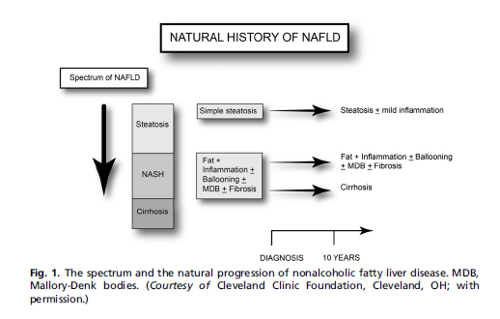

[**Stål P. Liver fibrosis in non-alcoholic fatty liver disease-diagnostic challenge with prognostic significance. World Journal of Gastroenterology: WJG. 2015 Oct 21;21(39):11077.**](NASH%20natural%20history%20and%20epidemiology/Stal%20Liver%20fibrosis%20in%20non-alcoholic%20fatty%20liver%20disease%20diagnostic%20challenge%20with%20prognostic%20significance.pdf)

* Advanced liver fibrosis (stage F3) and cirrhosis (stage F4) are histologic features that most accurately predict increased mortality in both liver-related and cardiovascular diseases
* Histopathologic classifications of NASH and fibrosis
  + In the American Association for the Study of Liver Diseases (AASLD) Practice Guidelines, NAFL is defined as the presence of hepatic steatosis with no evidence of hepatocellular injury (ballooning of the hepatocytes), whereas NASH comprises the presence of hepatic steatosis plus inflammation with ballooning, with or without fibrosis, **[5]**
    - **5. Chalasani N, Younossi Z, Lavine JE, Diehl AM, Brunt EM, Cusi K, Charlton M, Sanyal AJ. The diagnosis and management of nonalcoholic fatty liver disease: practice Guideline by the American Association for the Study of Liver Diseases, American College of Gastroenterology, and the American Gastroenterological Association. Hepatology 2012; 55: 2005-2023 [PMID: 22488764 DOI: 10.1002/hep.25762]**
  + *Matteoni et al* divided NAFLD into 4 subtypes, [**15]**
    - They demonstrated that **cirrhosis developed in 21%-28% of patients whose liver biopsies displayed NAFLD type 3 or 4, whereas only 4% of patients with NAFLD type 1 and none of those with type 2 had cirrhosis development after a mean follow-up of 10 years.**
    - **15. Matteoni CA, Younossi ZM, Gramlich T, Boparai N, Liu YC, McCullough AJ. Nonalcoholic fatty liver disease: a spectrum of clinical and pathological severity. Gastroenterology 1999; 116: 1413-1419 [PMID: 10348825]**
  + However, in the original study by Kleiner et al **[18]**, 16% of patients with a NAS ≥ 5 did not meet the diagnostic criteria for NASH.
    - **18. Kleiner DE, Brunt EM, Van Natta M, Behling C, Contos MJ, Cummings OW, Ferrell LD, Liu YC, Torbenson MS, Unalp-Arida A, Yeh M, McCullough AJ, Sanyal AJ. Design and validation of a histological scoring system for nonalcoholic fatty liver disease. Hepatology 2005; 41: 1313-1321 [PMID: 15915461 DOI: 10.1002/ hep.20701]**
  + Thus, NAS cannot be considered as a substitute for the diagnosis of NASH **[23].**
    - **23. Brunt EM, Kleiner DE, Wilson LA, Belt P, Neuschwander-Tetri BA. Nonalcoholic fatty liver disease (NAFLD) activity score and the histopathologic diagnosis in NAFLD: distinct clinicopathologic meanings. Hepatology 2011; 53: 810-820 [PMID: 21319198 DOI: 10.1002/hep.24127]**
  + Additionally, NAS was shown to be a poor predictor of fibrosis progression; therefore, it has also been questioned as a suitable endpoint for clinical studies **[24].**
    - **24. Ekstedt M, Franzén LE, Mathiesen UL, Kechagias S. Low clinical relevance of the nonalcoholic fatty liver disease activity score (NAS) in predicting fibrosis progression. Scand J Gastroenterol 2012; 47: 108-115 [PMID: 22126450 DOI: 10.3109/00365521.2011.634024]**
  + Based on Younossi et al (described above): These data indicate that fibrosis is a better predictor of liver-related mortality than NAS, which only grades steatosis and necro-inflammatory activity, **25.**
    - **25. Younossi ZM, Stepanova M, Rafiq N, Makhlouf H, Younoszai Z, Agrawal R, Goodman Z. Pathologic criteria for nonalcoholic steatohepatitis: interprotocol agreement and ability to predict liver-related mortality. Hepatology 2011; 53: 1874-1882 [PMID: 21360720]**
  + Recently, a new algorithm was developed by the Fatty Liver Inhibition of Progression Pathology Consortium based on a composite score evaluating Steatosis, Activity and Fibrosis (SAF score, **26**
    - The SAF scores steatosis (0-3), ballooning degeneration (0-2), lobular inflammation (0-2), and fibrosis (0-4).
    - **26. Bedossa P, Poitou C, Veyrie N, Bouillot JL, Basdevant A, Paradis V, Tordjman J, Clement K. Histopathological algorithm and scoring system for evaluation of liver lesions in morbidly obese patients. Hepatology 2012; 56: 1751-1759 [PMID: 22707395 DOI: 10.1002/hep.25889]**
* Natural course of Fibrosis
  + Progression of liver fibrosis is observed in one-third of patients 4-5 years after the first liver biopsy. Variables associated with progression are obesity and body mass index (BMI) [**28]**
    - **28. Fassio E, Alvarez E, Domínguez N, Landeira G, Longo C. Natural history of nonalcoholic steatohepatitis: a longitudinal study of repeat liver biopsies. Hepatology 2004; 40: 820-826 [PMID: 15382171 DOI: 10.1002/hep.20410]**
  + **Approximately one-third of NAFLD patients progress in the fibrosis stage during a five-year follow-up, some of whom have a more rapid course.**
    - In a meta-analysis comprising ten studies with 221 patients, 37.6% had progressive fibrosis over a mean follow-up time of 5.3 years. In this analysis, only age and inflammation in the initial biopsy were independent predictors of fibrosis progression, **[30]**
      * **30. Argo CK, Northup PG, Al-Osaimi AM, Caldwell SH. Systematic review of risk factors for fibrosis progression in non-alcoholic steatohepatitis. J Hepatol 2009; 51: 371-379 [PMID: 19501928 DOI: 10.1016/j.jhep.2009.03.019]**
    - In a study of 106 patients with NAFLD, fibrosis stage progressed in 37%, remained stable in 34% and regressed in 29%. Diabetes and body mass index were associated with fibrosis progression **[29].**
      * **29. Adams LA, Sanderson S, Lindor KD, Angulo P. The histological course of nonalcoholic fatty liver disease: a longitudinal study of 103 patients with sequential liver biopsies. J Hepatol 2005; 42: 132-138 [PMID: 15629518 DOI: 10.1016/j.jhep.2004.09.012]**
    - In a recent paper, these two cohorts were merged in a study comprising 229 patients with a mean follow-up of 26 years. In that study, advanced fibrosis (stage 3-4) was an independent predictor of overall and disease-specific mortality, whereas NAS > 4 was not associated with increased mortality **[13].**
      * **13. Ekstedt M, Hagström H, Nasr P, Fredrikson M, Stål P, Kechagias S, Hultcrantz R. Fibrosis stage is the strongest predictor for disease-specific mortality in NAFLD after up to 33 years of follow-up. Hepatology 2015; 61: 1547-1554 [PMID: 25125077 DOI: 10.1002/ hep.27368]**
* Current dogma: NAFLD is stable but NASH is progressive
  + Several recent studies have challenged this view and **demonstrated histological progression in NAFLD patients without histological signs of NASH at baseline, 9-12.**
    - **12. Harrison SA, Torgerson S, Hayashi PH. The natural history of nonalcoholic fatty liver disease: a clinical histopathological study. Am J Gastroenterol 2003; 98: 2042-2047 [PMID: 14499785 DOI: 10.1111/j.1572-0241.2003.07659.x]**
  + In a study from Hong-Kong, paired liver biopsies were evaluated, and 23% of patients with simple steatosis developed NASH over a three-year period, whereas the regression of NASH was only observed in one patient **[9]**
    - **9. Wong VW, Wong GL, Choi PC, Chan AW, Li MK, Chan HY, Chim AM, Yu J, Sung JJ, Chan HL. Disease progression of nonalcoholic fatty liver disease: a prospective study with paired liver biopsies at 3 years. Gut 2010; 59: 969-974 [PMID: 20581244 DOI:**
  + In a study on 108 NAFLD patients who underwent serial liver biopsies with a median interval of 6.6 years, 42% had fibrosis progression. Diabetes was significantly associated with fibrosis development**. There was no significant difference in the proportion exhibiting fibrosis progression between patients with NAFL or NASH at index biopsy (37% vs 43%) [11]**
    - **11. McPherson S, Hardy T, Henderson E, Burt AD, Day CP, Anstee QM. Evidence of NAFLD progression from steatosis to fibrosing steatohepatitis using paired biopsies: implications for prognosis and clinical management. J Hepatol 2015; 62: 1148-1155 [PMID: 25477264 DOI: 10.1016/j.jhep.2014.11.034]**
  + **A recent meta-analysis evaluated 411 patients with biopsy-proven NAFLD from 11 cohort studies (150 patients with NAFL and 261 patients with NASH). In the whole cohort, 33.6% of patients had fibrosis progression. This result was also observed in patients with NAFL but at a slower pace. In those with NAFL, it took an average of 14.3 years to progress one stage in fibrosis score; however, in those with NASH, the time to progress with one stage was halved to 7.1 years [10]**
    - **10. Singh S, Allen AM, Wang Z, Prokop LJ, Murad MH, Loomba R. Fibrosis progression in nonalcoholic fatty liver vs nonalcoholic steatohepatitis: a systematic review and meta-analysis of paired biopsy studies. Clin Gastroenterol Hepatol 2015; 13: 643-654.e1-e9; quiz e39-40 [PMID: 24768810 DOI: 10.1016/j.cgh.2014.04.014]**
  + Taken together, the data indicate that fibrosis progression is also observed in patients with NAFL, particularly in those with mild inflammatory changes, delicate fibrosis, older age or deterioration of metabolic risk factors. However, patients with NASH have a more rapid course, with a significant risk for liver-related mortality **[6].**
    - **6. Musso G, Gambino R, Cassader M, Pagano G. Meta-analysis: natural history of non-alcoholic fatty liver disease (NAFLD) and diagnostic accuracy of non-invasive tests for liver disease severity. Ann Med 2011; 43: 617-649 [PMID: 21039302 DOI: 10.3109/0785 3890.2010.518623]**
* **NAFLD and prognosis** 
  + Liver disease is the third leading cause of death in NAFLD after cardiovascular disease and malignancy **[34].**
    - **34. Ong JP, Pitts A, Younossi ZM. Increased overall mortality and liver-related mortality in non-alcoholic fatty liver disease. J Hepatol 2008; 49: 608-612 [PMID: 18682312 DOI: 10.1016/ j.jhep.2008.06.018]**
  + In a 28-year follow-up of 118 Swedish patients **with NAFLD, there was a 69% increased risk of death compared with the total population**, which was adjusted for sex, age, and calendar period. Those with simple steatosis had a 55% increased risk; however, in those with NASH, the risk was increased to 86% **[35]**
    - **35. Söderberg C, Stål P, Askling J, Glaumann H, Lindberg G, Marmur J, Hultcrantz R. Decreased survival of subjects with elevated liver function tests during a 28-year follow-up. Hepatology 2010; 51: 595-602 [PMID: 20014114 DOI: 10.1002/hep.23314]**
  + In another Swedish cohort study of 129 patients with biopsy-proven NAFLD with a mean follow-up of 13.7 years, survival and causes of death were compared with a matched reference population. **Mortality was increased in patients with NASH but not in those with NAFL**. The major causes of death were cardiovascular and liver-related events **[31]**
    - **31. Ekstedt M, Franzén LE, Mathiesen UL, Thorelius L, Holmqvist M, Bodemar G, Kechagias S. Long-term follow-up of patients with NAFLD and elevated liver enzymes. Hepatology 2006; 44: 865-873 [PMID: 17006923 DOI: 10.1002/hep.21327]**
  + **In a recent paper, these two cohorts were merged in a study comprising 229 patients with a mean follow-up of 26 years. In that study, advanced fibrosis (stage 3-4) was an independent predictor of overall and disease-specific mortality, whereas NAS > 4 was not associated with increased mortality [13].**
    - **13. Ekstedt M, Hagström H, Nasr P, Fredrikson M, Stål P, Kechagias S, Hultcrantz R. Fibrosis stage is the strongest predictor for disease-specific mortality in NAFLD after up to 33 years of follow-up. Hepatology 2015; 61: 1547-1554 [PMID: 25125077 DOI: 10.1002/ hep.27368]**
  + When evaluating distinct pathologic features, advanced fibrosis shows the best independent association with liver-related mortality **[25].**
    - **25. Younossi ZM, Stepanova M, Rafiq N, Makhlouf H, Younoszai Z, Agrawal R, Goodman Z. Pathologic criteria for nonalcoholic steatohepatitis: interprotocol agreement and ability to predict liver-related mortality. Hepatology 2011; 53: 1874-1882 [PMID: 21360720]**
  + The major causes of death in NAFL are cardiovascular disease and cancer **[8].**
    - **8. Dam-Larsen S, Becker U, Franzmann MB, Larsen K, Christoffersen P, Bendtsen F. Final results of a long-term, clinical follow-up in fatty liver patients. Scand J Gastroenterol 2009; 44: 1236-1243 [PMID: 19670076 DOI: 10.1080/00365520903171284]**
* Non-invasive methods
  + Non-invasive NAFLD fibrosis score (NFS) is associated with higher mortality **[36, 37, 38]**
    - * **36. Treeprasertsuk S, Björnsson E, Enders F, Suwanwalaikorn S, Lindor KD. NAFLD fibrosis score: a prognostic predictor for mortality and liver complications among NAFLD patients. World J Gastroenterol 2013; 19: 1219-1229 [PMID: 23482703 DOI: 10.3748/wjg.v19.i8.1219]**
      * **37 Angulo P, Bugianesi E, Bjornsson ES, Charatcharoenwitthaya P, Mills PR, Barrera F, Haflidadottir S, Day CP, George J. Simple noninvasive systems predict long-term outcomes of patients with nonalcoholic fatty liver disease. Gastroenterology 2013; 145: 782-9.e4 [PMID: 23860502 DOI: 10.1053/j.gastro.2013.06.057]**
      * **38 Perazzo H, Munteanu M, Ngo Y, Lebray P, Seurat N, Rutka F, Couteau M, Jacqueminet S, Giral P, Monneret D, Imbert-Bismut F, Ratziu V, Hartemann-Huertier A, Housset C, Poynard T. Prognostic value of liver fibrosis and steatosis biomarkers in type-2 diabetes and dyslipidaemia. Aliment Pharmacol Ther 2014; 40: 1081-1093 [PMID: 25186086 DOI: 10.1111/apt.12946]**
    - based on six routine clinical parameters, was developed and validated in > 700 patients with biopsy-proven NAFLD **[47].** 
      * **47. Angulo P, Hui JM, Marchesini G, Bugianesi E, George J, Farrell GC, Enders F, Saksena S, Burt AD, Bida JP, Lindor K, Sanderson SO, Lenzi M, Adams LA, Kench J, Therneau TM, Day CP. The NAFLD fibrosis score: a noninvasive system that identifies liver fibrosis in patients with NAFLD. Hepatology 2007; 45: 846-854 [PMID: 17393509]**
    - The parameters are **age, BMI, the presence of diabetes or impaired fasting glucose, the AST/ALT ratio, platelet count and albumin.**
    - A score below -1.455 has a high negative predictive value to exclude advanced fibrosis (stage 3-4), whereas a score > 0.676 predicts advanced fibrosis.
    - Only patients in the indeterminate range between these two values need to undergo
    - liver biopsy, thus avoiding up to 75% of biopsies
    - In a meta-analysis from 2010, the pooled AUROC, sensitivity and specificity of NFS for the detection of NASH with advanced fibrosis was 0.85 (0.80-0.93), 0.90 (0.82-0.99), and 0.97 (0.94-0.99) [6].
      * **6. Musso G, Gambino R, Cassader M, Pagano G. Meta-analysis: natural history of non-alcoholic fatty liver disease (NAFLD) and diagnostic accuracy of non-invasive tests for liver disease severity. Ann Med 2011; 43: 617-649 [PMID: 21039302 DOI: 10.3109/0785 3890.2010.518623]**
    - The NFS is endorsed by current American guidelines as a screening test to exclude low-risk individuals from further investigations [5]
      * **5. Chalasani N, Younossi Z, Lavine JE, Diehl AM, Brunt EM, Cusi K, Charlton M, Sanyal AJ. The diagnosis and management of nonalcoholic fatty liver disease: practice Guideline by the American Association for the Study of Liver Diseases, American College of Gastroenterology, and the American Gastroenterological Association. Hepatology 2012; 55: 2005-2023 [PMID: 22488764 DOI: 10.1002/hep.25762]**
  + NAFLD fibrosis score indicative of advanced fibrosis (NFS > 0.676) had a **69% increase in mortality**, mostly from CV events, and independent of other known risk factors [39]
    - **39. Kim D, Kim WR, Kim HJ, Therneau TM. Association between noninvasive fibrosis markers and mortality among adults with nonalcoholic fatty liver disease in the United States. Hepatology 2013; 57: 1357-1365 [PMID: 23175136 DOI: 10.1002/hep.26156]**

## [Rafiq N, Bai C, Fang Y, et al. Long-term follow-up of patients with nonalcoholic fatty liver. Clin Gastroenterol Hepatol 2009;7(2):234–8](NASH%20natural%20history%20and%20epidemiology/Rafiq%20et%20al%20Long-term%20follow-up%20of%20patients%20with%20nonalcoholic%20fatty%20liver.pdf).

* **Although overall mortality did not differ between the NAFLD subtypes, liver-related mortality was higher in patients with NASH (P < .05**). Independent predictors of liver-related mortality included histologic NASH, type II diabetes, older age at biopsy, lower albumin levels, and increased levels of alkaline phosphatase (P < .05). Conclusions: This long-term follow-up evaluation of NAFLD patients confirms that NASH patients have increased liver-related mortality compared with non-NASH patients. In addition, patients with NAFLD and type II diabetes are especially at risk for liver-related mortality

## [Angulo P, Kleiner DE, Dam-Larsen S, Adams LA, Bjornsson ES, Charatcharoenwitthaya P, et al. Liver Fibrosis, but No Other Histologic Features, Is Associated With Long-term Outcomes of Patients With Nonalcoholic Fatty Liver Disease. Gastroenterology. 2015;149(2):389-97 e10.](NASH%20natural%20history%20and%20epidemiology/Angulo%20et%20al%20Liver%20Fibrosis,%20but%20No%20Other%20Histologic%20Features,%20Is%20Associated%20With%20Long-term%20Outcomes%20of%20Patients%20With%20Nonalcoholic%20Fatty%20Liver%20Disease.pdf)

* We performed a retrospective analysis of 619 patients diagnosed with NAFLD from 1975 through 2005 at medical centers in the United States, Europe, and Thailand. Patients underwent laboratory and biopsy analyses, and were examined every 3–12 months after their diagnosis.
* Outcomes analyzed were overall mortality, liver transplantation, and liver-related events. Cumulative outcomes were compared by log-rank analysis. Cox proportional-hazards regression was used to estimate adjusted hazard ratios (HRs).
* Time at risk was determined from the date of liver biopsy to the date of outcome or last follow-up examination.
* **Over a median follow-up period of 12.6 years (range, 0.3–35.1 y), 193 of the patients (33.2%) died or underwent liver transplantation.**
* Features of liver biopsies significantly associated **with death or liver transplantation** included **fibrosis** **stage 1 (HR, 1.88; 95% confidence interval [CI], 1.28–2.77), stage 2 (HR, 2.89; 95% CI, 1.93–4.33), stage 3 (HR, 3.76; 95% CI, 2.40–5.89), and stage 4 (HR, 10.9; 95% CI, 6.06–19.62) compared with stage 0, in univariate analysis**

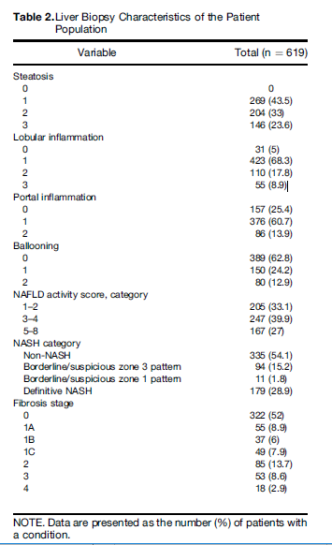

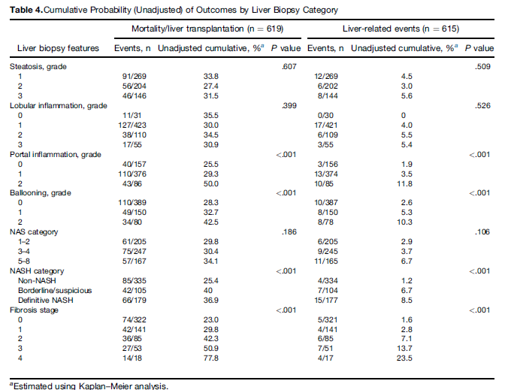

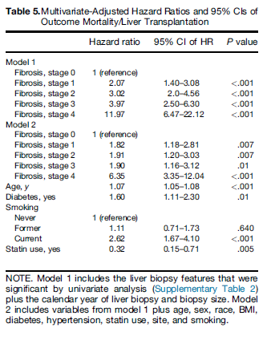

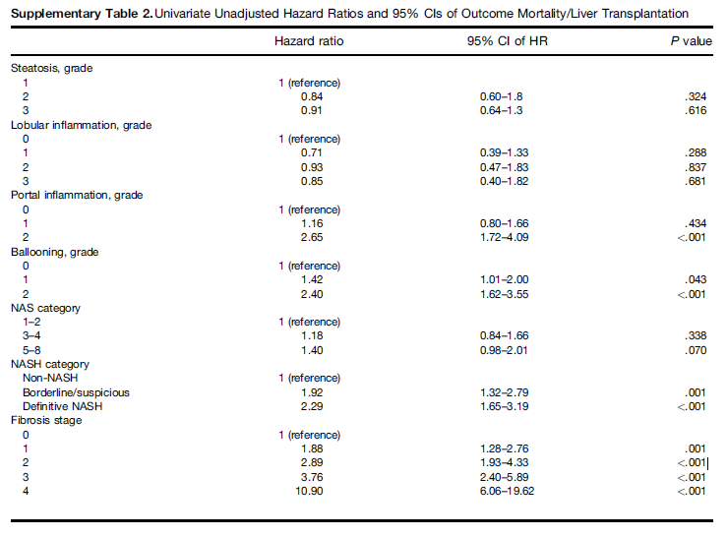

* As well as age (HR, 1.07; 95% CI, 1.05–1.08), diabetes (HR, 1.61; 95% CI, 1.13–2.30), current smoking (HR, 2.62; 95% CI, 1.67–4.10), and statin use (HR, 0.32; 95% CI, 0.14–0.70).
* Twenty-six patients (4.2%) developed liver-related events; **fibrosis stage 3 (HR, 14.2; 95% CI, 3.38–59.68) and stage 4 (HR, 51.5; 95% CI, 9.87–269.2) compared with stage 0, were associated significantly with the events.** 
  + **Liver related events =**

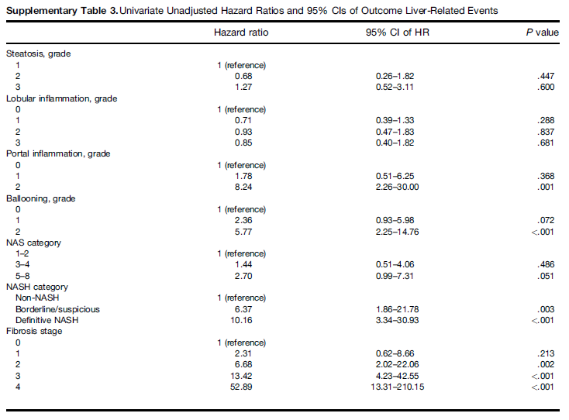

* Patients with fibrosis, regardless of steatohepatitis or NAFLD activity score, had shorter survival times than patients without fibrosis.

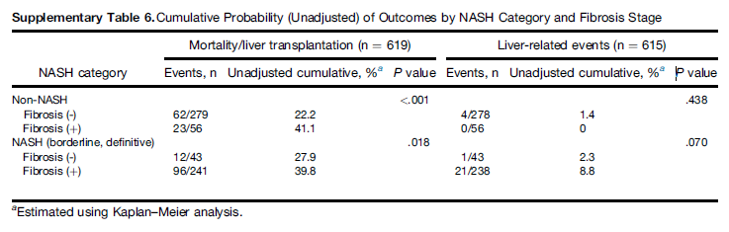

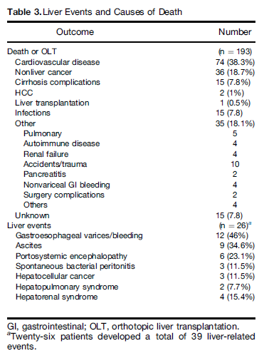

## [Golabi P, Stepanova M, Pham HT, et al. Non-alcoholic steatofibrosis (NASF) can independently predict mortality in patients with non-alcoholic fatty liver disease (NAFLD). BMJ open gastroenterology. 2018;5:e000198.](NASH%20natural%20history%20and%20epidemiology/Golabi%20et%20al%20Non-alcoholic%20steatofibrosis%20(NASF)%20can%20independently%20predict%20mortality%20in%20patients%20with%20non-alcoholic%20fatty%20liver%20disease%20(NAFLD).pdf)

* Hepatic fibrosis in patients with non-alcoholic fatty liver disease (NAFLD) independently predicts mortality. Given liver biopsy's invasive nature, non-invasive method to assess hepatic steatosis and fibrosis provides NAFLD risk stratification algorithm in clinical practice. NAFLD fibrosis score (NFS) is simple and non-invasive predictive model recommended by American Association for the Study of Liver Disease (AASLD) Guideline to identify patients with NAFLD with fibrosis risk. The aim of this study is to assess long-term outcomes of subjects with significant non-alcoholic steatofibrosis (NASF) as established by ultrasound (US) and NFS. Used National Health and Nutrition Examination Survey (NHANES III) with National Death Index-linked Mortality Files. NAFLD diagnosis established by the presence of moderate to severe hepatic steatosis on US without other causes of chronic liver disease (alcohol consumption <20 gr/day, hepatitis B surface-antigen negative, anti-hepatitis C virus antibody negative, transferrin saturation <50%). Significant hepatic fibrosis was estimated by high NFS (>0.676) and calculated with previously published formula. Subjects with NAFLD and high NFS have significant NASF. NHANES III included 20 050 adult participants. 2515 participants complete data and NAFLD with 5.1% (n=129) meeting criteria for significant SF. Subjects with significant SF were older, had higher body mass index, waist circumference and the homeostasis model assessment (HOMA) scores and higher rates of comorbidities (diabetes, congestive heart failure (CHF), stroke; all p<0.001). After median of 207 months of follow-up, overall mortality in NAFLD cohort was 30.0% (n=754). Crude mortality higher in subjects with significant SF (67.4% vs 28.0%, p<0.001). In multivariate survival analysis, predictors of overall mortality included significant SF (adjusted HR (aHR): 1.37; 95% CI 1.07 to 1.76, p=0.01), older age (aHR:1.08; 95% CI 1.07 to 1.09 per year), male gender (aHR:1.44; 95% CI 1.24 to 1.67), black race (aHR:1.24; 95% CI 1.04 to 1.48)), history of hypertension (aHR:1.40; 95% CI 1.20 to 1.64), diabetes (aHR:1.69; 95% CI 1.43 to 2.00), CHF (aHR:1.77; 95% CI 1.38 to 2.261), stroke (aHR:1.84; 95% CI 1.38 to 2.48) and smoking (aHR:1.74; 95% CI 1.47 to 2.07) (all p<0.02). Sensitivity analysis showed that the best association of SF with mortality is higher at NFS threshold of 0.80 (aHR:1.41; 95% CI 1.09 to 1.83, p=0.01). Significant NASF determined non-invasively is an independent predictor of mortality. These data should help clinicians to easily risk-stratify patients with NAFLD for close monitoring and treatment considerations in clinical trial setting.

## [Calzadilla Bertot L, Adams LA. The Natural Course of Non-Alcoholic Fatty Liver Disease. International journal of molecular sciences. 2016;17:774.](NASH%20natural%20history%20and%20epidemiology/Calzadilla%20et%20al%20The%20Natural%20Course%20of%20Non-Alcoholic%20Fatty%20Liver%20Disease.pdf)

* Emerging data suggests fibrosis, rather than NASH per se, to be the most important histological predictor of liver and non-liver related mortality
* NAFLD is projected to become the leading cause of liver related morbidity and mortality within 20 years and a leading indication for liver transplantation in the next few years, [2]
* At least 12 studies have analysed the progression of steatosis, steatohepatitis, and fibrosis in NAFLD cohorts by utilizing paired liver biopsies [7,9,11–20]. These studies suggest that one third of patients with NAFL and NASH have progressive fibrosis and 20% will have some regression over an average follow-up between 2.2 and 13.8 years [7,9,11–23].
* **In contrast to fibrosis progression over time, features of steatosis, inflammation and ballooning tend to reduce which is paralleled by reduction in amino-transaminase levels [12].**
* **Metabolic factors** 
  + Diabetes and obesity have demonstrated to be predictive of a higher rate of fibrosis progression in some but not all longitudinal studies [7–9,12,22]. An increase or decrease in body mass index over time, has been associated with progression or resolution of liver fibrosis respectively in NAFLD patients and the emergence of diabetes also appears to parallel fibrosis progression, whereas improved glycemic control parallels fibrosis improvement [7–9,22]. One meta-analysis examining the full spectrum of NAFLD found hypertension to be a risk factor for fibrosis progression, however an earlier meta-analysis limited to NASH patients did not [24,42].
* Clinical course
  + Overall, the risk of progression to cirrhosis and decompensation in NAFLD patients is low with a population based study demonstrating an incidence of 3.1% for both end-points over a mean 7.6 year follow-up
  + The risk of progression to end-stage liver disease is influenced by the severity of underlying liver histology; the majority of patients with NAFLD have simple steatosis, however, up to 30% of patients may have NASH [44] and are at greater risk. Several studies with up to 20 years follow-up, have demonstrated that the risk of progression to cirrhosis in patients with simple steatosis is between 0% and 4% [6,45,46]. In contrast, estimates of progression to cirrhosis in NASH patients varies with 10% developing decompensated liver disease over 13 years [11] and 25% developing cirrhosis over nine years [11]. The rate of progression is clearly heavily influenced by the underlying fibrosis stage, with NASH patients without fibrosis at significantly lower risk compared to those with advanced fibrosis.
  + Supporting these observations, analysis of over 11,000 participants in the NAHNES study conducted between 1989 and 2004 with median follow up of 14.5 years, **demonstrated increased (69%) overall mortality in NAFLD patients with advanced fibrosis assessed** by means of NAFLD fibrosis score, APRI and FIB 4. The increase in mortality in this subgroup was largely driven by cardiovascular disease (CVD) (**adjusted hazard ratio 2.7 to 3.5**) **[62].**
* Mortality
  + Compared with individuals of the general population of the same age and gender, those with NAFLD have a lower than expected survival, at a standardized mortality ratio from 1.34 to 1.69 according to American and Swedish studies [11,12].
* NAFL
  + Recent reports suggest NAFL may not be as benign as previously thought, with evidence of progression to advanced fibrosis, challenging the paradigm that risk of fibrosis progression is dichotomized according to the presence or absence of NASH (Table 2).
  + Wong et al reported that… 23% of patients with simple steatosis developed NASH in 3 years [7]
  + Cites above described Singh et al to drive home the point that non-NASH NAFLD can progress to fibrosis
* Prognostic Significance of NASH v Fibrosis
  + Recent evidence coming from prospective cohort studies suggest that fibrosis predicts liver and non-liver related mortality more reliably than NAS or its individual components **[64–66].**
    - **64. Younossi, Z.M.; Stepanova, M.; Rafiq, N.; Makhlouf, H.; Younoszai, Z.; Agrawal, R.; Goodman, Z. Pathologic criteria for nonalcoholic steatohepatitis: Interprotocol agreement and ability to predict liver-related mortality. Hepatology 2011, 53, 1874–1882.**
    - **65. Angulo, P.; Kleiner, D.E.; Dam-Larsen, S.; Adams, L.A.; Bjornsson, E.S.; Charatcharoenwitthaya, P.; Mills, P.R.; Keach, J.C.; Lafferty, H.D.; Stahler, A.; et al. Liver fibrosis, but no other histologic features, is associated with long-term outcomes of patients with nonalcoholic fatty liver disease. Gastroenterology 2015, 149, 389–397.**
  + A study by Younossi et al. of 209 NAFLD patients with a median follow up of 12 years found that advanced fibrosis was the only histological lesion independently associated with liver-related mortality (hazard ratio = 5.68, 95% confidence interval (1.5–21.4) [66]
  + More recently Ekstedt and colleagues analysed a cohort of 229 biopsy proven NAFLD patients followed for a mean of 26.4 years **[62].** Overall, NAFLD patients had an increased mortality compared with a matched reference population with NAFLD subjects with **fibrosis stage three or four at baseline having the worst prognosis (HR 3.3, CI 2.27–4.76, p < 0.001). In contrast patients with a high NAS (5–8) without severe fibrosis did not have increase mortality compared with reference population**
    - **62. Ekstedt, M.; Hagström, H.; Nasr, P.; Fredrikson, M.; Stål, P.; Kechagias, S.; Hultcrantz, R. Fibrosis stage is the strongest predictor for disease-specific mortality in NAFLD after up to 33 years of follow-up. Hepatology 2015, 61, 1547–1554.**
  + Finally, Angulo et al. conducted an international multicentre cohort study to determine the long term prognostic significance of histologic features of NAFLD **[65].** **This study confirmed that fibrosis stage rather than NASH, was the most important histological feature associated with overall survival and liver-related complications. Notably, even patients with mild fibrosis (stage 1) had a greater hazard for overall mortality compared to those with no fibrosis, although only those with moderate fibrosis (stage F2 and above) had a greater risk of liver related complications such as ascites, encephalopathy or varices**.

# NATURAL HISTORY

# PREVALENCE

## [Le MH, Devaki P, Ha NB, et al. Prevalence of non-alcoholic fatty liver disease and risk factors for advanced fibrosis and mortality in the United States. PloS one. 2017;12:e0173499.](NASH%20natural%20history%20and%20epidemiology/Le%20et%20al%20Prevalence%20of%20non-alcoholic%20fatty%20liver%20disease%20and%20risk%20factors%20for%20advanced%20fibrosis%20and%20mortality%20in%20the%20United%20States.pdf)

* **In the United States, non-alcoholic fatty liver disease (NAFLD) is the most common liver disease and associated with higher mortality according to data from earlier National Health and Nutrition Examination Survey (NHANES) 1988-1994. Our goal was to determine the NAFLD prevalence in the recent 1999-2012 NHANES, risk factors for advanced fibrosis (stage 3-4) and mortality.**
* **NAFLD was defined as having a United States Fatty Liver Index (USFLI) > 30 in the absence of heavy alcohol use and other known liver diseases.**
* **The probability of low/high risk of having advanced fibrosis was determined by the NAFLD Fibrosis Score (NFS).**
* **In total, 6000 persons were included; of which, 30.0% had NAFLD and 10.3% of these had advanced fibrosis.**
* **Five and eight-year overall mortality in NAFLD subjects with advanced fibrosis was significantly higher than subjects without NAFLD ((18% and 35% vs. 2.6% and 5.5%, respectively) but not NAFLD subjects without advanced fibrosis (1.1% and 2.8%, respectively).**

|  |  |
| --- | --- |
| **Disease state** | **Five-year mortality** |
| **General population** | **2.6%** |
| **Advanced Fibrosis** | **18%** |

* **NAFLD with advanced fibrosis (but not those without) is an independent predictor for mortality on multivariate analysis (HR = 3.13, 95% CI 1.93±5.08, p<0.001).**
* **In conclusion, in this most recent NHANES, NAFLD prevalence remains at 30% with 10.3% of these having advanced fibrosis.**
* **NAFLD per se was not a risk factor for increased mortality, but NAFLD with advanced fibrosis was. Mexican American ethnicity was a significant risk factor for NAFLD but not for advanced fibrosis or increased mortality**

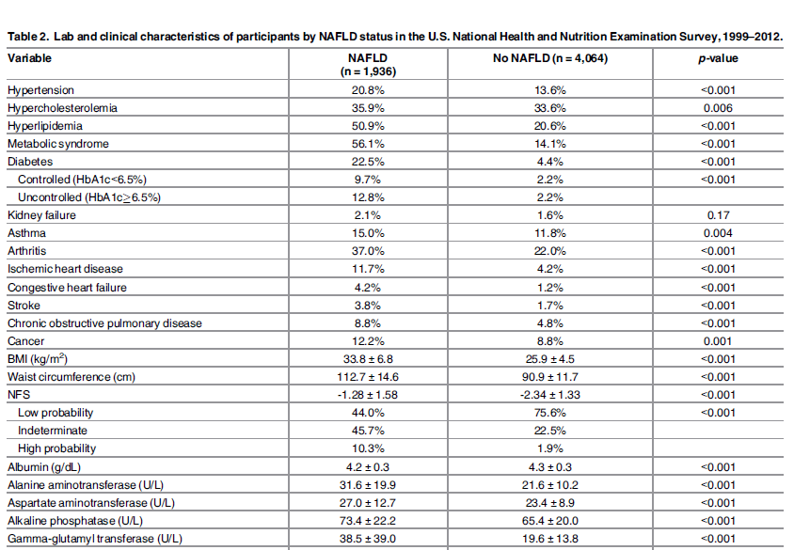

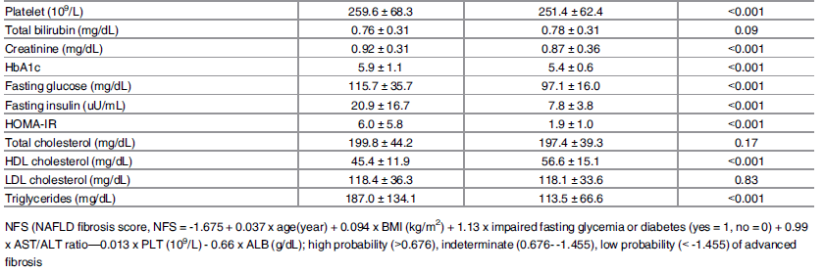

## [Kabbany MN, Conjeevaram Selvakumar PK, Watt K, et al. Prevalence of Nonalcoholic Steatohepatitis-Associated Cirrhosis in the United States: An Analysis of National Health and Nutrition Examination Survey Data. The American journal of gastroenterology. 2017;112:581-587.](NASH%20natural%20history%20and%20epidemiology/Kabbany%20et%20al%20Prevalence%20of%20NASH-Associated%20Cirrhosis%20in%20the%20US%20An%20Analysis%20of%20NHANES.pdf)

* RESULTS: A total of 7034 NHANES participants from 1999–2002 and 2009–2012 group were included with mean age of 46.2±0.59 and 47.3±0.51 years, respectively, at the time of screening. The **prevalence of NASH cirrhosis was significantly higher in 2009–2012 group** **(0.178%** with an estimated 417,524 American adults with NASH-associated cirrhosis) compared to 1999–2002 group (0.072%); P value<0.05. The prevalence of NAFLD with **advanced fibrosis also increased from 0.84 to 1.75% during the same time period ( P value<0.001)** corresponding to 4,104,871 American adults.
* During these time periods, there were also significant increases in obesity (29.8 vs. 36.6%), diabetes (8.3 vs. 11.9%), and insulin resistance (34.7 vs. 42.1%); P value <0.005 for all of them.
* CONCLUSIONS: **There has been a 2.5-fold and 2-fold increases in the prevalence of NASH cirrhosis and NAFLD associated advanced fibrosis**, respectively, in 2009–2012 compared to 1999–2002. Extrapolatiom of NHANES data suggests that in 2010, **417,524 in the US had NASH cirrhosis, and 4,104,871 had NAFLD-associated advanced fibrosis**. This represents a major disease burden and suggests the need for widespread programs to identify and treat those affected, and public health efforts aimed at controlling the burden of NAFLD and its complications.

## [Charlton MR, Burns JM, Pedersen RA, Watt KD, Heimbach JK, Dierkhising RA. Frequency and Outcomes of Liver Transplantation for Nonalcoholic Steatohepatitis in the United States. Gastroenterology. 2011;141:1249-1253.](NASH%20natural%20history%20and%20epidemiology/Charlton%20et%20al%20Frequency%20and%20Outcomes%20of%20Liver%20Transplantation%20for%20Nonalcoholic%20Steatohepatitis%20in%20the%20United%20States.pdf)

* The relative frequency of nonalcoholic steatohepatitis (NASH) as an indication for liver transplantation and comparative outcomes following transplantation are poorly understood. We analyzed the Scientific Registry of Transplant Recipients for primary adult liver transplant recipients from 2001 to 2009. From 2001 to 2009, 35,781 patients underwent a primary liver transplant, including 1959 for who NASH was the primary or secondary indication. **The percentage of patients undergoing a liver transplant for NASH increased from 1.2% in 2001 to 9.7% in 2009.** NASH is now the third most common indication for liver transplantation in the United States. No other indication for liver transplantation increased in frequency during the study period. Compared with other indications for liver transplantation, recipients with NASH are older (58.5±8.0 vs 53.0±8.9 years; P<.001), have a larger body mass index (>30 kg/m2) (63% vs 32%; P<.001), are more likely to be female (47% vs 29%; P<.001), and have a lower frequency of hepatocellular carcinoma (12% vs 19%; P<.001). Survival at 1 and 3 years after liver transplantation for NASH was 84% and 78%, respectively, compared with 87% and 78% for other indications (P=.67). Patient and graft survival for liver recipients with NASH were similar to values for other indications after adjusting for level of creatinine, sex, age, and body mass index. NASH is the third most common indication for liver transplantation in the United States and is on a trajectory to become the most common. Outcomes for patients undergoing a liver transplant for NASH are similar to those for other indications.

# PROGRESSION

**[Singh S, Allen AM, Wang Z, Prokop LJ, Murad MH, Loomba R. Fibrosis progression in nonalcoholic fatty liver vs nonalcoholic steatohepatitis: a systematic review and meta-analysis of paired biopsy studies. Clin Gastroenterol Hepatol 2015; 13: 643-654.e1-e9; quiz e39-40 [PMID: 24768810 DOI: 10.1016/j.cgh.2014.04.014](NASH%20natural%20history%20and%20epidemiology/Singh%20et%20al%20Fibrosis%20Progression%20in%20Nonalcoholic%20Fatty%20Liver%20vs%20Nonalcoholic%20Steatohepatitis%20A%20Systematic%20Review%20and%20Meta-analysis%20of%20Paired-Biopsy%20Studies.pdf)**

* Systematic review and meta-analysis to characterize rates of fibrosis progression in patients with NAFLD v NASH
* Paired liver biopsies were collected at least a year apart
* Calculated pooled-weighted **annual fibrosis progression rates (number of stages changed between the 2 biopsy samples)** with 95% confidence intervals (CIs), and identified clinical risk factors associated with progression
* Based on data from 11 cohort studies including 411 patients with biopsy proven NAFLD (150 with NAFL and 261 with NASH)
* The presence of hypertension (odds ratio, 1.94; 95% CI, 1.00–3.74) and a low AST:ALT ratio at the time of baseline biopsy was associated with the development of progressive fibrosis
* Baseline distributions in patients within NAFLD

|  |  |
| --- | --- |
| **Stage** | **Rate** |
| 0 | 35.8% |
| 1 | 32.5% |
| 2 | 16.7% |
| 3 | 9.3% |
| 4 | 5.7% |

-Advanced fibrosis estimate is higher than that reported in NHANES II

* Change in fibrosis

|  |  |
| --- | --- |
| **Change** | **Rate** |
| **progression** | **33.6%** |
| stable | 43.1% |
| **improvement** | **22.3%** |

* annual progression in patients with stage 0 at baseline (fibrosis progression rate)

|  |  |  |
| --- | --- | --- |
| **Disease state** | **Stage change (95% CI) per year** | **Times to 1 stage progression (95% CI)** |
| Simple steatosis | 0.07 (0.02-0.11) stages | 14.3 years (9.1-50.0 y) |
| NAFLD overall | 0.13 stages (0.07-0.18) | 7.7 years (5.5-14.8 y) |
| NASH | 0.14 stages (0.07-0.21) stages | 7.1 years (4.8-14.3 y) |

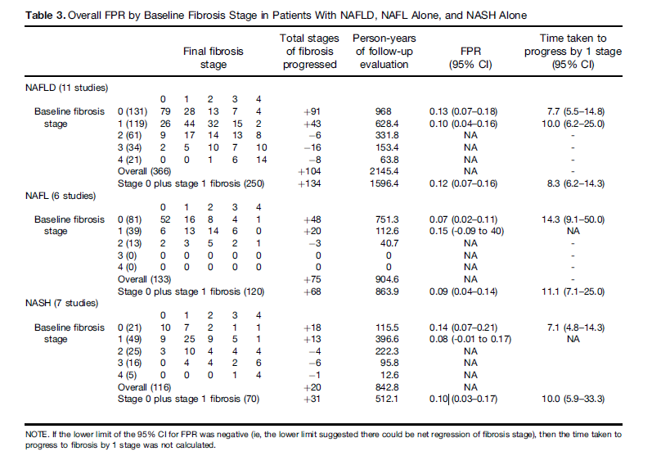

## [Thein H, Yi Q, Dore GJ, Krahn MD. Estimation of stage‐specific fibrosis progression rates in chronic hepatitis C virus infection: A meta‐analysis and meta‐regression. Hepatology. 2008;48:418-431.](NASH%20natural%20history%20and%20epidemiology/Thein%20et%20al%20Estimation%20of%20stage‐specific%20fibrosis%20progression%20rates%20in%20chronic%20hepatitis%20C%20virus%20infection%20A%20meta‐analysis%20and%20meta‐regression.pdf)

* Results remarkably similar to Singh et al., may be useful for advanced stage progression values if NASH specific values cannot be found

|  |  |
| --- | --- |
| **Transition state** | **Annual Probabilities** |
| F0 🡪 F1 | 0.117 (0.104-0.130) |
| F1 🡪 F2 | 0.085 (0.075-0.096) |
| F2 🡪 F3 | 0.120 (0.109-0.133) |
| F3 🡪 F4 | 0.116 (0.104-0.129) |

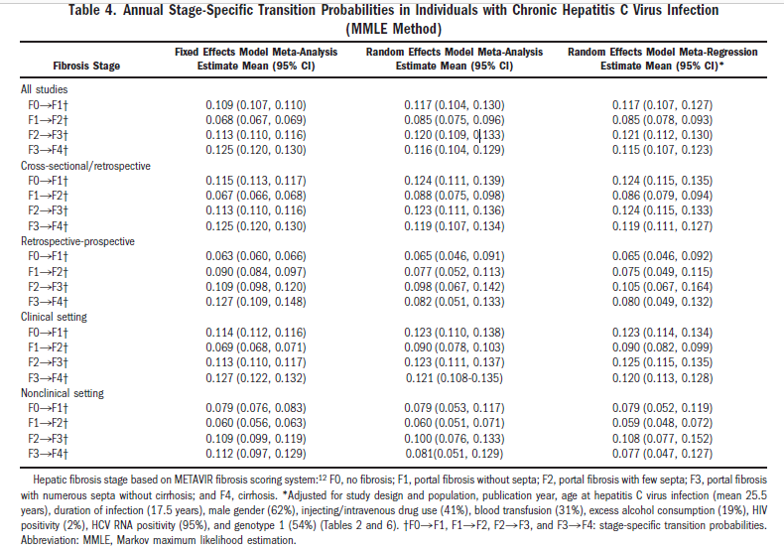

## [Harrison SA, Torgerson S, Hayashi PH. The natural history of nonalcoholic fatty liver disease: a clinical histopathological study. Am J Gastroenterol 2003; 98: 2042-](NASH%20natural%20history%20and%20epidemiology/Harrison%20et%20al%20The%20natural%20history%20of%20nonalcoholic%20fatty%20liver%20disease%20a%20clinical%20histopathological%20study.pdf)

* We retrieved nonalcoholic fatty liver cases from our histopathology database covering 1985 to 2001. We also identified patients in clinic with NASH on biopsy >1 yr prior. All patients were evaluated and clinical data obtained in clinic. Those patients qualifying for NASH therapeutic trials underwent liver biopsy pretreatment. One pathologist (S.T.) read all slides using a NASH grading and staging system.RESULTSA total of 22 patients had repeat biopsies a mean of 5.7 yr (range 1.4-15.7 yr) after the first biopsy. Nine were women, nine had diabetes, 11 had hypertension, and 14 had hyperlipidemia. Mean body mass index was 33.8 kg/m(2) (range 26.5-48.6 yr). Mean age was 50.6 yr (range 33-64 yr). Ten patients (45%) had fibrosis stage 1 or 2, and two patients (9%) had bridging fibrosis or cirrhosis (stage 3 or 4) on first biopsy. Seven (32%) had increases in fibrosis score. Four patients (18%) had decreases in fibrosis score. The percentage of patients with stage 3 or 4 increased from 9% to 18%. In two patients the disease progressed rapidly (fibrosis scores from 1 to 3 in 1.4 yr and from 2 to 4 in 2.6 yr). Only serum AST at last biopsy correlated with histological change, being higher in those with disease progression. Three patients progressed from steatosis to steatohepatitis with fibrosis.CONCLUSIONSNASH has a variable histological course. However, one third of patients have fibrosis progression, and one third of these have rapid progression to advanced fibrosis. Histological progression correlated with higher serum AST but no other clinical factors. Steatosis alone may progress to NASH with fibrosis.

## [Harrison, Stephen A., MD, FACP. Nonalcoholic Fatty Liver Disease and Fibrosis Progression: The Good, the Bad, and the Unknown. Clinical Gastroenterology and Hepatology. 2015;13:655-657.](NASH%20natural%20history%20and%20epidemiology/Harrison%20Nonalcoholic%20Fatty%20Liver%20Disease%20and%20Fibrosis%20Progression.pdf)

* Estimates for the prevalence of NAFLD vary widely, but within the United States it is thought that up to 45% of adults have NAFLD.1 Conservatively, this represents 75 to 100 million US adults, which dwarfs the estimated numbers of chronic hepatitis C patients within the United States.
* The majority of patients with NAFLD will have stable disease and are unlikely to progress much over a relatively long period of time.
* However, although it appears that a histopathologic diagnosis of NASH is more severe than a diagnosis of NAFL without meeting criteria for NASH, several caveats remain. For instance, what is meant by NAFL?
  + When assessing the widely accepted definition put forth by Kleiner and Brunt,4 in 2012, NAFL is defined as **isolated steatosis and steatosis with mild inflammation.**
  + The NAFLD practice guidelines endorsed by the American Association for the Study of Liver Disease, American College of Gastroenterology, and the American Gastroenterology Association, define NAFL as the presence of hepatic **steatosis without evidence of hepatocellular injury in the form of ballooning hepatocytes or fibrosis**.5 No comment is made about hepatic inflammation.
  + Recent data by Pais et al6 showed that **81% of patients with lobular inflammation progressed to NASH or bridging fibrosis over a mean of 3.3 years, compared with 20% of isolated steatosis patients who progressed to NASH or bridging fibrosis over a mean of 5.7 years**
* Another interesting, but alarming, finding in this study was the identification of a group of patients wh have rapid fibrosis progression. Although the overall study numbers were small, 5 of 29 patients with NAF and baseline stage 0 (17.2%) and 2 of 11 patients with NASH and baseline stage 0 (18.2%) developed stages 3 to 4 fibrosis over a mean follow-up period of 5.9 years (±3.7 y).

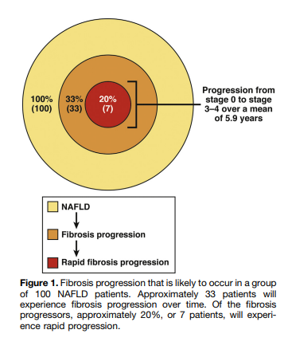

## [Estes C, Razavi H, Loomba R, Younossi Z, Sanyal AJ. Modeling the epidemic of nonalcoholic fatty liver disease demonstrates an exponential increase in burden of disease. Hepatology. 2018;67:123-133.](NASH%20natural%20history%20and%20epidemiology/Estes%20et%20al%20Modeling%20the%20epidemic%20of%20nonalcoholic%20fatty%20liver%20disease%20demonstrates%20an%20exponential%20increase%20in%20burden%20of%20disease.pdf)

* A Markov model was used to forecast NAFLD disease progression. Incidence of NAFLD was based on historical and projected changes in adult prevalence of obesity and type 2 diabetes mellitus (DM). Assumptions were derived from published literature where available and validated using national surveillance data for incidence of NAFLD-related HCC.
* Projected changes in NAFLD-related cirrhosis, advanced liver disease, and liver-related mortality were quantified through 2030. Prevalent NAFLD cases are forecasted to increase 21%, from 83.1 million (2015) to 100.9 million (2030), while prevalent NASH cases will increase 63% from 16.52 million to 27.00 million cases.
* Markov Model
  + The details of the Markov model are described in Supporting Sections S1-S4, and an overview is presented here. The model began with the annual estimated number of incident NAFLD cases, which was back calculated using the change in incidence of obesity and DM in the United States and the estimated prevalence of NAFLD in 2015 (see Supporting Section S4 for details).
  + Disease progression through 2030 was estimated through METAVIR fibrosis stage and advanced liver disease **(Fig. 1),** with annual adjustment for all-cause mortality (background mortality, excess cardiovascular deaths, and liver-related deaths). Disease progression was simulated by multiplying the total number of cases at a particular stage of the disease by a progression rate to the next stage.
  + **Age-specific fibrosis progression rates were back calculated based on assumptions for the distribution of cases by NASH status and fibrosis stage (Supporting Section S2).**
  + Factors influencing rates of progression and regression in the NAFLD population are heterogeneous. For the purpose of the model, progression rates were assumed to be the sum of forward progression minus the rate of regression, which is common among NAFLD cases based on studies of consecutive liver biopsies.
* Inputs
  + A literature search was used to identify research reporting the prevalence and incidence of NAFLD and NASH, including its stages. Indexed articles available on PubMed and nonindexed sources, such as national data reports, were used. In addition, the Delphi process (**Supporting Section S5**) was used in which experts were interviewed to identify and obtain consensus around crucial modeling inputs and to validate outputs for current and future disease burden against available empirical data. When input data were unavailable, expert input was used.
* Prevalence
  + There are varied estimates of NAFLD prevalence in the general population. An estimated 17%-51% of adults have NAFLD**.(4,15-17)** Analysis of liver ultrasound data collected between 1988 and 1994 from the Third National Health and Nutrition Examination Survey (NHANES III) reported that **19% of adults have NAFLD,(18)** while a **meta-analysis of studies from 2006-2014 estimated a NAFLD prevalence of 24% (20%-29%) in the general population. (10)**
  + The prevalence of NASH was calculated based on published estimates and modeling of fibrosis progression. **It was assumed that up to 5% of NAFLD cases without NASH could be NASH regressors, with most NASH regressors still in F0 stage**. Therefore, a relatively small number of cases in stages F1-F4 were assumed to be non-NASH fatty liver. However, the vast majority of modeled fibrotic cases (F1-F4) were assumed to be NASH.
  + Reported estimates show that 3%-5% of adults in the United States have NASH.(4,16,19,20) **This model assumes that approximately 20% of NAFLD cases would be classified as NASH in 2015, corresponding to 3% of the adult population.** Estimates of NASH prevalence and fibrosis progression rates among NAFLD cases are subject to some uncertainty due to the variable populations studied and the largely retrospective methodology used to assess progression.(21) For this analysis, it was estimated that 20%-25% of those with NAFLD currently have NASH and that about 20% of those with NASH have≥F3 fibrosis
  + A detailed list of studies reviewed for these estimates is provided in the supplemental documents available **online (Supporting Section S6).** It was also assumed that it would take 20-30 years for progression to cirrhosis and the rates of decompensation in those with cirrhosis would be about3%-4% annually.
* Mortality
  + A range of estimates has been reported for excess mortality among NAFLD cases, with some studies demonstrating little increase and others suggesting significantly elevated cardiovascular mortality.(29-31) A standard mortality ratio of 1.15 (1.00-1.35) was applied to background mortality rates for all age groups. Liver-related mortality is more markedly increased in the NAFLD population and was calculated separately as part of disease progression modeling.
* Discussion
  + Compared to the model presented by Younossi et al.,(12) our model presents similarities and differences. The models differed in the number of disease states as well as disease-state transition and mortality rates (Supporting Fig. S2). However, both models were calibrated to published data whenever accurate estimates were available.
  + The current model is dynamic, assessing changes over time in NAFLD incidence using obesity and DM trends. **This differs from steady-state models that assume constant transition rates.**
  + The models also differ in the estimated total number of NAFLD and NASH cases. This is largely due to the assumption used in the current model of increasing incidence of NAFLD based on substantial increases in adult obesity and DM cases since the collection of NHANES III data, while NAFLD prevalence in the prior model is reflective of data from NHANES III. In addition, the previous model includes progression to NASH as an input, while the current model bases fibrosis progression on NASH prevalence and assumptions for the proportion of NASH in each fibrosis stage.

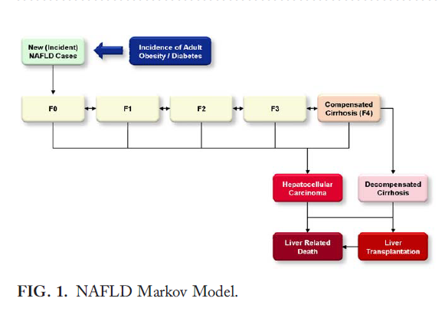

## [Estes et al SUPPLEMENT](PE%20Modeling/SUPPLEMENT%20Estes%20et%20al%20Modeling%20the%20Epidemic%20of%20Nonalcoholic%20Fatty%20Liver%20Disease%20Demonstrates%20an%20Exponential.pdf)

* The nonalcoholic fatty liver disease (NAFLD) Markov model was designed using Microsoft Excel® 2007 (Microsoft Corp., Redmond, WA) to track the NAFLD population by fibrosis stage as well as nonalcoholic steatohepatitis (NASH) status from 1950-2050.
* The model begins with the annual estimated number of incident NAFLD cases (as shown in the figure below). Fibrosis progression of all cases was modeled over time. The number of cases at any stage of liver disease was calculated and tracked by age and gender. The population was aged in one year age cohorts through age 84 and cases aged ≥85 years were tracked as a single cohort. Each year, the population in each age group, except for the ≥85 year cohort, was moved to the next age to simulate aging (after taking into account age specific mortality and new cases).
* Disease progression was estimated through fibrosis and liver disease stages (Figure 1) with annual adjustment for mortality (background mortality, and excess cardiovascular deaths), as described below. Liver related deaths were handled separately using published progression rates from advanced liver disease stages (decompensated cirrhosis, hepatocellular carcinoma (HCC)) and liver transplantation. Total cases by disease stage were calculated by summing the total cases from the previous year, the previous age, and new cases; and subtracting mortality and progression to subsequent stages as shown below.
* 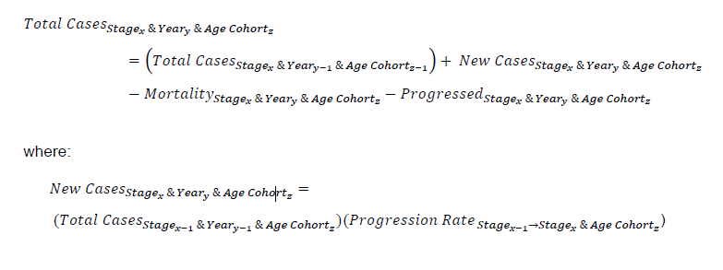
* 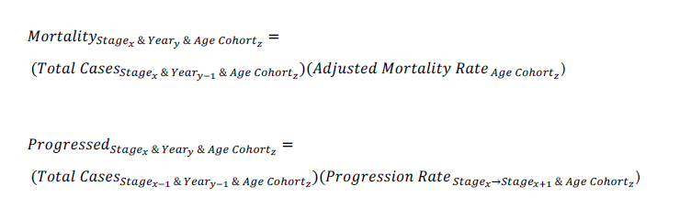
* Progression Rates
  + Disease progression was simulated by multiplying the total number of cases at a particular stage of the disease by a progression rate to the next stage (Figure 1) and validated using national surveillance data for incidence of NAFLD-related HCC, as described below. Age specific fibrosis progression rates were back-calculated based on assumptions for the distribution of cases by NASH status and fibrosis stage, as described below. In addition, the reported numbers of NAFLD related HCC cases, HCC deaths and decompensated cirrhosis cases were available for the US, and fibrosis progression rates were modified to fit reported data (Table 1). For the purpose of the model, progression rates were assumed to be the sum of forward progression minus the rate of regression, which is common among NAFLD cases based on studies of consecutive liver biopsies (2).
  + 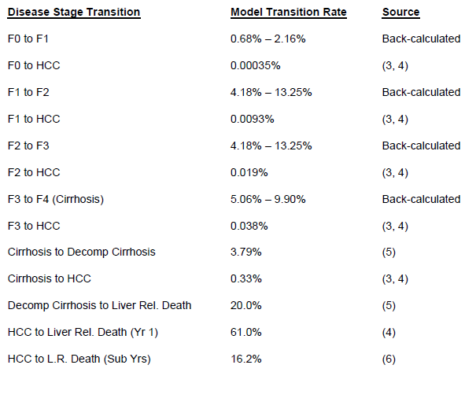
  + 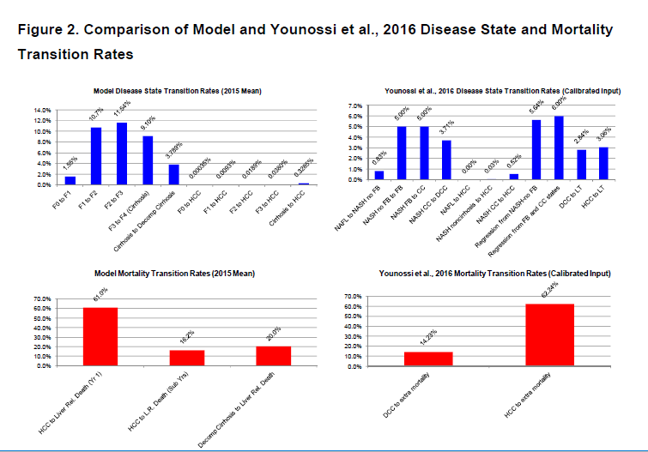

## [Adams LA, Sanderson S, Lindor KD, Angulo P. The histological course of nonalcoholic fatty liver disease: a longitudinal study of 103 patients with sequential liver biopsies. *Journal of Hepatology*. 2005;42:132-138.](NASH%20natural%20history%20and%20epidemiology/Adams%20et%20al%20The%20histological%20course%20of%20nonalcoholic%20fatty%20liver%20disease%20a%20longitudinal%20study.pdf)

* Background/Aims: The histological course of nonalcoholic fatty liver disease (NAFLD) remains undescribed. Therefore, we examined the liver histology of NAFLD patients who had undergone sequential liver biopsies.
* Methods: Data on 103 patients who underwent serial liver biopsies in the absence of effective treatment were reviewed, and biopsies scored in a blind fashion.
* Results: Mean interval between biopsies was **3.2** +/- 3.0 years (range 0.7–21.3). **Fibrosis stage apparently progressed in 37%, remained stable in 34% and regressed in 29%.** Severity of steatosis, inflammation, hepatocyte ballooning and
  + NASH progression was defined as a stage increase in fibrosis
* Mallory’s hyaline improved significantly. Aminotransferases decreased significantly between biopsies, paralleling improvement in steatosis and inflammatory features but not fibrosis stage. The rate of fibrosis change ranged from -2.05 to 1.7 stages/year. **By multivariate analysis, diabetes (P=0.007) and low initial fibrosis stage (P<0.001) were associated with higher rate of fibrosis progression, as was higher body mass index (P=0.008) when cirrhotics were excluded.**
  + **More complex multi-disease state model could incorporate this**
* Conclusions: Fibrosis in NAFLD progresses slowly over time with considerable variability in the rate of changes among patients. Changes of aminotransferases do not parallel changes in fibrosis stage. **Diabetic patients with elevated BMI** and low fibrosis stage are at risk for higher rates of fibrosis progression.

## [Wong VW, Wong GL, Choi PC, Chan AW, Li MK, Chan HY Chim AM, Yu J, Sung JJ, Chan HL. Disease progression of nonalcoholic fatty liver disease: a prospective study with paired liver biopsies at 3 years. Gut 2010; 59: 969-974](NASH%20natural%20history%20and%20epidemiology/Wong%20et%20al%20Disease%20progression%20of%20non-alcoholic%20fatty%20liver%20disease%20a%20prospective%20study%20with%20paired%20liver%20biopsies%20at%203%20years.pdf)

* REQUESTED THROUGH INTERLIBRARY LOAN
* Background: Patients with non-alcoholic steatohepatitis (NASH) have increased mortality and liver-related complications. In contrast, simple steatosis is considered benign and non-progressive
* Objective: To investigate disease progression in patients with different degrees of non-alcoholic fatty liver disease (NAFLD) activity.
* Design: Prospective longitudinal hospital-based cohort study.
* Patients**: Fifty-two patients (age 44±9 years) with biopsy-proven NAFLD had liver biopsies repeated at month 36.**
* Results: Among 13 patients with simple steatosis at baseline, 2 (15%) had a normal liver at month 36, 3 (23%) continued to have simple steatosis, 5 (39%) developed borderline NASH and 3 (23%) developed NASH. Among 22 patients with borderline NASH at baseline, 4 (18%) had simple steatosis and 13 (59%) had borderline NASH at month 36, while 5 (23%) developed NASH. Among 17 patients with NASH at baseline, 10 (59%) continued to have NASH and 6 (35%) had borderline NASH at month 36. Only 1 (6%) patient regressed to simple steatosis**. Overall, 14 (27%) patients had fibrosis progression, 25 (48%) had static disease, and 13 (25%) had fibrosis regression**. **Reduction in body mass index and waist circumference was independently associated with non-progressive disease activity and fibrosis**. The baseline serum levels and month 36 changes in adiponectin, tumour necrosis factor α, interleukin 6 and leptin were not associated with disease progression. Serum cytokeratin-18 fragment level reflected disease activity and its change correlated with the change in NAFLD activity score (R=0.51, p<0.001).
* Conclusions: **Patients with simple steatosis may still develop NASH and fibrosis progression. Weight reduction is associated with non-progressive disease. All patients with NAFLD should undergo periodic assessment and lifestyle modification.**

## [Nakahara T, Hyogo H, Yoneda M, et al. Type 2 diabetes mellitus is associated with the fibrosis severity in patients with nonalcoholic fatty liver disease in a large retrospective cohort of Japanese patients. Journal of Gastroenterology. 2014;49:1477-1484.](NASH%20natural%20history%20and%20epidemiology/Nakahara%20et%20al%20Type%202%20diabetes%20mellitus%20is%20associated%20with%20the%20fibrosis%20severity%20in%20patients%20with%20NAFLD.pdf)

* Reports distribution of fibrosis stages among a **cross-section of 1,365 Japanese patients with biopsy-proven NAFLD** 
  + Biopsy proven patients likely more severe in presentation
  + Prevalence in Japan is surprisingly similar to the US:
    - 9-30% of Japanese adults have NAFLD
    - 1-3% have NASH
* Distribution of stage of fibrosis in males
  + Stage 0: 22.6%
  + Stage 1: 34.1%
  + Stage 2: 26.7%
  + Stage 3: 14.5%
  + Stage 4: 2.1%
* Distribution of stage of fibrosis in females
  + Stage 0: 16.2%
  + Stage 1: 31.7%
  + Stage 2: 23.9%
  + Stage 3: 21.6%
  + Stage 4: 6.6%
* Rate of comorbidities
  + Dyslipidemia: 65.7%
    - Hypertriglyceridemia: 45.3%
    - LDL cholesterol: 37.5%
    - HDL cholesterol: 19.5%
  + Hypertension: 30.2%
  + Diabetes: 47.3%
* Associations
  + **Age was positively correlated to fibrosis stage** 
    - **Univariate odds ratio: 1.042 (1.032-1.053), P<0.0001**
    - **Multivariate odds ratio: 1.036 (1.021-1.051) P<0.0001**
      * **strength of association is high but effect size is relatively small**
  + **BMI ≥ 25 was positively correlated to fibrosis stage** 
    - **Univariate odds ratio: 1.566 (1.149-2.133) P=0.0045**
    - **Multivariate odds ratio: 1.568 (0.991-2.481) P=0.0545**
      * **Shy of statistical significance**
  + **Diabetes was positively correlated to fibrosis stage** 
    - **Univariate odds ratio: 2.544 (1.948-3.320), P<0.0001**
    - **Multivariate odds ratio: 2.387 (1.603-3.553), P<0.0001**
  + Oddly, hypertriglyceridemia was significantly negatively correlated with fibrosis stage
    - may reflect a deterioration of lipid metabolism with the progression of liver fibrosis towards liver cirrhosis.
  + Study also showed differences in gender in the association of the factors with fibrosis
* Multivariate analysis
  + Age and DM were significant risk factors for advanced fibrosis
* Discussion
  + Observational correlations, therefore direction of causation cannot be assumed

# MORTALITY

## [Ekstedt M, Hagström H, Nasr P, et al. Fibrosis stage is the strongest predictor for disease‐specific mortality in NAFLD after up to 33 years of follow‐up. Hepatology. 2015;61:1547-1554.](NASH%20natural%20history%20and%20epidemiology/Ekstedt%20et%20al%20Fibrosis%20stage%20is%20the%20strongest%20predictor%20for%20disease-specific%20mortality%20in%20NAFLD%20after%20up%20to%2033%20years%20of%20follow-up.pdf)

* The aim of the current study was to determine disease-specific mortality in NAFLD, and evaluate the NAS and fibrosis stage as prognostic markers for overall and disease-specific mortality.
* In a cohort study, data from 229 well-characterized Swedish patients with biopsy-proven NAFLD were collected. Mean follow-up was 26.4 (65.6, range 6-33) years.
* **NAFLD patients had an increased mortality compared with the reference population (hazard ratio [HR] 1.29, confidence interval [CI] 1.04-1.59, P50.020), with increased risk of cardiovascular disease (HR 1.55, CI 1.11-2.15, P50.01), hepatocellular carcinoma (HR 6.55, CI 2.14-20.03, P50.001), infectious disease (HR 2.71, CI 1.02-7.26, P50.046), and cirrhosis (HR 3.2, CI 1.05-9.81, P50.041).**

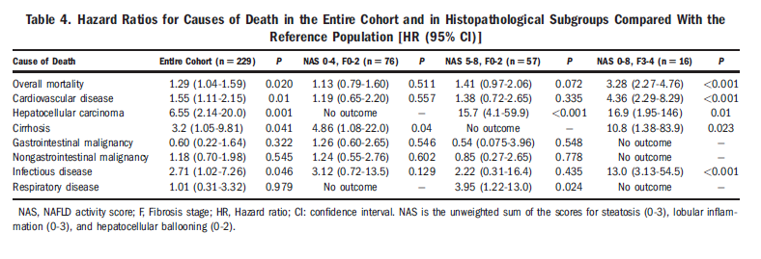

* Overall **mortality was not increased in patients with NAS 5-8 and fibrosis stage 0-2 (HR 1.41, CI 0.97-2.06, P=0.07),** whereas **patients with fibrosis stage 3-4, irrespective of NAS, had increased mortality (HR 3.3, CI 2.27-4.76, P< 0.001)**

[**Matteoni CA, Younossi ZM, Gramlich T, et al. Nonalcoholic fatty liver disease: a spectrum of clinical and pathological severity. Gastroenterology 1999;116(6): 1413–9.**](NASH%20natural%20history%20and%20epidemiology/Matteoni%20et%20al%20Nonalcoholic%20fatty%20liver%20disease%20A%20spectrum%20of%20clinical%20and%20pathological%20severity.pdf)

* Background & Aims: The spectrum of nonalcoholic fatty liver disease ranges from fatty liver alone to nonalcoholic steatohepatitis. Most previous studies have short follow-up and have not carefully delineated different histological types when determining clinical outcomes. The aim of this study was to compare clinical characteristics and outcomes of patients with different types of nonalcoholic fatty liver.
* Methods: All liver biopsy specimens from 1979 to 1987 with fat accumulation were assessed for inflammation, ballooning degeneration, Mallory hyaline, and fibrosis. Biopsy specimens were also assessed for histological iron and hepatitis C RNA. Outcomes were cirrhosis, mortality, and liver-related mortality.
* Results: Of 772 liver biopsy specimens, complete data were available in 132 patients. Fatty liver (type 1) did not differ from the other three types combined with respect to gender, race, age, or obesity. Cirrhosis was more common in the other types combined (22%) than fatty liver alone (4%; P ≤ 0.001). Overall mortality, histological iron, and hepatitis C did not differ between groups. Most of the liver-related deaths were in type 4.
* Conclusions: The outcome of cirrhosis and liver-related death is not uniform across the spectrum of nonalcoholic fatty liver. These poor outcomes are more frequent in patients in whom biopsies show ballooning degeneration and Mallory hyaline or fibrosis.
* 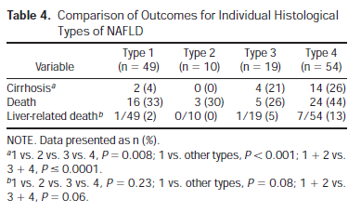

## [McCullough AJ. Pathophysiology of nonalcoholic steatohepatitis. J Clin Gastroenterol 2006;40(Suppl 1):S17–29.](NASH%20natural%20history%20and%20epidemiology/McCullough%20et%20al%20Pathophysiology%20of%20Nonalcoholic%20Steatohepatitis.pdf)

* Nonalcoholic fatty liver disease (NAFLD) affects approximately 30% of adults and 20% of children in the United States.
* A recent summary of available data indicated that in the United States the prevalence rates for NAFLD and NASH have increased from previous estimates and are now in the range of 17% to 33% for NAFLD1,4 and 5.7% to 17% for NASH.1
* Nonalcoholic steatohepatitis (NASH) is its most severe histologic form and progresses to cirrhosis in 20% of these patients.
  + cirrhosis develops in 15% to 25% of NASH patients.5–8
* In contrast, steatosis alone is reported to have a benign clinical course,5,15,16 although cirrhosis has occurred in 3% of patients with steatosis alone.5
* Once developed, 30% to 40% of patients with NASH cirrhosis will experience a liver-related death

## [Younossi ZM, Koenig AB, Abdelatif D, Fazel Y, Henry L, Wymer M. Global epidemiology of nonalcoholic fatty liver disease—Meta‐analytic assessment of prevalence, incidence, and outcomes. Hepatology. 2016;64:73-84.](NASH%20natural%20history%20and%20epidemiology/Younossi%20et%20al%20Global%20epidemiology%20of%20nonalcoholic%20fatty%20liver%20disease%20Metaanalytic%20assessment%20of%20prevalence,%20incidence,%20and%20outcomes.pdf)

* Fibrosis progression proportion,and **mean annual rate of progression in NASH** were 40.76% (95% CI: 34.69- 47.13) and **0.09 (95% CI: 0.06-0.12**). HCC incidence among NAFLD patients was 0.44 per 1,000 person-years (range, 0.29-0.66). Liver-specific mortality and overall mortality among NAFLD and NASH were 0.77 per 1,000 (range, 0.33- 1.77) and 11.77 per 1,000 person-years (range, 7.10-19.53) and 15.44 per 1,000 (range, 11.72-20.34) and 25.56 per 1,000 person-years (range, 6.29-103.80). **Incidence risk ratios for liver-specific and overall mortality for NAFLD were 1.94 (range, 1.28-2.92) and 1.05 (range, 0.70-1.56).**

[**Ekstedt M, Franzen LE, Mathiesen UL, et al. Long-term follow-up of patients with NAFLD and elevated liver enzymes. Hepatology 2006;44(4):865–73**](NASH%20natural%20history%20and%20epidemiology/Ekstedt%20et%20al%20Long‐term%20follow‐up%20of%20patients%20with%20NAFLD%20and%20elevated%20liver%20enzymes.pdf)**.**

* In a cohort study, 129 consecutively enrolled patients diagnosed with biopsy-proven NAFLD were reevaluated. Survival and causes of death were compared with a matched reference population. Living NAFLD patients were offered repeat liver biopsy and clinical and biochemical investigation. Mean follow-up (SD) was 13.7 (1.3) years. **Mortality was not increased in patients with steatosis**. **Survival of patients with nonalcoholic steatohepatitis (NASH) was reduced (P = .01).** **These subjects more often died from cardiovascular (P = .04) and liver-related (P=.04) causes**.

## [Adams LA, Lymp JF St, Sauver J et al. The natural history of nonalcoholic fatty liver disease: a population-based cohort study. Gastroenterology 2005;129:113–121.](NASH%20natural%20history%20and%20epidemiology/Adams%20et%20al%20The%20Natural%20History%20of%20Nonalcoholic%20Fatty%20Liver%20Disease%20A%20Population-Based%20Cohort%20Study.pdf)

* Study sought to determine survival and liver related morbidity among NAFLD patients
* 420 patients with **NAFLD** diagnosed between 1980-2000 were analyzed and compared to general Minnesota population
* Mean age at diagnosis was 49 years (SD = 15 y), 49% male,
* Mean follow up was 7.6 (SD = 1.0) years, 3,192 person-years follow up
* **Survival was lower than general population: (standardized mortality ratio 1.34 (95% CI 1.002-1.73, p=0.03)**
* **Higher mortality associated with age, (HR per decade 2.2, 95% CI 1.7-2.7), impaired fasting glucose/diabetes (HR 2.6, 95% CI 1.3-5.2), and cirrhosis (HR 3.1, 95% CI 1.2-7.8)**
  + Smoking, hypertension and ischemic heart disease were NOT significantly associated in this study

## [Lazo M, Hernaez R, Bonekamp S, et al. Non-alcoholic fatty liver disease and mortality among US adults: prospective cohort study. BMJ. 2011;343:1245-1245](NASH%20natural%20history%20and%20epidemiology/Lazo%20et%20al%20Non-alcoholic%20fatty%20liver%20disease%20and%20mortality%20among%20US%20adults%20a%20prospective%20cohort%20study.pdf).

* Objective To evaluate the association between non-alcoholic fatty liver disease and all cause and cause specific mortality in a representative sample of the US general population
* Design Prospective cohort study
* Setting **US Third National Health and Nutrition Examination Survey (NHANES III: 1988-94)** with follow-up of mortality to 2006
* Participants **11,371 adults aged 20-**74 participating in the Third National Health and Nutrition Examination Survey, with assessment of hepatic steatosis
* Main outcome measure Mortality from all causes, cardiovascular disease, cancer, and liver disease (up to 18 years of follow-up)
* Results The prevalence of non-alcoholic fatty liver disease with and without increased levels of liver enzymes in the population was 3.1% and 16.4%, respectively. Compared with participants without steatosis, those with non-alcoholic fatty liver disease but normal liver enzyme levels had multivariate adjusted hazard ratios for deaths from all causes of 0.92 (95% confidence interval 0.78 to 1.09), from cardiovascular disease of 0.86 (0.67 to 1.12), from cancer of 0.92 (0.67 to 1.27), and from liver disease of 0.64 (0.12 to 3.59). Compared with participants without steatosis, those with non-alcoholic fatty liver disease and increased liver enzyme levels had adjusted hazard ratios for deaths from all causes of 0.80 (0.52 to 1.22), from cardiovascular disease of 0.59 (0.29 to 1.20), from cancer of 0.53 (0.26 to 1.10), and from liver disease of 1.17 (0.15 to 8.93)
* **Conclusions Non-alcoholic fatty liver disease was not associated with an increased risk of death from all causes, cardiovascular disease, cancer, or liver disease.**

[**Dulai PS, Singh S, Patel J, et al. Increased risk of mortality by fibrosis stage in nonalcoholic fatty liver disease: Systematic review and meta‐analysis. Hepatology. 2017;65:1557-1565.**](NASH%20natural%20history%20and%20epidemiology/Dulai%20et%20al%20Increased%20risk%20of%20mortality%20by%20fibrosis%20stage%20in%20nonalcoholic%20fatty%20liver%20disease%20Systematic%20review%20and%20meta‐analysis.pdf)

* Liver fibrosis is the most important predictor of mortality in nonalcoholic fatty liver disease (NAFLD). Quantitative risk of mortality by fibrosis stage has not been systematically evaluated. **We aimed to quantify the fibrosis stage-specific risk of all-cause and liver-related mortality in NAFLD**. **Through a systematic review and meta-analysis**, we identified five adult NAFLD cohort studies reporting fibrosis stage-specific mortality (0-4). Using fibrosis stage 0 as a reference population, fibrosis stage-specific mortality rate ratios (MRRs) with 95% confidence intervals (CIs) for all-cause and liver-related mortality were estimated. The study is reported according to the Preferred Reporting Items for Systematic Reviews and Meta-Analyses statement. Included were 1,495 NAFLD patients with 17,452 patient years of follow-up. Compared to NAFLD patients with no fibrosis (stage 0), NAFLD patients with fibrosis were at an increased risk for all-cause mortality, and this risk increased with increases in the stage of fibrosis: stage 1, MRR = 1.58 (95% CI 1.19-2.11); stage 2, MRR = 2.52 (95% CI 1.85-3.42); stage 3, MRR = 3.48 (95% CI 2.51-4.83); and stage 4, MRR = 6.40 (95% CI 4.11-9.95). The results were more pronounced as the risk of liver-related mortality increased exponentially with each increase in the stage of fibrosis: stage 1, MRR = 1.41 (95% CI 0.17-11.95); stage 2, MRR = 9.57 (95% CI 1.67-54.93); stage 3, MRR = 16.69 (95% CI 2.92-95.36); and stage 4, MRR = 42.30 (95% CI 3.51-510.34). Limitations of the study include an inability to adjust for comorbid conditions or demographics known to impact fibrosis progression in NAFLD and the inclusion of patients with simple steatosis and nonalcoholic steatohepatitis without fibrosis in the reference comparison group. The risk of liver-related mortality increases exponentially with increase in fibrosis stage; these data have important implications in assessing the utility of each stage and benefits of regression of fibrosis from one stage to another

## [Hagström H, Nasr P, Ekstedt M, et al. Fibrosis stage but not NASH predicts mortality and time to development of severe liver disease in biopsy-proven NAFLD. Journal of hepatology. 2017;67:1265-1273.](NASH%20natural%20history%20and%20epidemiology/Hagstrom%20et%20al%20Fibrosis%20stage%20but%20not%20NASH%20predicts%20mortality%20and%20time%20to%20development%20of%20severe%20liver%20disease%20in%20biopsy-proven%20NAFLD.pdf)

* Non-alcoholic fatty liver disease (NAFLD) is very common in the general population, but identifying patients with increased risk of mortality and liver-specific morbidity remains a challenge.
* Non-alcoholic steatohepatitis (NASH) is thought to enhance this risk; therefore, resolution of NASH is a major endpoint in current pharmacologic studies. Herein, we aim to investigate the long-term prognosis of a large cohort of NAFLD patients, and to study the specific effect of NASH and fibrosis stage on prognosis.
* We conducted a retrospective cohort study of **646 biopsy-proven NAFLD patients**. Each case was matched for age, sex and municipality to ten controls. Outcomes **on mortality and severe liver disease, defined as cirrhosis, liver decompensation/failure or hepatocellular carcinoma, were evaluated using population-based registers**. Cox regression models adjusted for age, sex and type 2 diabetes were used to examine the **long-term risk according to fibrosis stage**. Likelihood ratio tests were used to assess whether adding NASH to these models increased the predictive capacity. Laplace regression was used to estimate the time to severe liver disease according to stage of fibrosis. **During a follow-up of mean 20years (range 0-40) equivalent to 139,163 person-years,** 12% of NAFLD patients and 2.2% of controls developed severe liver disease (p<0.001). **Compared to controls, the risk of severe liver disease increased per stage of fibrosis (hazard ratio ranging from 1.9 in F0 to 104.9 in F4).** Accounting for the presence of NASH did not change these estimates significantly (likelihood ratio test >0.05 for all stages of fibrosis).
* COMPARISON TO CONTROLS AND WITHIN NAFLD PROVIDED
* **Similar results were seen for overall mortality.** 
  + **Stage 1: HR 1.01 (95% CI 0.70-1.46), p = 0.95**
  + **Stage 2: HR 1.6 (95% CI 1.09-2.39) p=0.02**
  + **Stage 3: HR = 3.04 (95% CI 1.94-4.78), p<0.001**
  + **Stage 4: HR = 6.53 (95% CI 3.55-12.03), p<0.001**
* **In this, the largest ever study of biopsy-proven NAFLD**, **the presence of NASH did not increase the risk of liver-specific morbidity or overall mortality**. Knowledge of time to development of severe liver disease according to fibrosis stage can be used in individual patient counselling and for public health decisions. Non-alcoholic fatty liver disease (NAFLD) is very common in the general population, but reaching an accurate prognosis remains challenging. We investigate the long-term prognosis of a large cohort of NAFLD patients. In this, the largest ever study of biopsy-proven NAFLD, the presence of NASH did not increase the risk of liver-specific morbidity or overall mortality. Knowledge of time to development of severe liver disease according to fibrosis stage can be used in individual patient counselling and for public health decisions.

## [Fleming KM, Aithal GP, Card TR, West J. The rate of decompensation and clinical progression of disease in people with cirrhosis: a cohort study. Alimentary pharmacology & therapeutics. 2010;32:1343.](NASH%20natural%20history%20and%20epidemiology/Fleming%20et%20al%20The%20rate%20of%20decompensation%20and%20clinical%20progression%20of%20disease%20in%20people%20with%20cirrhosis%20a%20cohort%20study..pdf)

* We lack population-based estimates of the rate of decompensation in people with compensated cirrhosis as well as estimates of the manner in which the disease progresses once identified. To determine the rate of decompensation and clinical progression of disease in patients with cirrhosis based upon clinical symptoms recorded electronically in general practice data. Using Cox proportional hazards regression, **we modelled the rate of decompensation for patients from the UK General Practice Research Database with a diagnosis of cirrhosis between 1987 and 2002.** We determined the clinical progression in the first year following diagnosis and subsequently categorizing patients through time according to a simple clinical staging system agreed at the Baveno IV consensus conference. **The rate of decompensation in patients with compensated cirrhosis was found to be 11% overall**. The rate of decompensation was higher in the first year (at 31% compared with 7.3% afterwards) and in patients with an alcoholic aetiology. **Patients with compensated cirrhosis had a 1-year probability of proceeding directly to death of 7% compared with 20% in patients with decompensated cirrhosis**. Using data recorded in general practice records, it is possible to determine the rate of decompensation and the clinical progression of disease in people with cirrhosis. ([double dagger])Department of Gastroenterology, Kings Mill Hospital, Mansfield Road, Sutton, Ashfield, UK.

## [Fattovich G, Giustina G, Degos F, et al. Morbidity and mortality in compensated cirrhosis type C: A retrospective follow-up study of 384 patients. Gastroenterology. 1997;112:463-472.](NASH%20natural%20history%20and%20epidemiology/Fattovich%20et%20al%20Morbidity%20and%20mortality%20in%20compensated%20cirrhosis%20type%20C%20A%20retrospective%20follow-up%20study%20of%20384%20patients.pdf)

* Few data are available concerning **the long-term prognosis of chronic liver disease associated with hepatitis C virus infection.** This study examined **the morbidity and survival of patients with compensated cirrhosis type C**. A cohort of **384 European cirrhotic patients** was enrolled at seven tertiary referral hospitals and followed up for a mean period of 5 years. Inclusion criteria were biopsy-proven cirrhosis, abnormal serum aminotransferase levels, absence of complications of cirrhosis, and exclusion of hepatitis A and B viruses and of metabolic, toxic, or autoimmune liver diseases. Antibodies against hepatitis C virus were positive in 98% of 361 patients tested. **The 5-year risk of hepatocellular carcinoma was 7% and that of decompensation was 18%.** Death occurred in 51 patients (13%), with 70% dying of liver disease. Survival probability was 91% and 79% at 5 and 10 years, respectively. Two hundred five patients (53%) were treated with interferon alfa. After adjustment for clinical and serological differences at baseline between patients treated or not treated with interferon, the 5-year estimated survival probability was 96% and 95% for treated and untreated patients, respectively. In this cohort of patients, life expectancy is relatively long, in agreement with the morbidity data showing a slowly progressive disease.

# COMORBITIES

## [Bazick J, Donithan M, Neuschwander-Tetri BA, et al. Clinical Model for NASH and Advanced Fibrosis in Adult Patients With Diabetes and NAFLD: Guidelines for Referral in NAFLD. Diabetes care. 2015;38:1347-1355.](NASH%20natural%20history%20and%20epidemiology/Bazick%20et%20al%20Clinical%20Model%20for%20NASH%20and%20Advanced%20Fibrosis%20in%20Adult%20Patients%20With%20Diabetes%20and%20NAFLD.pdf)

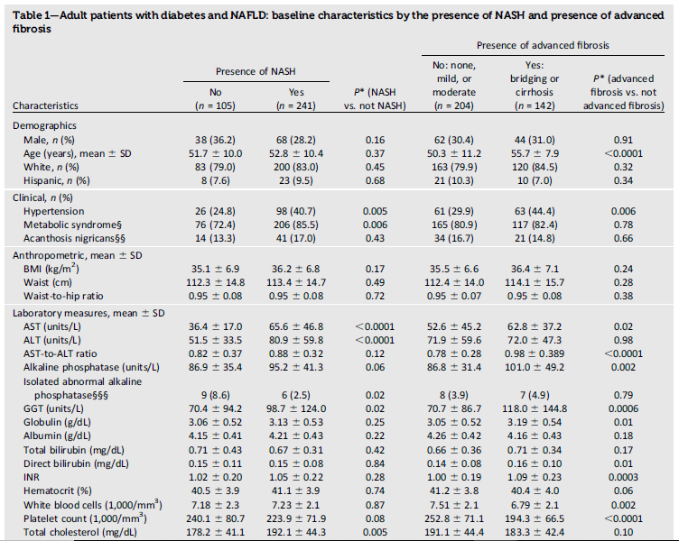

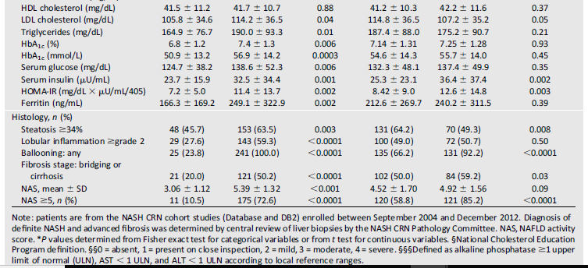

# COSTS

## [Younossi ZM, Henry L, Stepanova M, et al. The Economic and Clinical Burden of Non-Alcoholic Fatty Liver Disease in the United States. Journal of Hepatology. 2015;2016;64:S502-S503.](Costs%20of%20NAFLD%20and%20NASH/Younossi%20et%20al%20The%20Economic%20and%20Clinical%20Burden%20of%20NAFLD%20in%20the%20US%20and%20Europe.pdf)

* There is uncertainty around the economic burden of NAFLD. We constructed a steady-state prevalence model to quantify this burden in the United States and Europe. Five models were constructed to estimate the burden of NAFLD in the United States and four European countries.
  + Clinically, NASH seems to be more common and potentially more progressive in the setting of insulin resistance and diabetes mellitus**.(7)** Other studies have also shown that diabetes mellitus is an independent predictor of advanced fibrosis and long-term mortality in NAFLD**.(8,9)** In addition, the presence of advanced fibrosis (stage > or =2) in NAFLD has been associated with increased liver-related mortality**.(10,11)** These data, therefore, may be an indicator that grade of fibrosis is a surrogate for predicting liver-related mortality
    - **7) Hossain N, Afendy A, Stepanova M, Nader F, Srishord M, Rafiq N, et al. Independent predictors of fibrosis in patients with nonalcoholic fatty liver disease. Clin Gastroenterol Hepatol 2009; 7:1224-1229.**
    - **8) Otgonsuren M, Stepanova M, Gerber L, Younossi ZM. Anthropometric and clinical factors associated with mortality in subjects with nonalcoholic fatty liver disease. Dig Dis Sci 2013;58:1132-1140.**
    - **9) Younossi ZM, Gramlich T, Matteoni CA, Boparai N, McCullough AJ. Nonalcoholic fatty liver disease in patients with type 2 diabetes. Clin Gastroenterol Hepatol 2004;2:262-265. Erratum in: Clin Gastroenterol Hepatol 2004;2:522.**
    - **~~10) Younossi ZM, Stepanova M, Rafiq N, Makhlouf H, Younoszai Z, Agrawal R, et al. Pathologic criteria for nonalcoholic steatohepatitis: interprotocol agreement and ability to predict liver-related mortality. HEPATOLOGY 2011;53(6):1874-1882.~~**
    - **~~11) Angulo P, Kleiner DE, Dam-Larsen S, Adams LA, Bjornsson ES, Charatcharoenwitthaya P, et al. Liver fibrosis, but no other histologic features, is associated with long-term outcomes of patients with nonalcoholic fatty liver disease. Gastroenterology 2015;149:389-397.~~**
* Model
  + Models were built using a series of interlinked Markov chains, each representing age increments of the NAFLD and the general populations. Incidence and remission rates were calculated by calibrating against real-world prevalence rates. The data were validated using a computerized disease model called DisMod II. NAFLD patients transitioned between nine health states (nonalcoholic fatty liver, nonalcoholic steatohepatitis [NASH], NASH w fibrosis, NASH-compensated cirrhosis, NASH-decompensated cirrhosis, hepatocellular carcinoma, liver transplantation, post-liver transplant, and death). Transition probabilities were sourced from the literature and calibrated against real-world data.
  + Each model was constructed using a series of interlinked Markov chains in Microsoft Excel spreadsheets, using the general structure shown in Fig. 1, which depicts a Markov model for the general population.
  + Within the general population, individuals were classified into four possible states: susceptible, NAFLD, NAFLD-specific deaths, and all-cause deaths.
  + Individual transition probabilities between these states were calculated by applying incidence, remission, mortality, and NAFLD-specific mortality rates.(1-15)
  + Cohorts of patients were followed in 5-year bands. It is important to note that including patients aged under 20 may introduce confounding due to those with potential inherited metabolic disorders associated with early NAFLD; however, this population was still included for completeness of the model.
    - 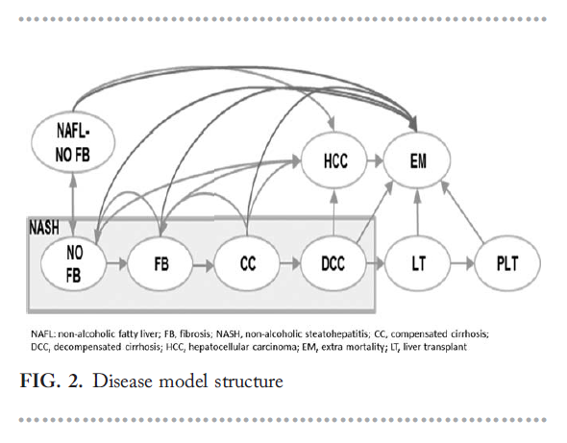
* Inputs
  + Incidence rates were applied in 5-year intervals and calculated using the calibration method described below; 5-year age bands were selected for these parameters as they were not expected to vary significantly within these bands
    - 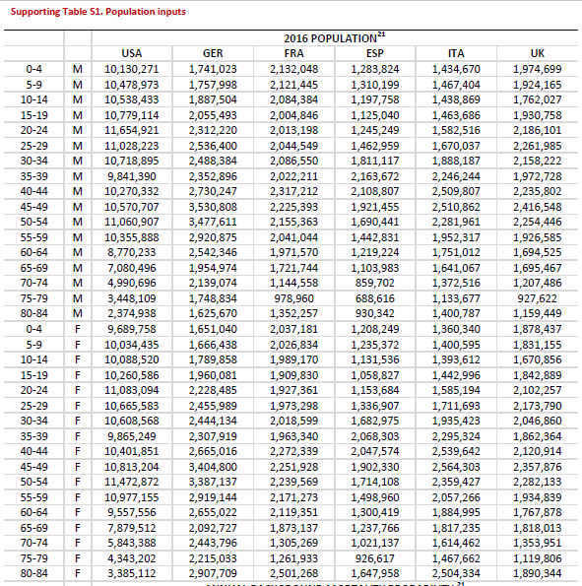
    - 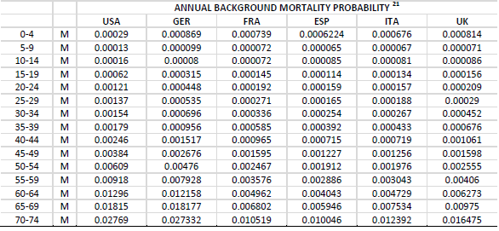
    - 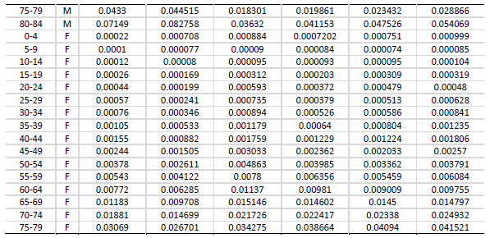
  + Given the limited amount of data available for the age-specific natural history of NAFLD, a base transition matrix without regard to age was built from the published literature (Supporting Table S2)(22-31); where data gaps existed, values were imputed from the primary sources used in a **recent cost-effectiveness analysis of patients with hepatitis C.(32)**
    - 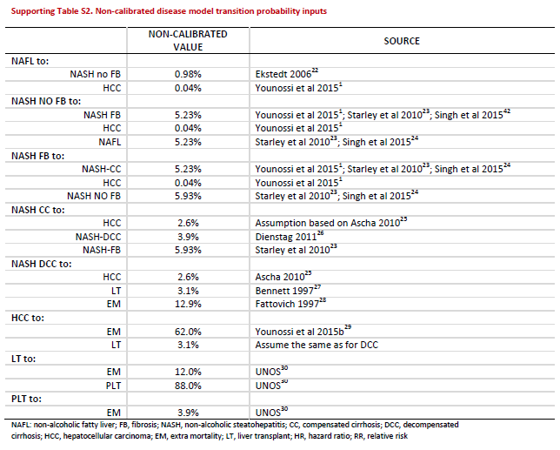
  + **These probabilities were then varied over four distinct age bands (<20, 20-44, 45-64, and 65+) by applying relative risks (RRs) to the base transition matrix.**
  + **The** **age specific RRs for all progressive transition probabilities with the exception of transition to LT were based on risk of death PLT obtained from the United Network for Organ Sharing database (Supporting Table S3).(30,31)**
    - 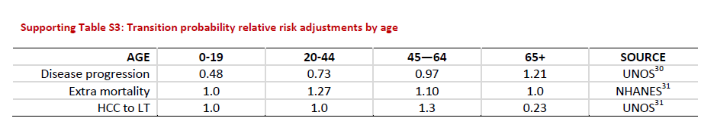
  + Gender-specific adult NAFLD prevalence rates for the United States were obtained from the **National Health and Nutrition Examination Survey III (NHANES III) database across the four age bands included in the model and adjusted using an RR factor of 1.45 to reflect the difference between these prevalence rates and the rates reported in a recent metaanalysis.(1, 31)**
  + 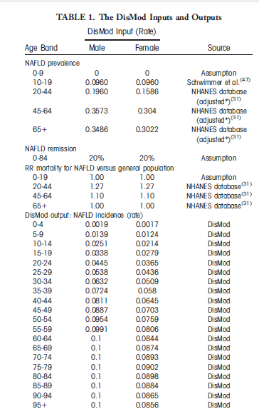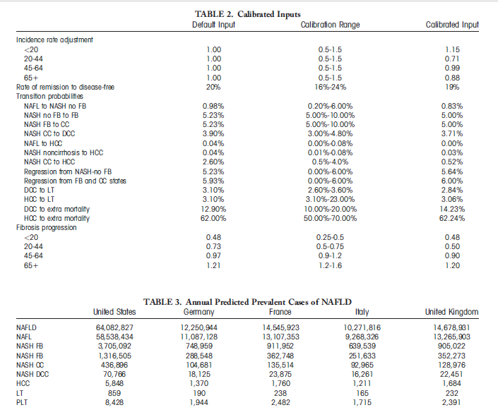
  + Utilities were obtained directly from NAFLD patients using Short Form-6D scores (**Supporting Table S5).**Costs were sourced from the literature and local fee schedules.
    - 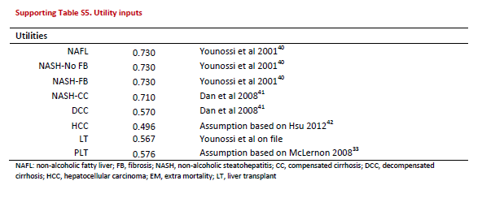
* Costing
  + In the model’s base case, both direct medical costs and societal costs were considered. Conservatively, additional costs due to the presence of comorbid conditions(e.g., treatment costs, complication costs) were not modeled.
  + Annual costs of each health state at a macro level were sourced from recent publications **(Supporting Table S4).(33-38)** **Costs for patients in lesser-progressed model health states were micro-costed using resource use inputs from hepatology experts mapped to national fee schedules. For the US analysis, annual hospitalization costs for NAFLD without cirrhosis were obtained from a recent Medicare cost analysis,(18,19)** **and those costs were assumed to apply across all NAFL and noncirrhotic NASH health states**. Hospitalization costs were adjusted for European markets using an adjustment factor.
  + 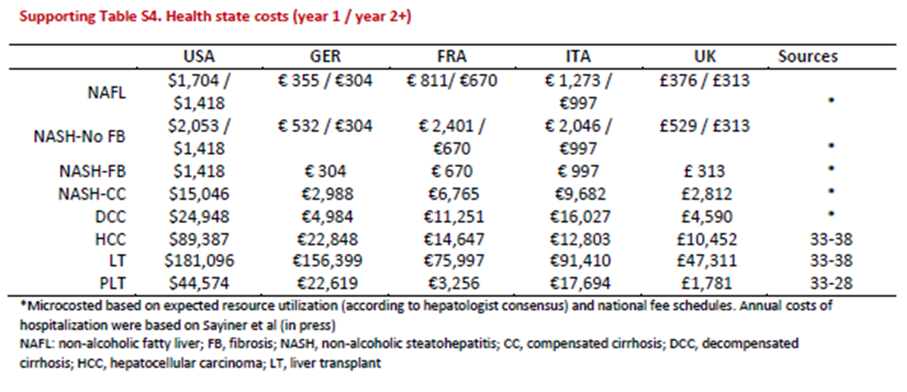
  + Societal costs were calculated by estimating the annual quality-adjusted life-years (QALYs) lost due to NAFLD and by applying a monetary value to this QALY estimate.
  + **QALYs were measured by assigning utility scores of between 1 (perfect health) and 0 (death) to each NAFLD health state and multiplying the utility scores by survival, weighted by health state.**
  + **QALYs lost were calculated as the difference between the projected QALYs in the NAFLD population and the projected QALYs in the general population, weighted by age, as sourced from the National Health Measurement study.(31,39-45)**
* Results
  + In the United States, over 64 million people are projected to have NAFLD, with annual direct medical costs of about $103 billion **($1,613 per patient**). In the Europe-4 countries (Germany, France, Italy, and United Kingdom), there are ~52 million people with NAFLD with an annual cost of about e35 billion (from **e354 to e1,163 per patient**). Costs are highest in patients aged 45-65. The burden is significantly higher when societal costs are included.

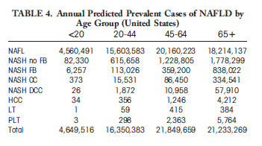

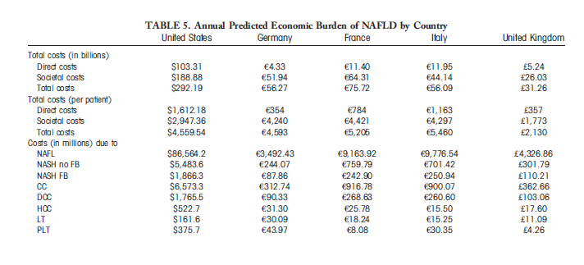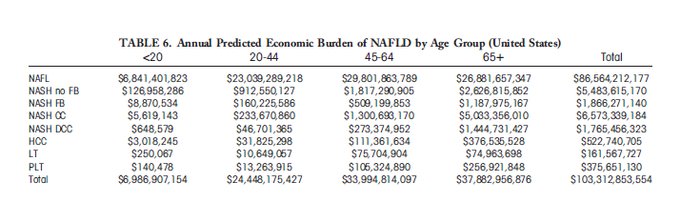

## [Allen AM, Van Houten HK, Sangaralingham LR, Talwalkar JA, McCoy RG. Healthcare Cost and Utilization in Nonalcoholic Fatty Liver Disease: Real-World Data from a Large US Claims Database. Hepatology (Baltimore, Md.). 2018.](Costs%20of%20NAFLD%20and%20NASH/Allen%20et%20al%20Healthcare%20Cost%20and%20Utilization%20in%20Nonalcoholic%20Fatty%20Liver%20Disease%20Real%20World%20Data%20from%20a%20Large%20US%20Claims%20Database.pdf)

**Medians** reported

|  |  |  |
| --- | --- | --- |
| **Disease State** | **Costs PPPY** | **Incremental Costs PPPY** |
| control | $2,298 (IQR $681 - $6,580) |  |
| NAFLD new diagnosis | $7,804 (IQR $3,068-$18,688) | $5,506 |
| NAFLD long term | $3,789 (IQR $1,176-$10,539) | $1,491 |

Liver biopsies, imaging, and hospitalizations accounted for majority of costs

## [McAdam-Marx C, McGarry LJ, Hane CA, Biskupiak J, Deniz B, Brixner DI. All-cause and incremental per patient per year cost associated with chronic hepatitis C virus and associated liver complications in the United States: a managed care perspective. Journal of managed care pharmacy : JMCP. 2011;17:531.](Costs%20of%20HCV/McAdam-Marx%20et%20al%20All-Cause%20and%20Incremental%20Per%20Patient%20Per%20Year%20Cost%20Associated%20with%20Chronic%20Hep%20C.pdf)

**Medians** reported

|  |  |
| --- | --- |
| **Disease State** | **Incremental Costs PPPY** |
| HCV without Liver Disease | $5,873 |
| Compensated Cirrhosis | $5,348 |
| Decompensated Cirrhosis | $27,739 |
| HCC | $43,412 |
| All Liver Transplant | $94,030 |
| Liver Transplant First Year | $168,845 |
| Liver Transplant after First Year | $38,030 |
| All HCV | $9,688 |

## [Doble B, Wordsworth S, Rogers CA, et al. What Are the Real Procedural Costs of Bariatric Surgery? A Systematic Literature Review of Published Cost Analyses. Obesity Surgery. 2017;27:2179-2192.](Costs%20of%20NAFLD%20and%20NASH/Doble%20et%20al%20What%20Are%20the%20Real%20Procedural%20Costs%20of%20Bariatric%20Surgery%20A%20Systematic%20Literature%20Review%20of%20Published%20Cost%20Analyses.pdf)

* This review aims to evaluate the current literature on the procedural costs of bariatric surgery for the treatment of severe obesity. Using a published framework for the conduct of micro-costing studies for surgical interventions, existing cost estimates from the literature are assessed for their accuracy, reliability and comprehensiveness based on their consideration of seven ‘important’ cost components. MEDLINE, PubMed, key journals and reference lists of included studies were searched up to January 2017. Eligible studies had to report per-case, total procedural costs for any type of bariatric surgery broken down into two or more individual cost components. A total of 998 citations were screened, of which 13 studies were included for analysis. Included studies were mainly conducted from a US hospital perspective, **assessed either gastric bypass or adjustable gastric banding procedures** and considered a range of different cost components. **The mean total procedural costs for all included studies was US$14,389 (range, US$7423 to US$33,541).** No study considered all of the recommended ‘important’ cost components and estimation methods were poorly reported. The accuracy, reliability and comprehensiveness of the existing cost estimates are, therefore, questionable. There is a need for a comparative cost analysis of the different approaches to bariatric surgery, with the most appropriate costing approach identified to be micro-costing methods. Such an analysis will not only be useful in estimating the relative cost-effectiveness of different surgeries but will also ensure appropriate reimbursement and budgeting by healthcare payers to ensure barriers to access this effective treatment by severely obese patients are minimised.

**Makary MA, Clark JM, Shore AD, et al. Medication Utilization and Annual Health Care Costs in Patients With Type 2 Diabetes Mellitus Before and After Bariatric Surgery. Archives of Surgery. 2010;145:726-731**

* To examine the relationship of bariatric surgery with the use of diabetes medications and with total health care costs in patients with type 2 diabetes mellitus. We studied 2235 adults with type 2 diabetes and **commercial health insurance who underwent bariatric surgery in the United States during a 4-year period from January 1, 2002, through December 31, 2005**. We used administrative claims data to measure the use of diabetes medications at specified time intervals before and after surgery and total median health care costs per year. Seven states in the Blue Cross/Blue Shield Obesity Care Collaborative. Two thousand two hundred thirty-five patients with type 2 diabetes mellitus who underwent bariatric surgery. Surgery was associated with elimination of diabetes medication therapy in 1669 of 2235 patients (74.7%) at 6 months, 1489 of 1847 (80.6%) at 1 year, and 906 of 1072 (84.5%) at 2 years after surgery. Reduction of use was observed in all classes of diabetes medications. **The median cost of the surgical procedure and hospitalization was $29 959.** In the 3 years following surgery, total annual health care costs per person increased by 9.7% ($616) in year 1 but then decreased by 34.2% ($2179) in year 2 and by 70.5% ($4498) in year 3 compared with a preoperative annual cost of $6376 observed from 1 to 2 years before surgery. Bariatric surgery is associated with reductions in the use of medication and in overall health care costs in patients with type 2 diabetes. Health insurance should cover bariatric surgery because of its health and cost benefits..

# PE Modeling

## [Younossi ZM, Park H, Dieterich D, Saab S, Ahmed A, Gordon SC. The value of cure associated with treating treatment‐naïve chronic hepatitis C genotype 1: Are the new all‐oral regimens good value to society? Liver International. 2017;37:662-668.](PE%20Modeling/Younossi%20et%20al%20The%20value%20of%20cure%20associated%20with%20treating%20treatment‐naïve%20chronic%20hepatitis%20C%20genotype%201%20Are%20the%20new%20all‐oral%20regimens%20good%20value%20to%20society.pdf)

* Background information to collect for NAFLD, NASH
  + Present population and prevalence of patients with NAFLD, and NASH
  + Present costs associated with NAFLD, NASH
  + Present major cost drivers and their associated contributions
* Assumptions
  + 1.52 million treatment-naïve HCV-GT1 patients in the US
  + $50,000 as value of a QALY
  + Cost of regimens
    - Assumed only drug costs
* Transition State Probabilities
* We utilized a decision-analytic Markov model, previously described20 to model a cohort of prevalent US chronic hepatitis C GT1 treatment-naïve patients over a lifetime horizon. The analysis was **modelled from the payer perspective**, and patients entered the model with a mean age of 52 years.
  + Authors previously state: In this context, the best economic perspective should be used to assess the long-term economic value of cure to society.
    - What are the different considerations in PE modeling from payer vs society prespective?
      * Work productivity likely not of interest to the payer
      * Health outcomes and healthcare utilization likely is of interest
  + **20. Younossi ZM, Park H, Saab S, Ahmed A, Dieterich D, Gordon SC. Cost-effectiveness of all-oral ledipasvir/sofosbuvir regimens in patients with chronic hepatitis C virus genotype 1 infection. Aliment Pharmacol Ther. 2015a;41:544–563.**
* **Outcomes and costs were discounted at an annual rate of 3.0%, in accordance with AMCP guidelines**
  + **What does this mean?**
* The value of cure was defined as the increase in quality-adjusted life years (QALYs) multiplied by the value of a QALY (in the model’s base case, $50 000) minus the increase in treatment costs. 22
  + **22. Neumann PJ, Cohen JT, Weinstein MC. Updating cost-effectiveness–the curious resilience of the $50,000-per-QALY threshold. N Engl J Med. 2014;371:796–797.**
* Cost growth with new technology is regarded as justified by the associated value to society when the estimated value of cure is >0 but as not justified when the value of cure is <0. Analyses were performed assuming only the cost of drug treatment, as well as the lifetime total treatment cost.
* Sustainedvirological response (SVR), transition probabilities, utilities and mortality were based on literature review and consensus by hepatologists, and have been described previously.20 Drug costs were sourced from Redbook, using wholesale acquisition costs 24
  + **24. Red Book Online [Internet]. Micromedex 2.0. http://www.micromedexsolutions.com/home/dispatch. Accessed October 15, 2015.**
* Since the valuation of a QALY at $50 000 may be outdated,22 we ran a scenario analysis varying the value of a QALY upto $150 000. One-way deterministic sensitivity analyses explored a range of values for parameters previously determined to be key drivers of the model. Sustained viral response rates were varied by ±10% from the base case and drug acquisition costs were varied by ±20% from the base case to assess the impact of these parameters on the value of cure results.

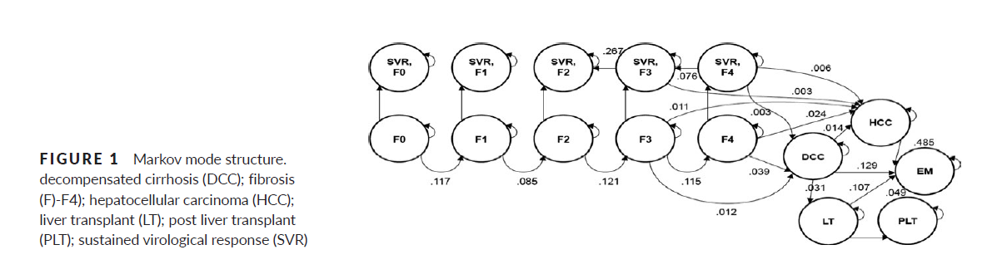

* Utility Values and Sourcing
  + 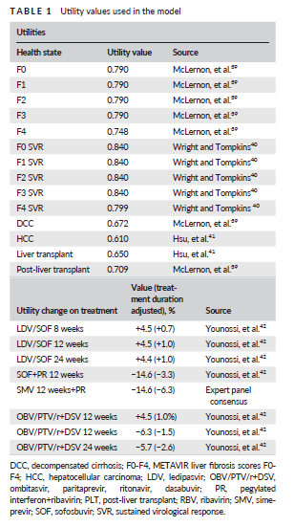

## [Younossi ZM, Park H, Saab S, Ahmed A, Dieterich D, Gordon SC. Cost‐effectiveness of all‐oral ledipasvir/sofosbuvir regimens in patients with chronic hepatitis C virus genotype 1 infection. Alimentary Pharmacology & Therapeutics. 2015;41:544-563.](PE%20Modeling/Younossi%20et%20al%20Cost‐effectiveness%20of%20all%20oral%20ledipasvir%20sofosbuvir%20regimens%20in%20patients%20with%20chronic%20hepatitis%20C%20virus%20genotype%201%20infection.pdf)

* A hybrid decision-tree and Markov state-transition model was developed. For a cohort of 10,000 patients, the model captured outcomes for several pairings of LDV/SOF with comparators, including long-term health outcomes, number need to treat, life-years gained, quality-adjusted life-years (QALYS) gained, incremental cost-effectiveness ratios and costs per sustained virologic response (SVR)
* **A hybrid decision-tree and Markov state-transition model was developed in Microsoft Excel 2010** to estimate the cost-effectiveness of LDV/SOF therapy in patients monoinfected with HCV genotype 1 compared with currentl available regimens, taking into account health outcomes, HRQoL and costs. The perspective of the modem was that of **a third-party commercial or government payer in the US**, including managed care health plans, accountable care organisations, state Medicaid plans and self-insured employers. **Therefore, only direct medical and pharmaceutical costs were included in the model**.
* The model followed a hypothetical cohort of 10 000 adult patients with HCV genotype 1. The model was structured as an initial decision tree, which patients entered at the initiation of treatment, receiving either LDV/SOF or one of the comparator treatments, followed by a state-transition model to project patient outcomes (Figure 1). Patients entered the model at varying stages of liver fibrosis, including patients without cirrhosis **(METAVIR fibrosis scores: F0 no fibrosis; F1 portal fibrosis without septa; F2 portal fibrosis with few septa; and F3 numerous septa without cirrhosis) or with CC (F4).** Upon completion of each regimen, patients were assessed for SVR, stratified by fibrosis stage. In the state-transition model, for each 1-year model cycle, patients remained in or transitioned between the following health states: baseline fibrosis stage (F0–F4); SVR stratified by fibrosis score (SVR F0–F4); decompensated cirrhosis (DCC); hepatocellular carcinoma (HCC); liver transplant; post-liver transplant and death.
* **Characteristics of the modelled patient population were based on baseline characteristics in the LDV/SOF clinical trials and related published literature.12, 13, 21**The efficacy and safety metrics were derived **from indirect comparisons rather than a network meta-analysis.** The mean age was 52 years and the mean body weight was 78 kg.
* Patients who did not achieve SVR were assumed to progress through the natural course of the disease as if untreated, and could remain in their current health state or transition to sequential health states in any 1-year model cycle. According to the natural course of disease, patients without CC could transition to a more advance stage of fibrosis based on transition probabilities sourced from a meta-analysis,39 to account for the heterogeneity observed across studies in the literature. Patients with a METAVIR fibrosis score of F3 or F4 could additionall progress to advanced liver disease such as DCC or HCC. Those with DCC could transition to HCC or receive a liver transplant, while those with HCC were permitted to transition to liver transplant or to death. Patients with a successful liver transplant remained in the post-liver transplant health state until their death.
* 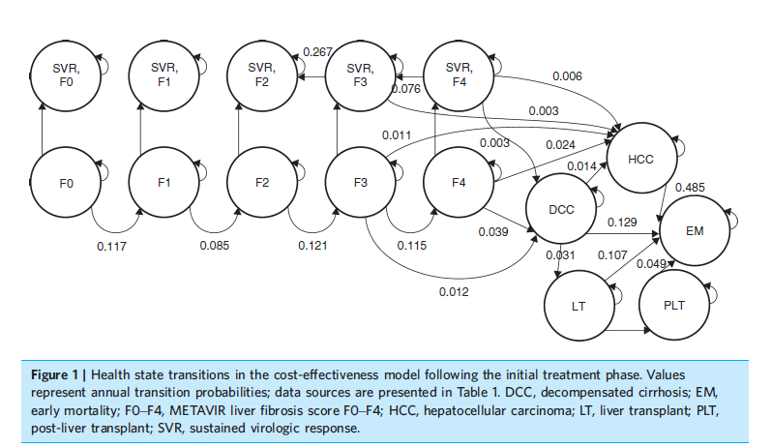
* In contrast to the clinical inputs, costs were sourced from real-life retrospective data or from publicly available costing sources. Four types of HCV-related cost were included in the model: drug acquisition costs; monitoring costs; adverse event costs; and health state costs. All costs were in US dollars (2014) and, where necessary, were inflated using the medical care component of the consumer price index 51
  + **51. Statistics BoL. Consumer Price Index. Washington, DC: Bureau of Labor Statistics, U.S. Department of Labor, 2014.**
* Monitoring costs differed by treatment regimen, level of treatment experience and cirrhosis status. Weekly costs were calculated according to monitoring-resource use (based on AASLD monitoring guidelines20 and consensus from the national panel of hepatologists) and unit costs; unit costs were taken from the 2014 Resource-Based Relative Value Scale (RBRVS).53 Total monitoring costs over the treatment period were then aggregated from the weekly totals and treatment duration (including early discontinuation). Adverse event costs were calculated based on the incidence of each event, and the pharmacy costs and number of appointments (office visits) for the management of each event. These pharmacy costs were based on drug treatment algorithms (validated by the national panel of hepatologists) and the wholesale acquisition costs.52 All adverse events were assumed to be associated with one office visit with both a doctor and a nurse together. Office visit costs were sourced from the RBRVS.53
  + **53. Resource-Based Relative Values Scale (R-BRVS). The Essential RBRVS: A Comprehensive Listing of RBRVS Values for CPT and HCPCS Codes. Salt Lake City, UT, USA: Optum Insight Inc, 2014.**
  + **54. Gordon SC, Muir AJ, Lim JK, et al. The Frequency and Management of Adverse Events in Chronic Hepatitis (HCV) Treated with Boceprevir or Telaprevir: Real World Experience from HCV-TARGET Longitudinal Observational Study. Hepatology 2013 58: 1104A.**
  + **55. McAdam-Marx C, McGarry LJ, Hane CA, Biskupiak J, Deniz B, Brixner DI. All-cause and incremental per patient per year cost associated with chronic hepatitis C virus and associated liver complications in the United States: a managed care perspective. J Manag Care Pharm 2011; 17: 531–46.**

## [Tapper EB, Sengupta N, Hunink MGM, Afdhal NH, Lai M. Cost-Effective Evaluation of Nonalcoholic Fatty Liver Disease With NAFLD Fibrosis Score and Vibration Controlled Transient Elastography. The American journal of gastroenterology. 2015;110:1298-1304](PE%20Modeling/Tapper%20et%20al%20%20Cost-Effective%20Evaluation%20of%20Nonalcoholic%20Fatty%20Liver%20Disease%20With%20NAFLD%20Fibrosis%20Score%20and%20Vibration%20Controlled%20Transient%20Elastography.pdf).

* We sought to compare the cost-effectiveness of four different strategies to assess fibrosis risk in patients with NAFLD: vibration controlled transient elastography (VCTE), the NAFLD fibrosis score (NFS), combination testing with NFS and VCTE, and liver biopsy (usual care). We developed a probabilistic decision analytical microsimulation state-transition model wherein we simulated a cohort of 10,000 50-year-old Americans with NAFLD undergoing evaluation by a gastroenterologist. VCTE performance was obtained from a prospective cohort of 144 patients with NAFLD.
  + This study simulated the natural history over 30 years of a cohort presenting for evaluation with elevated liver enzymes (>40 IU/l) and a liver ultrasound consistent with steatosis owing to NAFLD.
  + All patients had a negative evaluation for excessive alcohol intake, hepatitis C, hepatitis B, drug-induced liver injury, or hemochromatosis. We assume that patients with decompensated cirrhosis have been diagnosed clinically and managed accordingly.
  + We assume that all patients were given an empiric trial of lifestyle modification and were referred to gastroenterology after the finding of persistent liver enzyme elevation when reassessed after 6 months. All patients have NAFLD in this model; however the stage of their disease is unknown.
  + The goals of this analysis are to model two outcomes simultaneously based on the generation of discounted costs (2014 US dollars) and discounted quality-adjusted life years (QALY) that accrue to our cohort over time. By dividing the QALYs by costs for each clinical strategy, we may determine the incremental cost-effectiveness ratios in pairwise comparisons.
  + We derived the relative proportion of patients with simple steatosis, NASH without advanced fibrosis (METAVIR stage 0–2 fibrosis), advanced fibrosis (METAVIR stage 3 fibrosis), and cirrhosis from our referral clinic from 1996 to 2013.
  + The combined proportion from these cohorts with simple steatosis, NASH without advanced fibrosis, advanced fibrosis, and cirrhosis are, respectively, 46.6% (201), 36.7% (158), 11.1% (48), and 5.6% (24).
* 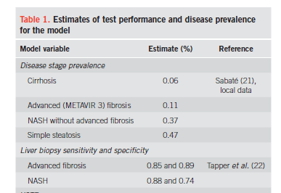
* The rate of NASH regression to simple steatosis was modifiable with treatment. Both lifestyle interventions and vitamin E were associated with improvement of histological inflammation (17,19,20). Th e magnitude of improvement was derived from a randomized control trial comparing both modalities (17). In accordance with published guidelines, we restricted vitamin E to patients with biopsy-proven NASH ( 2,17 ) As vitamin E has not been associated with improvements in fibrosis ( 17), patients with advanced fibrosis on biopsy were not candidates for therapy. Adherence to either lifestyle interventions or vitamin E therapy is assumed to be 50% based on estimates from the World Health Organization (21).
* The model assumed an annual cycle length and terminated after 30 years. All costs, life years, and utilities were discounted at a rate of 3%. Half-cycle correction was performed. All costs were inflated to 2014 values and converted to American dollars. Sensitivity analyses were performed for all variables. The main results are derived from probabilistic sensitivity analyses, which were performed using Monte Carlo microsimulation of 10,000 patients with 10,000 samples taken from the input parameter distributions.
* Both the NFS alone and the NFS/VCTE strategies were cost effective at $5,795 and $5,768 per quality-adjusted life years (QALY), respectively. In the microsimulation, the NFS alone and NFS/ VCTE strategies were the most cost-effective (dominant) in 66.8 and 33.2% of samples given a willingness-to-pay threshold of $100,000 per QALY.
  + NFS has high negative predictive value in excluding the presence of advanced fibrosis

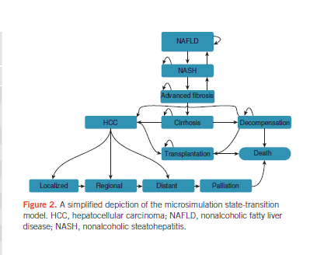

## [Tapper et al SUPPLEMENT](PE%20Modeling/SUPPLEMENT%20Tapper%20et%20al%20Cost-Effectiveness%20Evaluaton%20of%20NAFLD%20with%20NAFLD%20Fibrosis%20Score.doc)

**Methods - Transition Probabilities**

* Ranges were derived from the references listed. When high quality data from population-wide sources were available, ***beta distributions*** were used. When drawn from beta distributions, the ranges listed reflect + two standard deviations. When single center estimates or author assumptions were available, ***a triangular distribution was employed reflecting the published range or a range of + 20% when one estimate was available***.
* The annual mortality rate was ***abstracted from the Center for Disease Control population-based life table and converted to a rate.***13
  + **13. National Vital Statistics Reports. United States Life Tables., 2007**
* Thereafter it was multiplied by the **standardized mortality ratio for a patient with NAFLD/NASH - 1.34 (95% CI: 1.003–1.76**) - and converted back to an annual probability of mortality for patients with NAFLD and NASH.14
  + **14. Adams LA, Lymp JF, St Sauver J, et al. The natural history of nonalcoholic fatty liver disease: a population-based cohort study. Gastroenterology 2005;129:113-121.**
* Survival for patients with advanced fibrosis and compensated cirrhosis treated in a similar fashion, by adjusting CDC data with a mortality hazard ratio derived from a defined cohort of patients with NAFLD and advanced fibrosis or compensated cirrhosis **- 3.28 (95% CI 2.27-4.76)**.15 
  + **15. Ekstedt M, Hagström H, Nasr P, et al. Fibrosis stage is the strongest predictor for disease‐specific mortality in NAFLD after up to 33 years of follow‐up. Hepatology 2014**.
* Mortality rates for decompensated cirrhosis16, 17, hepatocellular carcinoma18 and post-transplantation19, 20 were independent of CDC data and abstracted from the relevant literature as listed in Supplementary Table 1.
  + **17. Ratib S, Fleming KM, Crooks CJ, et al. 1 and 5 year survival estimates for people with cirrhosis of the liver in England, 1998–2009: A large population study. Journal of hepatology 2014;60:282-289.**
  + **18. Altekruse SF, McGlynn KA, Reichman ME. Hepatocellular carcinoma incidence, mortality, and survival trends in the United States from 1975 to 2005. Journal of Clinical Oncology 2009;27:1485-1491.**
  + **19. Organ Procurement and Transplantation Network.**
  + **20.** [**http://srtr.org/annual_Reports/2011/data_tables_section9.aspx**](http://srtr.org/annual_Reports/2011/data_tables_section9.aspx)**.**
* Given the wide variability of treatment options for hepatocellular carcinoma, this model used generalizable data abstracted from actual care on a population level as recorded by the Surveillance, Epidemiology, and End Results (SEER) database. Using SEER, transition probabilities, treatment decisions and costs are divided by the stage of disease into nationally representative per-patient averages. In our model, the major branch points for state-transition were transplantation, resection, chemotherapy and palliative care. The transitions are not exclusive of local therapy such as transarterial chemoembolization or radiofrequency ablation which are utilized for each stage and contribute to the costs recorded in SEER. The model assumed that patients receiving chemotherapy would receive sorafenib which has emerged as the standard of care for chemotherapy candidates.
* Patients were considered candidates for transplantation until age 65. Candidates for transplantation had decompensated cirrhosis and/or hepatocellular carcinoma. Once a patient under the age of 65 developed such an indication, they were considered for the transplant wait-list. The rate of rejection from the waitlist for patients with NAFLD has been assessed once previously at a large transplant center. This data was incorporated in a beta-distribution: 47.6 % (196/412).21

**Supplementary Table 1: Reference case estimates and distributions of probabilities used in the model**

|  |  |  |
| --- | --- | --- |
| ***Health State*** | **Estimate (Distribution)** | **Reference** |
| Probability of NAFLD developing NASH | 0.028 (0.00 – 0.063) | 28 |
| Probability of NASH developing advanced fibrosis | 0.10 (0.045 – 0.145) | 28 |
| Probability of advanced fibrosis progressing to cirrhosis* | 0.072 (0.057 - 0.086) | 29 |
| Probability of NASH regressing to NAFLD | 0.038 (0.00 – 0.09) | 30 |
| Probability of advanced fibrosis regressing to NASH | 0.029 (0.00 – 0.09) | 30, 31 |
| ***Cirrhosis*** |  |  |
| Probability of decompensation |  |  |
| During first year of diagnosis | 0.25 (0.23 - 0.28) | 32 |
| After first year of diagnosis | 0.055 (0.048 - 0.062) | 32 |
| Probability of developing hepatocellular carcinoma | 0.026 (0.026 - 0.05) | 33, 34 |
| ***Decompensated Cirrhosis*** |  |  |
| Probability of developing hepatocellular carcinoma | 0.026 (0.026 - 0.05) | 33, 34 |
| Probability of liver transplant for listed patients | 0.34 (0.32 – 0.37) | 20 |
| Probability of all cause mortality | 0.16 (0.15-0.38) | 16, 17 |
| ***Post liver transplant*** |  |  |
| Probability of survival during first year | 0.86 (0.86 – 0.87) | 19 |
| Probability of survival after first year | 0.0.93 (0.92 – 0.95) | 35 |
| ***Hepatocellular Carcinoma (HCC)*** |  |  |
| Localized Stage at diagnosis* | 0.57 (0.46 – 0.68) | 36 |
| Transplant (Age < 65) | 0.04 (0.03 – 0.05) | 36 |
| Resection (Age < 65) | 0.12 (0.11 – 0.14) | 36 |
| Resection (Age > 65) | 0.10 (0.09 – 0.12) | 36 |
| Mortality | 0.23 (0.20 – 0.26) | 18 |
| Regional Stage at diagnosis |  |  |
| Resection (Age < 65) | 0.065 (0.05 – 0.08) | 36 |
| Resection (Age > 65) | 0.0092 (0.005 – 0.014) | 36 |
| Sorafenib | 0.15 (0.14 – 0.16) | 36 |
| Mortality | 0.21 (0.18 – 0.24) | 18 |
| Distant Stage at diagnosis* | 0.19 (0.15 – 0.22) | 36 |
| Sorafenib | 0.25 (0.20 – 0.30) | 36 |
| Mortality during first year of sorafenib | 0.56 (0.50 - 0.62) | 37 |
| Transition to palliative care from sorafenib | 0.9 | assumption |
| Mortality after first year of sorafenib | 0.85 | 37 / assumption |
| Mortality during palliative care | 0.94 (0.92 – 0.96) | 18 |

NAFLD = Nonalcoholic Fatty Liver Disease , NASH = Nonalcoholic Steatohepatitis  
All estimates are assessed in the probabilistic decision model using beta distributions except where an (*) indicates a triangular distribution.

**References for Supplementary Table 1**

16. Fleming KM, Aithal GP, Card TR, et al. All‐cause mortality in people with cirrhosis compared with the general population: a population‐based cohort study. Liver International 2012;32:79-84.

17. Ratib S, Fleming KM, Crooks CJ, et al. 1 and 5 year survival estimates for people with cirrhosis of the liver in England, 1998–2009: A large population study. Journal of hepatology 2014;60:282-289.

18. Altekruse SF, McGlynn KA, Reichman ME. Hepatocellular carcinoma incidence, mortality, and survival trends in the United States from 1975 to 2005. Journal of Clinical Oncology 2009;27:1485-1491.

**28. Wong VW-S, Wong GL-H, Choi PC-L, et al. Disease progression of non-alcoholic fatty liver disease: a prospective study with paired liver biopsies at 3 years. Gut 2010;59:969-974.**

**29. Ekstedt M, Franzén LE, Mathiesen UL, et al. Long‐term follow‐up of patients with NAFLD and elevated liver enzymes. Hepatology 2006;44:865-873.**

**30. Adams LA, Sanderson S, Lindor KD, et al. The histological course of nonalcoholic fatty liver disease: a longitudinal study of 103 patients with sequential liver biopsies. Journal of hepatology 2005;42:132-138.**

**31. Sanyal AJ, Chalasani N, Kowdley KV, et al. Pioglitazone, vitamin E, or placebo for nonalcoholic steatohepatitis. New England Journal of Medicine 2010;362:1675-1685.**

**32. Fleming KM, Aithal G, Card T, et al. The rate of decompensation and clinical progression of disease in people with cirrhosis: a cohort study. Alimentary pharmacology & therapeutics 2010;32:1343-1350.**

**33. Ascha MS, Hanouneh IA, Lopez R, et al. The incidence and risk factors of hepatocellular carcinoma in patients with nonalcoholic steatohepatitis. Hepatology 2010;51:1972-1978.**

**34. Sanyal AJ, Banas C, Sargeant C, et al. Similarities and differences in outcomes of cirrhosis due to nonalcoholic steatohepatitis and hepatitis C. Hepatology 2006;43:682-689.**

**35. Jain A, Reyes J, Kashyap R, et al. Long-term survival after liver transplantation in 4,000 consecutive patients at a single center. Annals of surgery 2000;232:490.**

**36. Lang K, Danchenko N, Gondek K, et al. The burden of illness associated with hepatocellular carcinoma in the United States. Journal of hepatology 2009;50:89-99.**

37. Llovet JM, Ricci S, Mazzaferro V, et al. Sorafenib in advanced hepatocellular carcinoma. New England Journal of Medicine 2008;359:378-390.

38. Bennett WG, Inoue Y, Beck JR, et al. Estimates of the cost-effectiveness of a single course of interferon-α2b in patients with histologically mild chronic hepatitis C. Annals of internal medicine 1997;127:855-865.

**Methods – Costs**

* Costs are detailed in supplementary table 2. This model was analyzed from the perspective of the healthcare system, accounting for direct medical costs alone. Gamma distributions were used for costs. Data was preferentially abstracted from primary studies of American healthcare costs, excluding reports of charges. The costs of specific items were not accounted for (e.g. blood tests). Rather, population-based averages utilized for healthcare expenditures at each stage from routine care (for NAFLD, NASH and NASH with advanced fibrosis) to cirrhosis care (e.g. screening tests), stage-specific HCC care, and transplantation. However, where appropriate, additional costs atop routine care (e.g. liver biopsy, specialist visit, medication) supplemented the otherwise average costs. When patients progressed to a morecostly state in a given stage, a one-time transition cost equivalent to the cost of the costlier state was assessed. When American data was unavailable, as in the case of VCTE,22 costs inflated to 2014 dollars in their original currency and then converted to American dollars using the appropriate conversion rates on August 16, 2014. All costs were rounded to the nearest dollar.

|  |  |  |  |  |
| --- | --- | --- | --- | --- |
| **Supplementary Table 2: Estimated Costs**  **in 2014 US dollars** |  |  |  |  |
|  | Estimate | Range | Reference | |
| **Annual Costs** |  |  |  | |
| Routine specialist care  (no therapy) | 244 | 90 – 537 | 38 | |
| **Compensated Cirrhosis** | **1,268** | **742 – 1,793** | 11, 38, 39 | |
| **Decompensated cirrhosis** | **16,263** | **13011 - 40198** | 11, 38, 39 | |
| Specialist Annual Visit | 249 | 199 – 299 | 40 | |
| Vitamin E | 70 | 70 - 164 | 41 | |
| Lifestyle modifications | 1,877 | 1502 – 2,252 | 42, 43 | |
| **Hepatocellular Carcinoma** |  |  |  | |
| First year of diagnosis | 41,460 | 29,141 – 51592 | 39, 44, 45 | |
| Localized | 42,645 | 38,380 – 46,910 | 39, 44, 45 | |
| Regional | 39,421 | 35,479 – 43,363 | 39, 44, 45 | |
| Distant | 33,064 | 29,758 – 41,580 | 39, 44, 45 | |
| Distant - Sorafenib | 80,117 | 64,094 – 96,141 | 25 | |
| Palliative care | 44,042 | 22,021 – 88083 | 46-48 | |
| **One Time Costs** |  |  |  | |
| Vibration-Controlled Transient-Elastography | 100 | 80 – 120 | 22 | |
| Liver Biopsy | **1,558** | **1,168 – 1,948** | 11 | |
| Liver resection | 40,156 | 20,078 – 80,311 | 46-48 | |
| Liver Transplant (First Year) | 318,157 | 247,679 – 318,157 | 36, 49 | |
| **Death from any cause** | **57,088** | **35,987 – 61,088** | 50, 51 | |

All costs are assessed in the probabilistic decision model using gamma distributions

**References for Supplementary Table 2**

**38. Bennett WG, Inoue Y, Beck JR, et al. Estimates of the cost-effectiveness of a single course of interferon-α2b in patients with histologically mild chronic hepatitis C. Annals of internal medicine 1997;127:855-865.**

**39. Coffin PO, Scott JD, Golden MR, et al. Cost-effectiveness and population outcomes of general population screening for hepatitis C. Clinical infectious diseases 2012;54:1259-1271.**

40. Permanente K. Charge Master, 2012.

41. Davey PJ, Schulz M, Gliksman M, et al. Cost–effectiveness of vitamin E therapy in the treatment of patients with angiographically proven coronary narrowing (CHAOS trial). The American journal of cardiology 1998;82:414-417.

42. Eddy DM, Schlessinger L, Kahn R. Clinical outcomes and cost-effectiveness of strategies for managing people at high risk for diabetes. Annals of Internal medicine 2005;143:251-264.

43. Group DPPR. Costs associated with the primary prevention of type 2 diabetes mellitus in the diabetes prevention program. Diabetes Care 2003;26:36-47.

**44. Thein HH, Isaranuwatchai W, Campitelli MA, et al. Health care costs associated with hepatocellular carcinoma: A population‐based study. Hepatology 2013;58:1375-1384.**

**45. Tan JA, Joseph TA, Saab S. Treating hepatitis C in the prison population is cost‐saving. Hepatology 2008;48:1387-1395.**

46. Lin O, Keeffe E, Sanders G, et al. Cost‐effectiveness of screening for hepatocellular carcinoma in patients with cirrhosis due to chronic hepatitis C. Alimentary pharmacology & therapeutics 2004;19:1159-1172.

47. McCusker J, Brudevold C. Health services utilization and costs of care in terminal cancer: implications for hospice programs. Home health care services quarterly 1984;5:61-74.

48. Polednak A, Shevchenko I. Hospital charges for terminal care of cancer patients dying before age 65. Journal of health care finance 1997;25:26-34.

49. Showstack J, Katz PP, Lake JR, et al. Resource utilization in liver transplantation: effects of patient characteristics and clinical practice. JAMA 1999;281:1381-1386.

50. Hogan C, Lunney J, Gabel J, et al. Medicare beneficiaries’ costs of care in the last year of life. Health affairs 2001;20:188-195.

51. Hoover DR, Crystal S, Kumar R, et al. Medical expenditures during the last year of life: findings from the 1992–1996 Medicare current beneficiary survey. Health services research 2002;37:1625-1642.

11. **Hagan L, Yang Z, Ehteshami M, et al. All‐oral, interferon‐free treatment for chronic hepatitis C: cost‐effectiveness analyses. Journal of viral hepatitis 2013;20:847-857.**

**Methods – Utilities**

* Utilities are detailed in supplementary Table 3. Triangular distributions were employed for utilities with multiple estimates in the literature; otherwise for values without published ranges, a distribution of + 20% was assumed. **Only patient-derived state-utility estimates were only included, excluding estimates from expert opinion.** The utility state associated with NAFLD (bland steatosis) was assumed to be equivalent to the well-state (1.0) without a range. Post-transplant utility was divided into year one and > year 2. It was assumed to be constant for all years after 2.23-25
  + **23. Siebert U, Sroczynski G, Rossol S, et al. Cost effectiveness of peginterferon α-2b plus ribavirin versus interferon α-2b plus ribavirin for initial treatment of chronic hepatitis C. Gut 2003;52:425-432.**
  + **24. McLernon DJ, Dillon J, Donnan PT. Health-state utilities in liver disease: a systematic review. Medical Decision Making 2008.**
  + **25. Mahady SE, Wong G, Craig JC, et al. Pioglitazone and vitamin E for nonalcoholic steatohepatitis: a cost utility analysis. Hepatology 2012;56:2172-2179.**
* When a patient transitioned to a state with lower utility during a given stage, a one-time disutility equivalent to the difference between states was assessed. Liver biopsy was associated with a one-time disutility of 0.005 QALY.26 Added pill burden from vitamin E and specialist visits were associated with a marginal disutility of 0.001 QALY.27
  + **26. Canavan C, Eisenburg J, Meng L, et al. Ultrasound elastography for fibrosis surveillance is cost effective in patients with chronic hepatitis C virus in the UK. Digestive diseases and sciences 2013;58:2691-2704.**
  + **27. Vijan S, Sussman JB, Yudkin JS, et al. Effect of patients’ risks and references on health gains with plasma glucose level lowering in type 2 diabetes mellitus. JAMA Internal Medicine 2014;174:1227-1234.**

|  |  |  |  |  |  |
| --- | --- | --- | --- | --- | --- |
| Supplementary Table 3: Health State quality of life weights |  | |  |  |  |
| Health State | Estimate | | Range | | Reference |
| Nonalcoholic Fatty Liver Disease | 1 | * | |  | assumption |
| Nonalcoholic Steatohepatitis | 0.95 | 0.90 – 1.0 | | 23 | |
| **Well with Advanced Fibrosis** | **0.92** | **0.65 – 0.95** | | **52****,** **53** | |
| Compensated cirrhosis | 0.78 | 0.71 – 0.89 | | 23, 52-54 | |
| Decompensated cirrhosis | 0.6 | 0.46 – 0.71 | | 52-56 | |
| Liver transplant (1st year) | 0.69 | 0.55 – 0.78 | | 56 | |
| Liver transplant (2nd year) | 0.79 | 0.62 – 0.79 | | 23, 54, 56 | |
| Hepatocellular Carcinoma (HCC) | 0.65 | 0.52 – 0.78 | | 54 | |
| Decompensated cirrhosis and HCC | 0.57 | 0.46 – 0.68 | | 57 | |
| Palliative care | 0.40 | 0.32 – 0.48 | | 57 | |

All estimates are assessed in the probabilistic decision model using triangular distributions

**References for Supplementary Table 2**

**23. Siebert U, Sroczynski G, Rossol S, et al. Cost effectiveness of peginterferon α-2b plus ribavirin versus interferon α-2b plus ribavirin for initial treatment of chronic hepatitis C. Gut 2003;52:425-432.**

**52. Dan AA, Kallman JB, Srivastava R, et al. Impact of chronic liver disease and cirrhosis on health utilities using SF‐6D and the health utility index. Liver Transplantation 2008;14:321-326.**

**53. Younossi ZM, Boparai N, McCormick M, et al. Assessment of utilities and health-related quality of life in patients with chronic liver disease. The American journal of gastroenterology 2001;96:579-583.**

**54. Chong CA, Gulamhussein A, Heathcote EJ, et al. Health-state utilities and quality of life in hepatitis C patients. The American journal of gastroenterology 2003;98:630-638.**

**55. Thein H-H, Krahn M, Kaldor JM, et al. Estimation of utilities for chronic hepatitis C from SF-36 scores. The American journal of gastroenterology 2005;100:643-651.**

**56. Ratcliffe J, Longworth L, Young T, et al. Assessing health‐related quality of life pre–and post–liver transplantation: A prospective multicenter study. Liver Transplantation 2002;8:263-270.**

**57. Cucchetti A, Piscaglia F, Cescon M, et al. Cost-effectiveness of hepatic resection versus percutaneous radiofrequency ablation for early hepatocellular carcinoma. Journal of hepatology 2013;59:300-307.**

**Methods – Data Analysis**

* The incidence of NASH was derived with reference to population data from the US census bureau. In 2013, there were a total of **4,511,845** 50 year-old Americans. **Though 46% of the population is felt to have NAFLD, the proportion of Americans with NASH (12%) was employed for this analysis as these patients are most likely to be detected through liver enzyme evaluations**. Accordingly the number of 50 year-old Americans who could present for evaluation of possible **liver disease attributable to NASH in was 541,421**. The effective lifetime of this technology was assumed to be 10 years. The annual population EVPI was discounted at a rate of 3%.

## [Zhang E, Wartelle-Bladou C, Lepanto L, Lachaine J, Cloutier G, Tang A. Cost-utility analysis of nonalcoholic steatohepatitis screening. European radiology. 2015;25:3282-3294.](PE%20Modeling/Zhang%20et%20al%20Cost-Utility%20Analysis%20of%20Nonalcoholic%20Steatohepatitis%20Screening.pdf)

* 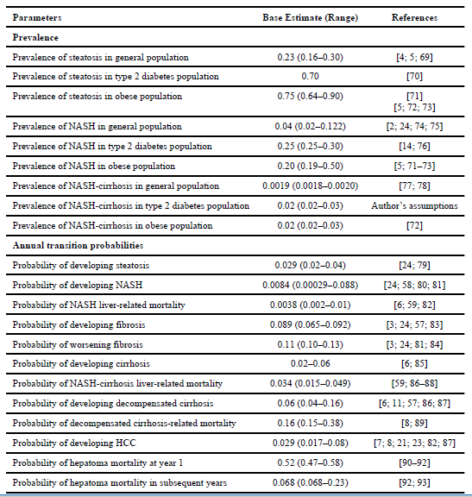

## [Mahady SE, Wong G, Craig JC, George J. Pioglitazone and vitamin E for nonalcoholic steatohepatitis: A cost utility analysis. Hepatology. 2012;56:2172-2179](PE%20Modeling/Mahady%20et%20al%20Pioglitazone%20and%20Vitamin%20E%20for%20Nonalcoholic%20Steatohepatitis.pdf).

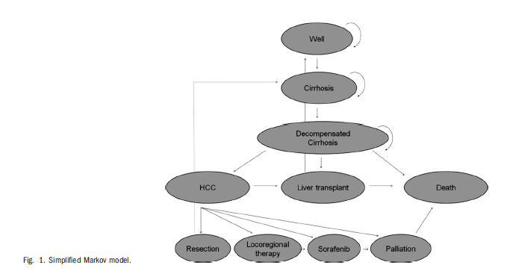

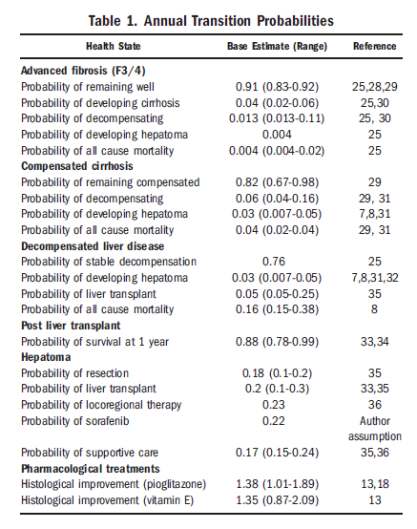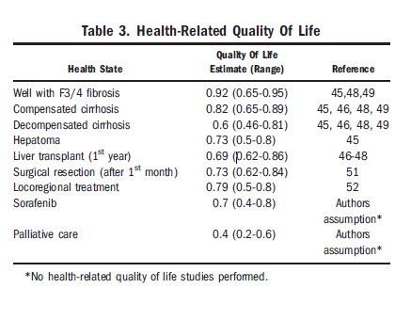

## [Bennett WG, Inoue Y, Beck JR, Wong JB, Pauker SG, Davis GL. Estimates of the cost-effectiveness of a single course of interferon-alpha 2b in patients with histologically mild chronic hepatitis C. Annals of internal medicine. 1997;127:855.](PE%20Modeling/Bennet%20et%20al%20Estimates%20of%20the%20cost-effectiveness%20of%20a%20single%20course%20of%20interferon-alpha%202b%20in%20patients%20with%20histologically%20mild%20chronic%20hepatitis%20C..pdf)

* Meta-analysis of five prospective trials and cost-effectiveness analysis. Projection of the clinical and economic outcomes expected from loss of hepatitis C virus was done by using a Markov simulation.
* Cost Methodology
  + Because charges often vary among providers and can be artificially inflated because of payer mix and institutional costs, the use of charges tends to bias an economic analysis in favor of treatment by increasing the cost of disease. Thus, we used costs or adjusted charges, not full charges, to make the model more widely applicable and to remove a potential bias in favor of interferon-a2b treatment.
  + Because variable cost data were not available for outpatient medical care, charges for outpatient physician visits, outpatient laboratory evaluations, and radiography were summed and adjusted by a 50% cost-to-charge ratio to estimate completeoutpatient costs
  + discounting assumes that money saved or spent and years saved or lost in the future are not worth as much as they are today. This process reduces future costs and future life-years by a fixed percentage each year (7) so that up-front costs, such as the cost of interferon-a2b treatment, weigh more than the projected future costs of potential late complications from the disease.
  + Because discounting, particularly of survival benefits, is somewhat controversial, we also calculated costs and life expectancy without discounting (Table 4)

## [McLernon DJ, Dillon J, Donnan PT. Health-state utilities in liver disease: a systematic review. Medical decision making : an international journal of the Society for Medical Decision Making. 2008;28:582.](PE%20Modeling/McLernon%20et%20al%20Health-state%20utilities%20in%20liver%20disease%20a%20systematic%20review.PDF)

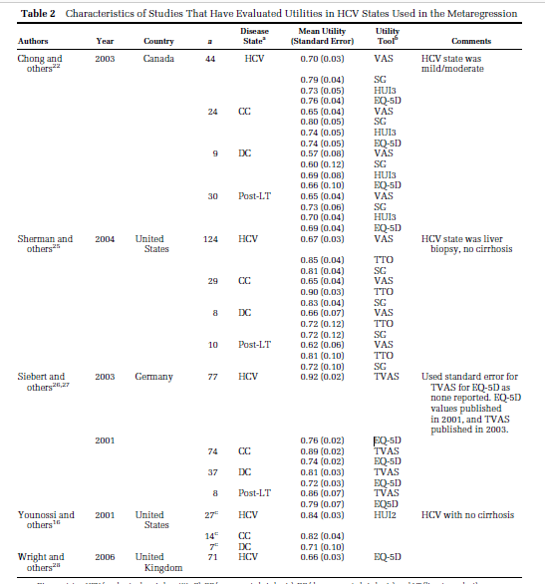

## Keating CL, Dixon JB, Moodie ML, et al. Cost-Effectiveness of Surgically Induced Weight Loss for the Management of Type 2 Diabetes: Modeled Lifetime Analysis. Diabetes Care. 2009;32:567-574..

* Abstract: To estimate the cost-effectiveness of surgically induced weight loss relative to conventional therapy for the management of recently diagnosed type 2 diabetes in class I/II obese patients. This study builds on a within-trial cost-efficacy analysis. **The analysis compares the lifetime costs and quality-adjusted life-years (QALYs) between the two intervention groups**. Intervention costs were extrapolated based on observed resource utilization during the trial. The proportion of patients in each intervention group with **remission of diabetes at 2 years was the same as that observed in the trial**. Health care costs for patients with type 2 diabetes and outcome variables required to derive estimates of QALYs were sourced from published literature. A health care system perspective was adopted. Costs and outcomes were discounted annually at 3%. Costs are presented in 2006 Australian dollars (AUD) (currency exchange: 1 AUD = 0.74 USD). The mean number of years in diabetes remission over a lifetime was 11.4 for surgical therapy patients and 2.1 for conventional therapy patients. Over the remainder of their lifetime, surgical and conventional therapy patients lived 15.7 and 14.5 discounted QALYs, respectively. The mean discounted lifetime costs were 98,900 AUD per surgical therapy patient and 101,400 AUD per conventional therapy patient. Relative to conventional therapy, surgically induced weight loss was associated with a mean health care saving of 2,400 AUD and 1.2 additional QALYs per patient. **Surgically induced weight loss is a dominant intervention (it both saves health care costs and generates health benefits) for managing recently diagnosed type 2 diabetes in class I/II obese patients in Australia.**
* An incremental cost-effectiveness analysis was undertaken, where the net costs and effectiveness of surgical therapy compared with conventional therapy were calculated and expressed as an incremental cost-effectiveness ratio (ICER). Costs include the lifetime cost of the interventions and the health care costs to treat type 2 diabetes. Effectiveness results are expressed as the number of quality-adjusted life-years (QALYs) gained. Analysis was undertaken from a health care system perspective. The use of health care resources by government, private insurers, and patients is included in the cost analysis. Outcomes are primarily acquired by patients (rather than government and private insurers); therefore, QALYs are used as the unit of measure on the benefits side of the analysis. Discounted (3% per annum) costs and QALYs were estimated. Costs are reported in 2006 Australian dollars (AUD). Costs sourced from alternative years are presented in 2006 values by applying the relevant price deflators (8). The midyear 2006 currency exchange rate, according to the XE currency Web site (9) was 1 AUD to 0.74 USD.
* A Markov model that is representative of the natural history of type 2 diabetes for patients managed by either surgical therapy or conventional was constructed using TreeAge Pro Suite 2008 with links to Excel

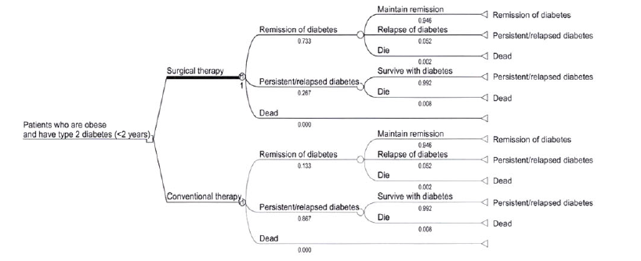

* **Trial intervention effect.** The trial intervention effect (type 2 diabetes status at end of trial) was applied as the relative risk of remission for surgical relative to conventional therapy patients. Uncertainty around the intervention effect was captured by assuming a normal probability distribution around the log of the relative risk reported for the RCT (6). **Univariate probabilistic uncertainty analysis was undertaken to examine the effect of uncertainty around the relative risk using a Monte Carlo simulation. Simulation for 1,000 cohorts, each involving 20,000 iterations, was used to estimate the 95% uncertainty interval (UI) around the mean ICER and probabilities of acceptable cost-effectiveness. All patients were assumed to have a mean duration of type 2 diabetes of 3 years at the end of the trial. Therefore, benefits associated with diabetes remission accumulated after the trial period only.**
* **Intervention costs.** Surgical therapy maintenance costs were applied each year that surgical patients remained alive. The frequency of outpatient medical consultations and investigations was estimated by surgical experts at the Centre for Obesity Research and Education, Monash University, who have maintained a database of 4,500 LAGB patients over 14 years.
  + Surgical therapy complication costs were applied each year that surgical patients remained alive. Lifetime complication rates were estimated based on published data (10) and consultation with the authors to extrapolate results over the lifetime. The cumulative probability of a complication was estimated to be 17% every 10 years. To derive annual costs, it was assumed that complication rates were independent and constant over time. Resource use for surgical procedures to mitigate complications was estimated by trial surgeons based on the LAGB surgery for trial patients (7) (with adaptations to operating time, length of admission, and prosthesis requirements [details available on request])
* **Transition probabilities.** Annual probabilities for relapse of type 2 diabetes were applied to patients in the diabetes remission health state. The Swedish Obese Study (SOS) and the Greenville Series report that, for patients achieving diabetes remission after surgically induced weight loss, the mean duration of remission is 10 years and substantially greater than 16 years, respectively (3,5). An estimate at the lower end of this range (13 years) is adopted for the primary analysis and was converted to a constant annual probability for relapse**.**
  + Annual mortality probabilities were applied each year that patients were alive and were assigned based on type 2 diabetes status and age. Because of an absence of evidence regarding mortality risks for patients in remission from type 2 diabetes, this risk was assumed to be the same as that for patients without diabetes. Age-specific annual mortality probabilities for patients with and without diabetes were sourced from a 2008 study by Magliano et al. (16), which combined data from a national Australian cohort study (AusDiab) with national Australian mortality data. All model inputs and sources are summarized in Tables 1 and 2.
* **Uncertainty analysis**. The impact of model variable uncertainty on the ICER was tested. **Values tested reflected worst-case scenarios (i.e., decreasing cost-effectiveness of surgical therapy) and are described in Tables 1 and 2**. The impact of combinations of variables likely to be related were tested, including 1) combining all intervention costs in worst-case scenarios and 2) combining intervention effect and duration of diabetes remission in worst-case scenarios. Uncertainty in modeling assumptions was also tested, including 1) adding an additional LAGB surgical event to the lifetime intervention cost for each surgical patient (i.e., reflecting a routine LAGB replacement), 2) applying fixed health care treatment costs and utilities associated with type 2 diabetes (i.e., excluding the effects of disease duration and age), 3) applying type 2 diabetes mortality probabilities to all patients (i.e., assuming that the mortality probability of the population free of diabetes is not transferable to patients in type 2 diabetes remission), and 4) **introducing a 0.03% probability of postoperative mortality for LAGB patients (i.e., superseding the actual zero mortality found in a trial with a probability reported by a systematic review [17]).** **Threshold analysis was undertaken to identify the minimum duration of diabetes remission required to deem surgical therapy cost-effective, assuming a willingness to pay threshold of 50,000 AUD per QALY (18).**

## [Ademi Z, Kim H, Zomer E, Reid CM, Hollingsworth B, Liew D. Overview of pharmacoeconomic modelling methods: Pharmacoeconomic methods. British Journal of Clinical Pharmacology. 2013;75:944-950](PE%20Modeling/Ademi%20et%20al%20Overview%20of%20pharmacoeconomic%20modelling%20methods.pdf)

* **Decision Analysis**
  + 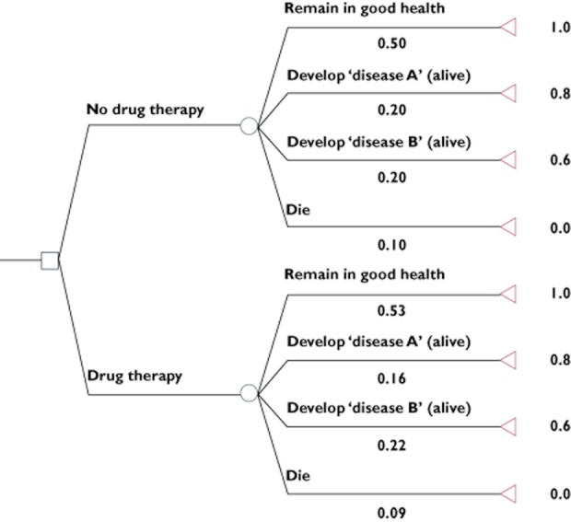
  + The square is the decision node, the point where alternative treatment options are defined. In this example, two choices are defined: ‘No drug therapy’ and ‘Drug therapy’. The circles represent chance nodes, from which emanate the possible consequences of each choice. These are called transition states.
  + In the example (Figure 1), as is often the case in pharmacoeconomic analyses, payoffs are expressed as utilities. Utilities provide a measure of health value and applies penalties to time spent in less-than-perfect health [8]. Utilities are useful because they provide a summary measure of health, and allow for comparison of disparate conditions.
  + To analyze (evaluate) a decision analysis tree, the expected value of each branch is calculated by multiplying the payoff associated with each transition by the probability of it occurring, and summing these. That is, the expected value of each main branch (‘No drug therapy’ and ‘Drug therapy’) is: Σ (payoff × transition probability).
  + The net cost per unit of benefit gained from intervention is the incremental cost-effectiveness ratio (ICER), which is the main outcome of interest in cost-effectiveness, including pharmacoeconomic, analyses.
  + Basic decision analysis considers only one sequence of events within one time-frame. This is a limitation if the conditions being simulated have different sequential stages, and/or data inputs (such as transition probabilities or costs) evolve with time. To overcome this inherent limitation of basic decision analysis, Markov modelling [10, 13] is often employed.
* **Markov Modelling**
  + 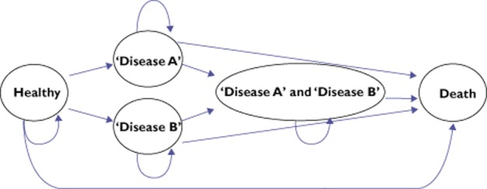
  + To capture all possible events, multiple health states need to be modelled, each with its own set of possible transitions. The exception is death, from which no transitions can be made. Death is considered an **absorbing state.**
  + A **Markov chain** describes a sequence of events in which the likelihood of an event occurring is dependent on the preceding event. A Markov chain has no length limit, but will end in an event that is absorbing. A Markov model often comprises more than one Markov chain
  + The key features of a Markov model are:
    - that individuals reside in one of a finite set of **mutually exclusive health states.**
    - that time is represented by discrete periods called cycles, and individuals move between health states, or remain in their current health states, at the end of each cycle.
    - that movements are governed by transition probabilities that are specific to each health state and each cycle.
  + The main limitation of Markov models is that with any cycle, the possible transitions which individuals can make depend **only on the state they are in, and not on how they arrived at that state.**
  + **This characteristic is often known as the Markov assumption. This problem with the Markov assumption is especially highlighted in two settings. First, when more than one disease is being considered, because many diseases are inter-dependent and the probability of one is often affected by the prior occurrence of another. Secondly, when model inputs (such as transition probabilities, utilities and costs) evolve over time. For example, as the age of model subjects increases with repeated cycles, their risks of diseases will increase.**
  + **The first problem is overcome by including as many health states as is required to capture important disease combinations. However, inclusion of too many health states into a Markov model can render it unwieldy. Paradoxically, a complex Markov model that attempts to reflect more accurately multiple related conditions may be subject to more uncertainty because of the need for more data inputs and assumptions to be made about them.**
  + **The second problem of evolving data inputs is overcome by including cycle specific inputs. For some inputs, cycle specificity is easily estimated, such as age-related changes to risks of disease, but for others it poses a challenge due to a lack of data, such as age specificity of disease costs and utilities.**
* **Discounting**
  + **In pharmacoeconomic modelling, all measures of health and costs are referenced to the baseline time, and future measures of life/health and costs are discounted [14] by convention**
    - **14. Severens JL, Milne RJ. Discounting health outcomes in economic evaluation: the ongoing debate. Value Health. 2004;7:397–401**
  + **Discount rates vary, but are generally between 3% and 5% annually [14, 15].**
  + In pharmacoeconomic modelling, a common formula used for discounting is:
    - 
  + where N(disc) is the discounted measure of life/health or cost, N(undisc) is the undiscounted (actual) measure, d is the discount rate and t is the time elapsed since the reference (baseline) time.
* **Uncertainty analysis** 
  + **Because pharmacoeconomic modelling is based on conjecture, it is important that uncertainty be expressed in the modelling outputs. Indeed, the expression of uncertainty is a fundamental part of any clinical and applied research, as epitomized by the 95% confidence interval that surrounds most estimates**
    - Models are vulnerable to uncertainty because they rely on multiple data inputs, and as the number of inputs and modelling steps increase, so too will uncertainty in outputs. In addition, assumptions have to be made in many instances, which serve to increase uncertainty even further.
  + **Monte Carlo simulation [16] refers to a method of undertaking multiple simulations of a model, each time taking samples from specified uncertainty ranges of the model's inputs (as opposed to point estimates). These uncertainty ranges are most often expressed as probability distributions. Probability distributions describe the range of possible values for a parameter as well as the probability of each value occurring. Common types of probability distributions include ‘gamma’, ‘uniform’, ‘normal’ and ‘triangular’. Probability distributions that relate to data inputs for a model are often called input distributions.**
  + 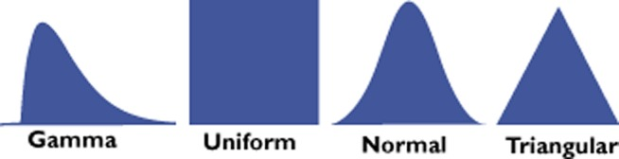
  + **As Monte Carlo simulation involves multiple simulations, it therefore generates multiple outputs, from which probability distributions can also be derived. These are often called output distributions. With only a small number of iterations in a Monte Carlo simulation, the output distribution is not well defined. However, as more iterations are run, the output distribution becomes more definable and is said to become stable. This phenomenon is known as convergence [17]. A sufficient number of iterations must be undertaken in Monte Carlo simulation such that convergence of an output distribution occurs.**
  + **Monte Carlo simulation modelling is also known as stochastic modelling. This defines a type of modelling in which there is a range of possible outputs that is dependent on the probabilistic nature of inputs. In contrast, models whose outputs are fixed because their inputs do not vary are known as deterministic models.**
* **Software**
  + **TreeAge (TreeAge Software Inc, Williamstown, MA, USA) is a commonly-used software package designed specifically for decision analyses. It is a powerful program that also allows for construction of complex Markov models and incorporates uncertainty analyses via Monte Carlo simulation.**
  + **Microsoft Excel (Microsoft Corporation, Redmond, WA, USA) is also widely used to undertake pharmacoeconomic analyses. Being entirely flexible, it can be programmed to simulate decision analysis and Markov modelling.**
  + **Monte Carlo simulation is not possible in Excel itself, but this feature can be added with installation of the macro @RISK (Palisade Corporation, Ithaca, NY, USA).**
* **Suggested approach**
  + Outcomes are usually net costs, net health benefits expressed as life years gained or QALYs gained and ICERs (the ratio of net costs to net health benefits). Costs will depend on the perspective adopted for the pharmacoeconomic evaluation, which should be clearly defined. The two common perspectives are the health system perspective, which captures only costs met by healthcare financiers, and the societal perspective, which captures all costs, including those outside of the healthcare system (such as occurs with loss of productivity). Life years and QALYs gained are extrapolated from the reduction in the risk of the target disease and/or death, and all assumptions made about the translation of treatment benefit to health gain need to be carefully considered.
  + The time frame considered in a pharmacoeconomic model is called the time horizon. Expression of the time horizon in any economic evaluation is important because ICERs vary with time. They generally decrease (that is, the intervention becomes more cost-effective) as the time horizon increases. **Another key consideration related to the time horizon is the assumption made regarding the benefits of the drug compared with the comparator over time. This is especially important in instances where the modelled time horizon exceeds the time frame of the clinical trial(s) from which efficacy measures are derived.**

## [Sonnenberg FA, Beck JR. Markov models in medical decision making: a practical guide. Medical decision making : an international journal of the Society for Medical Decision Making. 1993;13:322.](PE%20Modeling/Sonnenberg%20Markov%20Models%20in%20Medical%20Decision%20Making%20A%20Practical%20Guide.pdf)

* Markov models are useful when a decision problem involves risk that is continuous over time, when the timing of events is important, and when important events may happen more than once. Representing such clinical settings with conventional decision trees is difficult and may require unrealistic simplifying assumptions. Markov models assume that a patient is always in one of a finite number of discrete health states, called Markov states. All events are represented as transitions from one state to another. **A Markov model may be evaluated by matrix algebra, as a cohort simulation, or as a Monte Carlo simulation**. A newer representation of Markov models, the Markov-cycle tree, uses a tree representation of clinical events and may be evaluated either as a cohort simulation or as a Monte Carlo simulation. The ability of the Markov model to represent repetitive events and the time dependence of both probabilities and utilities allows for more accurate representation of clinical settings that involve these issues
* The Markov model provides a far more convenient way of modelling prognosis for clinical problems with ongoing risk. The model assumes that the patient is always in one of a finite number of states of health referred to as Markov states. All events of interest are modelled as transitions from one state to another. Each state is assigned a utility, and the contribution of this utility to the overall prognosis depends on the length of time spent in the state.
* **The time horizon of the analysis is divided into equal increments of time, referred to as Markov cycles.**
* **A special type of Markov process in which the transition probabilities are constant over time is called a Markov chain. If it has an absorbing state, its behavior over time can be determined as an exact solution by simple matrix algebra, as discussed below. The DEALE can be used to derive the constant mortality rates needed to implement a Markov chain. However, the availability of specialized software to evaluate Markov processes and the greater accuracy afforded by age specific mortality rates have resulted in greater reliance on Markov processes with time-variant probabilities.**
* **The Markov cohort simulation is the most intuitive representation of a Markov process. The difference between a cohort simulation and the matrix formulation may be thought of as analogous to the difference between determining the area under a curve by dividing it into blocks and summing their areas versus calculating the area by solving the integral of the function describing the curve**
* **As an alternative to simulating the prognosis of a hypothetical cohort of patients, the Monte Carlo simulation determines the prognoses of a large number of individual patients. This is illustrated in figure 13. Each patient begins in the starting state (i.e., the WELL state), and at the end of each cycle, a random-number generator is used together with the transition probabilities to determine in which state the patient will begin the next cycle. Just as for the cohort simulation, the patient is given credit for each cycle spent in a non-dead state and each state may be adjusted for quality of life**
* Each representation has specific advantages and disadvantages for particular purposes. The simulations (Markov cohort, Monte Carlo, and cycle tree) permit the analyst to specify transition probabilities and incremental utilities that vary with time. Such variation is necessary to model certain clinical realities, such as the increase in baseline mortality rate with age. A disadvantage common to all simulations (cohort, cycle tree, and Monte Carlo) is the necessity for repetitive and time-consuming calculations. However, the availability of specialized microcomputer software to perform these simulations has made this much less of an issue. The fundamental matrix solution is very fast because it involves only matrix algebra and provides an &dquo;exact&dquo; solution that is not sensitive to cycle time (as in the cohort simulation) or number of trials (as in the Monte Carlo simulation).

# Synthesis and Calculations

## TREATMENT OUTCOMES

\***Improvement in fibrosis is defined as a > or = 1 stage improvement in fibrosis score**

**TZDs, Vitamin E, metformin, elafibranor, selonsenib have NOT been shown to modify fibrosis, will be modeled after transition state probabilities are determined for possible modification of secondary outcomes of interest – weight loss, A1C, cholesterol, blood pressure**

|  |  |  |  |  |  |  |  |  |
| --- | --- | --- | --- | --- | --- | --- | --- | --- |
| **Study Name** | **Agent** | **Improvement in Fibrosis\*** | **Weight loss** | **A1C** | **Cholesterol & Triglycerides** | **Blood Pressure** | **Adverse Events** | **Follow up time (actual or mean)** |
| Zein CO, Yerian LM, Gogate P et al. Pentoxifylline improves  nonalcoholic steatohepatitis: a randomized placebocontrolled  trial. Hepatology 2011; 54: 1610–9.. | **Pentoxifylline** | Percent of patients with improvement approached significance (35% v 15.4%, p=0.17) | * No change observed in either study | * Not reported | * Not reported | * Not reported | * No statistically significant differences observed in either study | * Zein et al., **56 weeks**, n=55 patients |
| Neuschwander-Tetri BA, Loomba R, Sanyal AJ, Lavine JE, Van Natta ML, Abdelmalek MF, et al. Farnesoid X nuclear receptor ligand obeticholic acid for non-cirrhotic, non-alcoholic steatohepatitis **(FLINT):** a multicentre, randomised, placebo-controlled trial. Lancet. 2015;385(9972):956-65. | **Obeticholic acid** | **RR, 2.0 (1.2-3.4, p=0.004)** | * Weight was significantly reduced in OCA group vs placebo, mean difference -2.2 kg (CI -3.7 to -0.6, P=0.008) * BMI was also significantly reduced in OCA v placebo, mean difference was -0.7 (CI -1.3 to -0.2, P=0.01) | * No change observed | * Significant increases in total cholesterol (+0.38 mmol/L, CI 0.16-0.6, P=0.0009) * Significant decreases in HDL (-0.06, CI -0.10 to -0.01, P=0.01), * Significant increases in LDL (+0.45, CI 0.26-0.65, P<0.0001) vs placebo * No significant effect on triglycerides | * SBP was significantly improved in the OCA group v placebo, mean difference -3 mmHg (CI -7 to 0, P = 0.05) * No significant effect on DBP | * LDL, HDL, and total cholesterol increases | 72 weeks, n=141 |
| Friedman SL, Ratziu V, Harrison SA, et al. A randomized, placebo‐controlled trial of cenicriviroc for treatment of nonalcoholic steatohepatitis with fibrosis. Hepatology. 2018;67:1754-1767 | **Cenicriviroc** | **OR 2.20** [95% CI 1.11-4.35]  Significantly greater rate of fibrosis improvement by ≥ 1 stage (20% v **10%,** p = 0.02) | * No change observed | * No change observed | * No change observed | * No change observed | * No statistically significant differences observed | 52 weeks, n=289 |
| Glass LM, Dickson RC, Anderson JC, et al. Total Body Weight Loss of ≥10 % Is Associated with Improved Hepatic Fibrosis in Patients with Nonalcoholic Steatohepatitis. Digestive Diseases and Sciences. 2015;60:1024-1030 | **Weight loss of ≥10% TBW** | **OR 17.14** (95% CI 3.05-96.28) - univariate  Adjusted OR 8.14 (95% CI 1.08-61.17) - multivariate  Significantly greater rate of fibrosis improvement by ≥ 1 stage (63.2% v **9.1%,** p=0.001)  **Odds ratio < 10%**  **Assume Odds ratio = RR** | * Weight loss ≥10 % following the first liver biopsy was achieved by 16 patients (34.7 %) in the whole cohort | * Not reported, needs to be sourced from another placebo-controlled study | * Not reported, needs to be sourced from another placebo-controlled study | * Not reported, needs to be sourced from another placebo-controlled study | None expected from weight loss alone | **Mean 4.5 years**, n=45, only 12 patients underwent bariatric surgery |
| Glass LM, Dickson RC, Anderson JC, et al. Total Body Weight Loss of ≥10 % Is Associated with Improved Hepatic Fibrosis in Patients with Nonalcoholic Steatohepatitis. Digestive Diseases and Sciences. 2015;60:1024-1030 | **Bariatric surgery** | **OR 18.90 (2.10-170.39) – univariate**  **Adjusted OR 4.10 (0.32-52.12)**  **Significantly greater rate of fibrosis improvement by 1 stage (75% v 9.1%)** | * No average weight loss reported * Bariatric surgery patients were more successful at losing > or = 10% TBW (83% v 19%) | * Not reported, needs to be sourced from another placebo-controlled study | * Not reported, needs to be sourced from another placebo-controlled study | * Not reported, needs to be sourced from another placebo-controlled study | * Not reported, needs to be sourced from another placebo-controlled study | **Mean 4.5 years**, n=45, only 12 patients underwent bariatric surgery |

## CONVERSION TO RELATIVE RISKS

**Pentoxifylline**

* Relative Risk = probability in exposed / probability in unexposed
* Convert probabilities to annual probabilities
  + *In this case, 56 weeks is approximately 1 year and 1 month, probabilities will not be converted*
* Relative risk = 0.35 / 0.154 = **2.2727 RR of a 1 stage improvement in fibrosis with 1 year of PTX**

**Obeticholic Acid**

* **RR, 2.0 (1.2-3.4, p=0.004) at** 72 week mark
* Duration of study is 72 weeks 🡪
  + *Do RR need to be adjusted for time?*
  + *Per Wikipedia: because the record of the odds ratio is estimated as a linear function of the explanatory variables, the estimated odds ratio for 70-year-olds and 60-year-olds associated with the type of treatment would be the same in logistic regression models where the outcome is associated with drug and age, although the relative risk might be significantly different. In cases like this, statistical models of the odds ratio often reflect the underlying mechanisms more efficiently.*
* probability 🡪 rate 🡪 probability 🡪 RR
* Probability in exposed =
  + 22% per Neuschwander-Tetri results
  + Rate = [-ln(1-0.22)] / 1.3808 years = 0.179940
  + Probability (1 year) = 1 – e^(-0.179940) = 0.16467
* Probability in unexposed =
  + **13%** per Neuschwander-Tetri results
  + Rate = [-ln(1-0.13)] / 1.3803 years = 0.100892
* Relative risk = probability in exposed / probability in unexposed
  + 0.16467 / 0.100892 = **1.6322 RR of 1 stage improvement in fibrosis with 1 year of OCA**
  + **LOW - Is this an underestimate? Assumes effects are rate constant instead of tapering off like they tend to**
  + **Can I just use original RR 2.0?**

**Cenicriviroc**

* **OR 2.20 [95% CI 1.11-4.35]**
* Significantly greater rate of fibrosis improvement by ≥ 1 stage (20% v **10%,** p = 0.02)
  + Probability in unexposed ≤ 10%
  + Assume Odds ratio = RR
* Duration is already 1 year
* Keep OR = 2.2 and assume **RR ~ 2.2 for 1 stage in improvement in fibrosis with 1 year of CVC**

**Weight loss**

* Unadjusted OR 17.14 (95% CI 3.05-96.28)
* Adjusted OR 8.14 (95% CI 1.08-61.17) – adjusted in multivariate analysis for confounders
  + **Do these need to be adjusted for time?**
* RR 🡪 probability 🡪 rate 🡪 probability 🡪 RR
* Probability in exposed
  + 63.2% per Glass result
  + Rate = [-ln(1-0.632) / 4.5 years = 0.22214
  + Probability (1 year) = 1 – e ^ (-0.22214) = 0.199204
* Probability in unexposed
  + 9.1% per Glass results
  + Rate = [-ln(1-0.091) / 4.5 years = 0.0212022
  + Probability (1 year) = 1 – e ^ (-0.0212022) = 0.0209 **(LOW)**
    - Should be about 10%?
    - Again distribution matter – about 10% regressed overall over 1 year AND overall over 3 years (can’t be scaled down)
    - **Can I just assume 10% regressed in first year spontaneously given what we know this?**
* RR
  + =probability in exposed / probability in unexposed
  + 0.199204 / 0.091 = **2.18 RR for 1 stage improvement in fibrosis 1 year with weight loss**
    - **Using original unexposed probability (which approximates literature reported annual regression rate) yielded LOW RR**
    - **Assumes rate is constantly increasing up to follow up time of 5 years when its actually probably tapering off**
  + 0.199204 / 0.0209 **= 9.53 RR for 1 stage improvement in fibrosis 1 year with weight loss**
    - **Using back extrapolated probability in unexposed yieled better final RR despite the 1 year regression probability not matching up with the majority of actual data (~10-11% annual fibrosis regression by ≥1 stage probability**
    - **Fundamental problem is to assume rate is constant and extrapolate like this is to create more confusion**
* **Raw relative risk = probability in exposed/ probability in unexposed = 0.632 / 0.091 = 6.94505 at 5.4 years**
  + **Also better than the 2.18 number**
  + **Most realistic number thus far**

**Bariatric Surgery**

* **Raw relative risk = probability in exposed/probability in unexposed = 0.75 / 0.091 =** **8.2417** at 5.4 years

**Fundamental Issue**

* **Cannot assume the rate of these effects are constant**
* **🡪 throws off the RR estimate to manipulate it too much**
* **Just using raw RR without adjusting for time seem to yield better estimates**
* **Possible is we created an actual rate distribution we could better model RR**

## [PROBABILITES, RATES, RISK RATIOS, ODDS, AND ODDS RATIOS](PE%20Modeling/Health%20Services%20Research%20and%20Development%20VA.GOV%20Deriving%20Transition%20Probabilities%20for%20Decision%20Models.pdf)

[**https://www.hsrd.research.va.gov/for_researchers/cyber_seminars/archives/819-notes.pdf**](https://www.hsrd.research.va.gov/for_researchers/cyber_seminars/archives/819-notes.pdf)

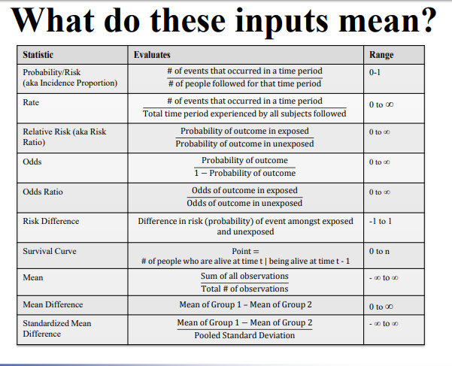

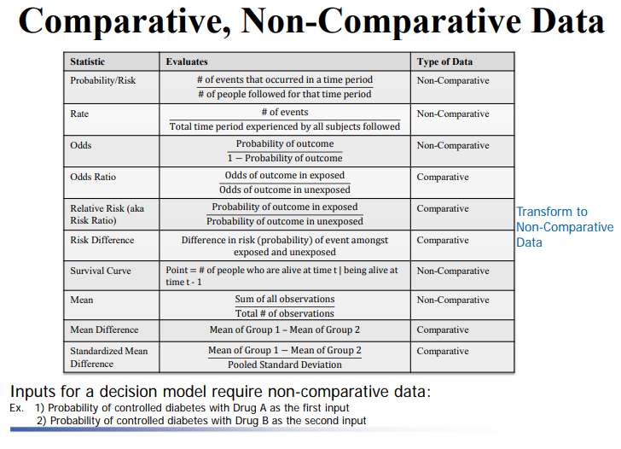

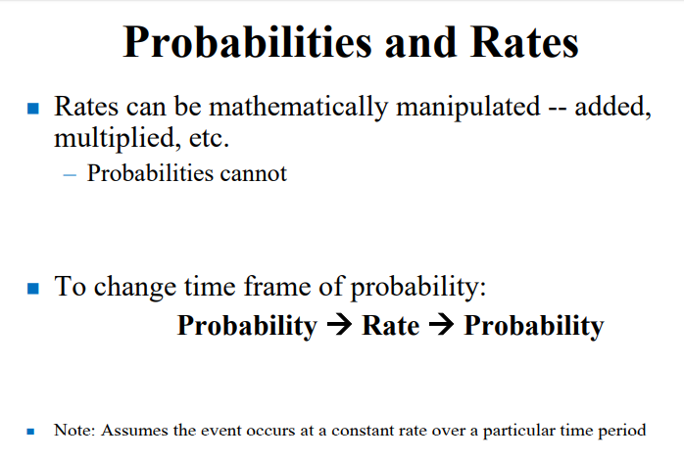

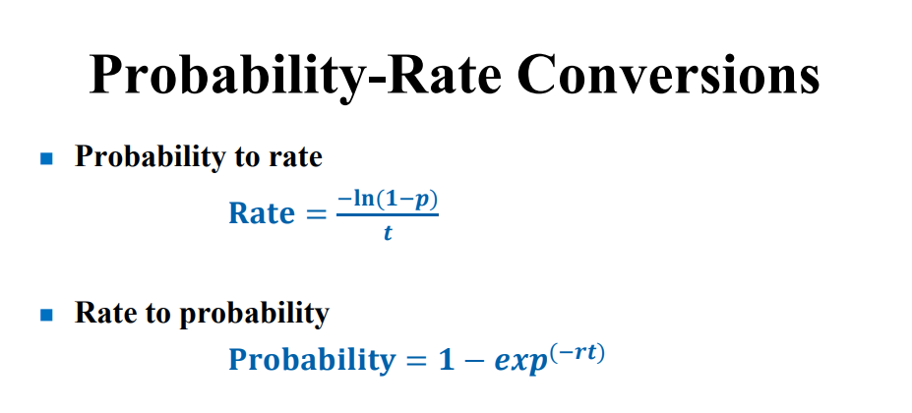

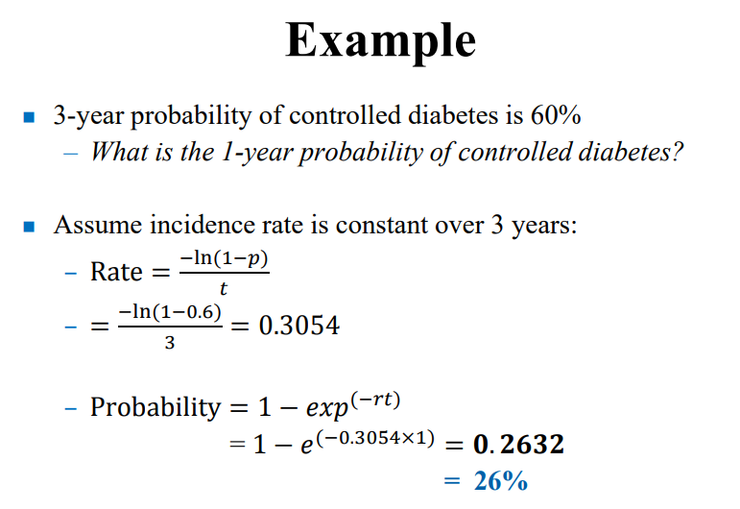

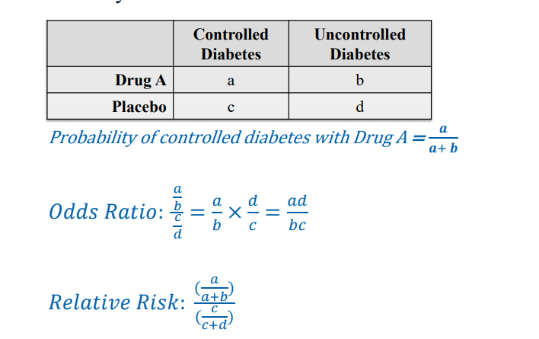

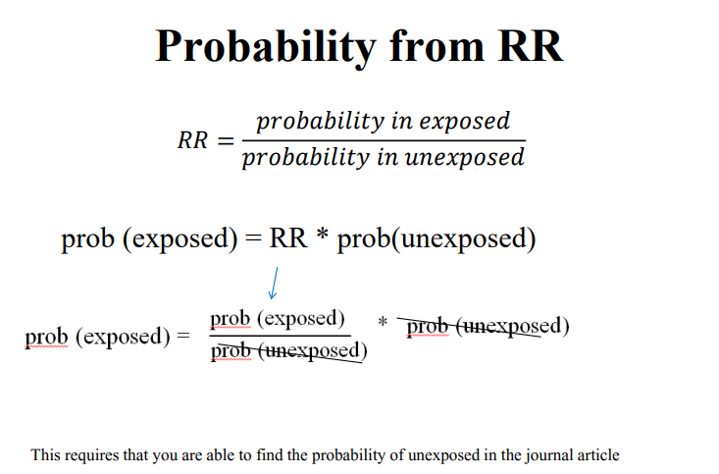

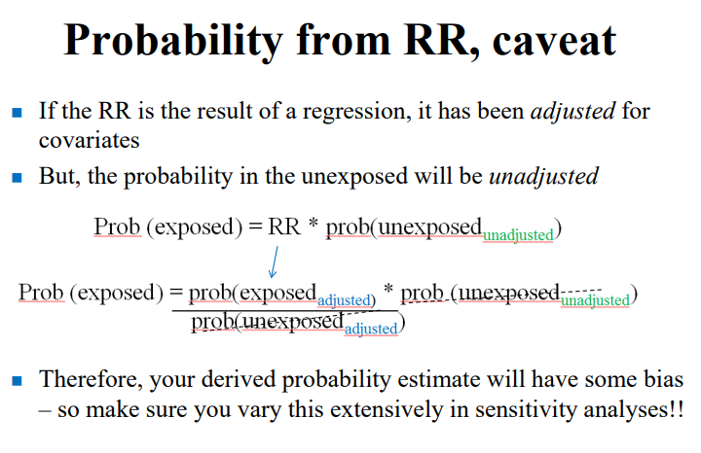

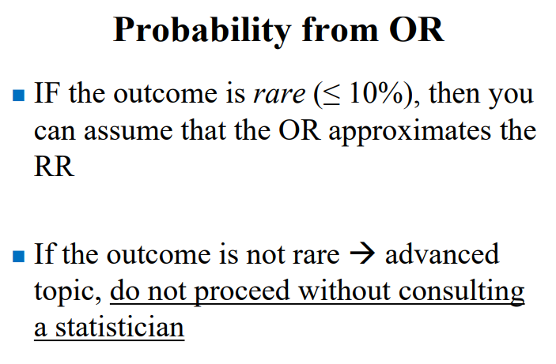

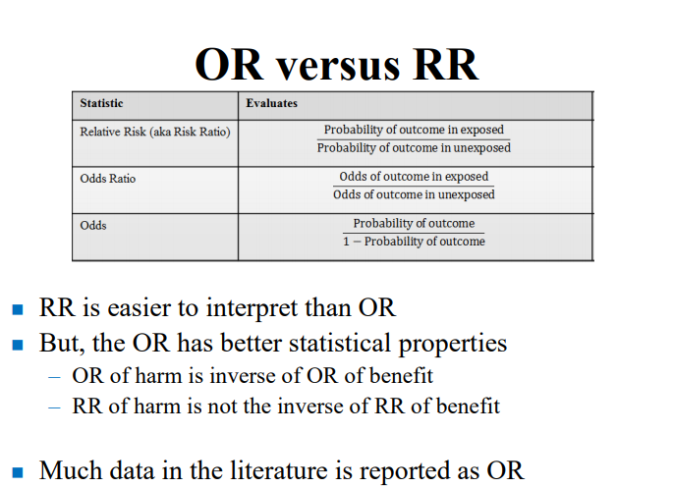

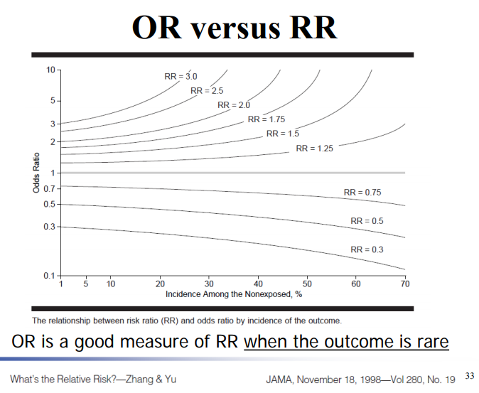

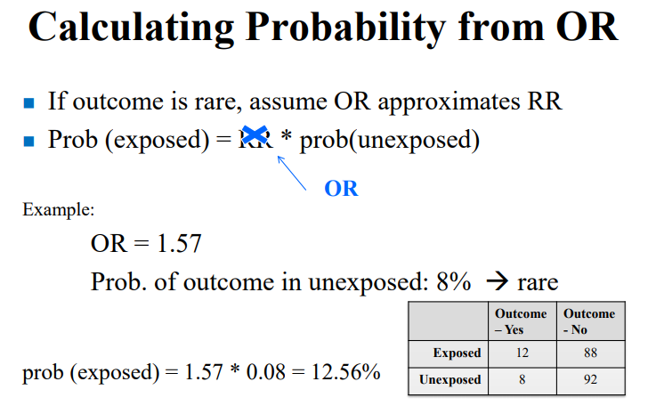

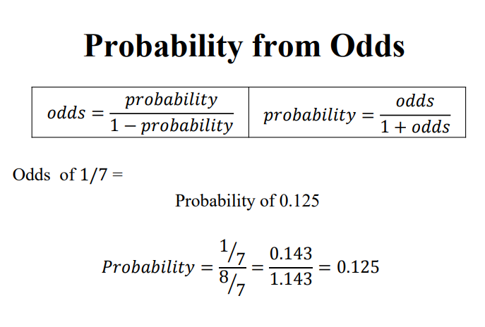

## BASELINE CHARACTERISTICS OF NASH POPULATION





## GENERAL POPULATION DISTRIBUTION AND MORTALITY RATES

Younossi ZM, Henry L, Stepanova M, et al. The Economic and Clinical Burden of Non-Alcoholic Fatty Liver Disease in the United States. Journal of Hepatology. 2015;2016;64:S502-S503.

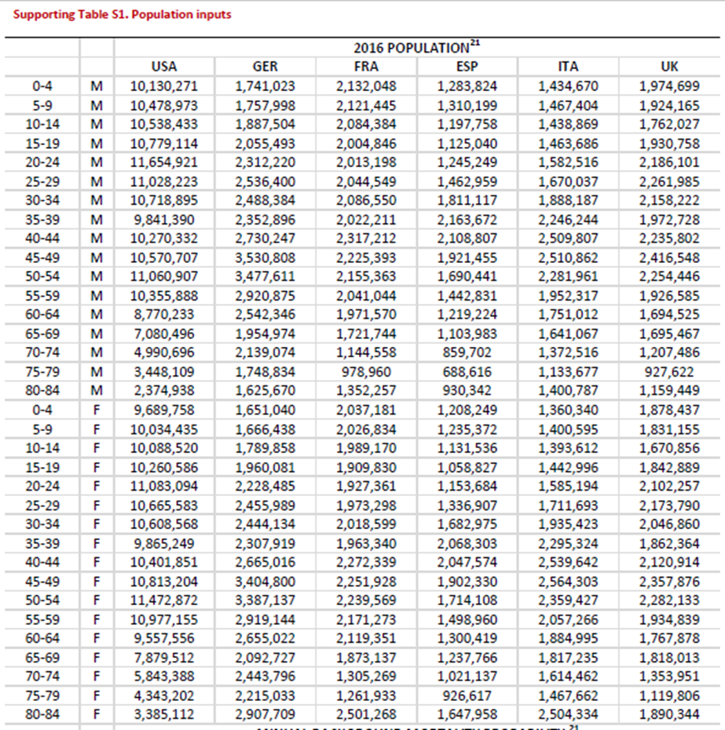





## PREVALENCE OF NAFLD, NASH, AND SPECIFIC FIBROSIS STAGE

**Le MH, Devaki P, Ha NB, et al. Prevalence of non-alcoholic fatty liver disease and risk factors for advanced fibrosis and mortality in the United States. PloS one. 2017;12:e0173499.**

**Estes C, Razavi H, Loomba R, Younossi Z, Sanyal AJ. Modeling the epidemic of nonalcoholic fatty liver disease demonstrates an exponential increase in burden of disease. Hepatology. 2018;67:123-133.**

* There are varied estimates of NAFLD prevalence in the general population. An estimated 17%-51% of adults have NAFLD.(4,15-17) Analysis of liver ultrasound data collected between 1988 and 1994 from the Third National Health and Nutrition Examination Survey (NHANES III) reported that 19% of adults have NAFLD,(18) while a meta-analysis of studies from 2006-2014 estimated a NAFLD prevalence of 24% (20%-29%) in the general population. (10)
* The prevalence of NASH was calculated based on published estimates and modeling of fibrosis progression. It was assumed that up to 5% of NAFLD cases without NASH could be NASH regressors, with most NASH regressors still in F0 stage. Therefore, a relatively small number of cases in stages F1-F4 were assumed to be non-NASH fatty liver. However, the vast majority of modeled fibrotic cases (F1-F4) were assumed to be NASH.
* Reported estimates show that 3%-5% of adults in the United States have NASH.(4,16,19,20) This model assumes that approximately 20% of NAFLD cases would be classified as NASH in 2015, corresponding to 3% of the adult population. Estimates of NASH prevalence and fibrosis progression rates among NAFLD cases are subject to some uncertainty due to the variable populations studied and the largely retrospective methodology used to assess progression.(21) For this analysis, it was estimated that 20%-25% of those with NAFLD currently have NASH and that about 20% of those with NASH have≥F3 fibrosis

**Tapper EB, Sengupta N, Hunink MGM, Afdhal NH, Lai M. Cost-Effective Evaluation of Nonalcoholic Fatty Liver Disease With NAFLD Fibrosis Score and Vibration Controlled Transient Elastography. The American journal of gastroenterology. 2015;110:1298-1304**

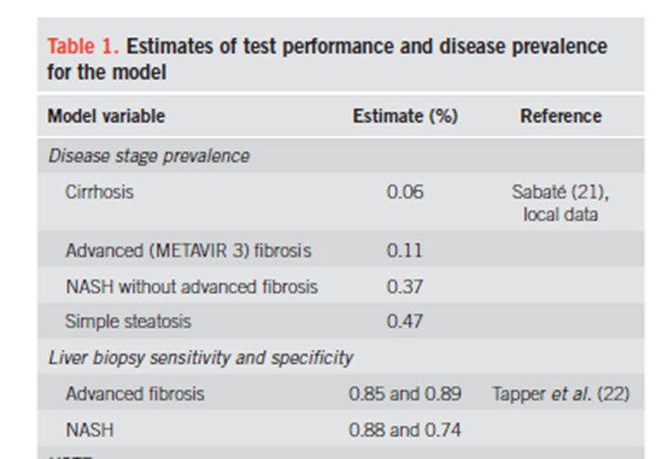

**Zhang E, Wartelle-Bladou C, Lepanto L, Lachaine J, Cloutier G, Tang A. Cost-utility analysis of nonalcoholic steatohepatitis screening. European radiology. 2015;25:3282-3294.**



**Singh S, Allen AM, Wang Z, Prokop LJ, Murad MH, Loomba R. Fibrosis progression in nonalcoholic fatty liver vs nonalcoholic steatohepatitis: a systematic review and meta-analysis of paired biopsy studies. Clin Gastroenterol Hepatol 2015; 13: 643-654.e1-e9; quiz e39-40 [PMID: 24768810 DOI: 10.1016/j.cgh.2014.04.014**

**Baseline distributions in patients with NAFLD**

|  |  |
| --- | --- |
| **Stage** | **Proportion of NAFLD** |
| 0 | 35.8% |
| 1 | 32.5% |
| 2 | 16.7% |
| 3 | 9.3% |
| 4 | 5.7% |

**Estes C, Razavi H, Loomba R, Younossi Z, Sanyal AJ. Modeling the epidemic of nonalcoholic fatty liver disease demonstrates an exponential increase in burden of disease. Hepatology. 2018;67:123-133.**

**Baseline distributions**

|  |  |  |
| --- | --- | --- |
| **Stage** | **Proportion of NAFLD** | **Proportion of NASH** |
| 0 | 84.2% | 21.21% |
| 1 | 7.7% | 38.1% |
| 2 | 4.1% | 20.6% |
| 3 | 2.4% | 12.1% |
| 4 | 1.5% | 7.88% |

**🡪DISTRIBUTION DIFFERS SUBSTANTIALLY FROM RESULTS OF SINGH ET AL**

* **Singh et al study potentially biased by use of clinical data (more likely to be progressed than general population**
* **Estes’ estimates will be used**

## AGE-SPECIFIC PREVALENCES

**Younossi ZM, Henry L, Stepanova M, et al. The Economic and Clinical Burden of Non-Alcoholic Fatty Liver Disease in the United States. Journal of Hepatology. 2015;2016;64:S502-S503**

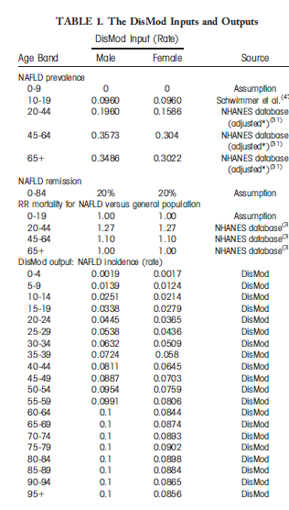

**Reported in Estes et al: based on data from NHANES III, a national cross sectional survey including over 12,000 adults**

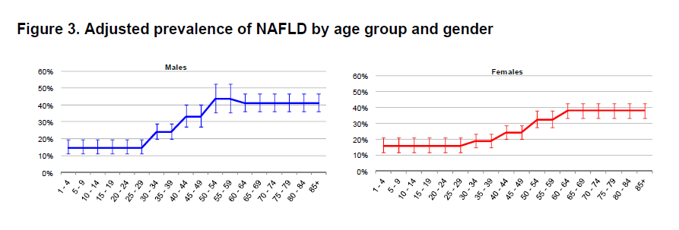

**MORTALITY**

**Estes C, Razavi H, Loomba R, Younossi Z, Sanyal AJ. Modeling the epidemic of nonalcoholic fatty liver disease demonstrates an exponential increase in burden of disease. Hepatology. 2018;67:123-133.**

* A range of estimates has been reported for **excess mortality among NAFLD cases**, with some studies demonstrating little increase and others suggesting significantly elevated cardiovascular mortality.(29-31) **A standard mortality ratio of 1.15 (1.00-1.35)** was applied to background mortality rates for all age groups. Liver-related mortality is more markedly increased in the NAFLD population and was calculated separately as part of disease progression modeling.

**Tapper EB, Sengupta N, Hunink MGM, Afdhal NH, Lai M. Cost-Effective Evaluation of Nonalcoholic Fatty Liver Disease With NAFLD Fibrosis Score and Vibration Controlled Transient Elastography. The American journal of gastroenterology. 2015;110:1298-1304**

* **The annual mortality rate was abstracted from the Center for Disease Control population-based life table and converted to a rate**.13 **Thereafter it was multiplied by the standardized mortality ratio for a patient with NAFLD/NASH - 1.34 (95% CI: 1.003–1.76) - and converted back to an annual probability of mortality for patients with NAFLD and NASH**.14 Survival for patients with advanced fibrosis and compensated cirrhosis treated in a similar fashion, by adjusting CDC data with a mortality hazard ratio derived from a defined cohort of patients with NAFLD and advanced fibrosis or compensated cirrhosis - 3.28 (95% CI 2.27-4.76).15 Mortality rates for decompensated cirrhosis16, 17, hepatocellular carcinoma18 and post-transplantation19, 20 were independent of CDC data and abstracted from the relevant literature as listed in Supplementary Table 1.
  + Adams LA, Lymp JF, St Sauver J, et al. The natural history of nonalcoholic fatty liver disease: a population-based cohort study. Gastroenterology 2005;129:113-121.

## TRANSITION STATE PROBABILITIES COMPARISON

**Estes C, Razavi H, Loomba R, Younossi Z, Sanyal AJ. Modeling the epidemic of nonalcoholic fatty liver disease demonstrates an exponential increase in burden of disease. Hepatology. 2018;67:123-133.**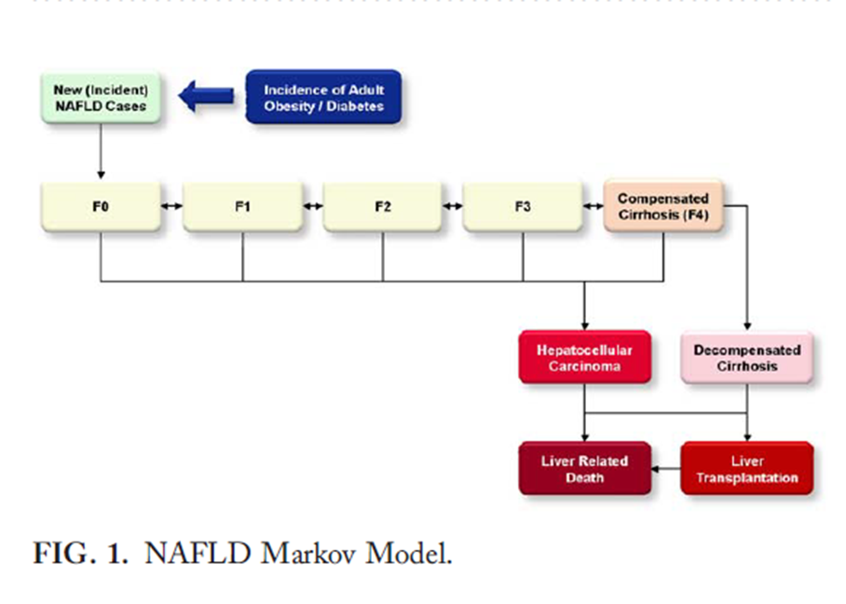

**Younossi ZM, Henry L, Stepanova M, et al. The Economic and Clinical Burden of Non-Alcoholic Fatty Liver Disease in the United States. Journal of Hepatology. 2015;2016;64:S502-S503.**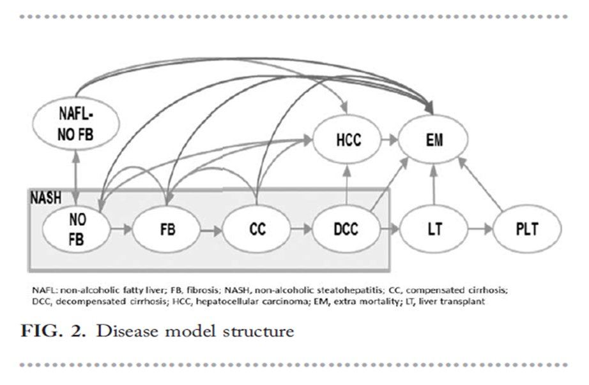

**Tapper EB, Sengupta N, Hunink MGM, Afdhal NH, Lai M. Cost-Effective Evaluation of Nonalcoholic Fatty Liver Disease With NAFLD Fibrosis Score and Vibration Controlled Transient Elastography. The American journal of gastroenterology. 2015;110:1298-1304.– offers advantage of stratifying by Advanced Fibrosis – which is shown to be associated with a specific mortality ratio**



**Zhang E, Wartelle-Bladou C, Lepanto L, Lachaine J, Cloutier G, Tang A. Cost-utility analysis of nonalcoholic steatohepatitis screening. European radiology. 2015;25:3282-3294.**

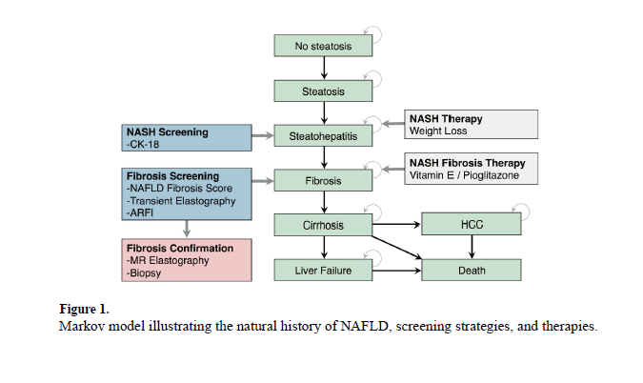

*Patients with fibrosis (F1 – F4) are assumed to have NASH

|  |  |  |  |  |
| --- | --- | --- | --- | --- |
| **Disease Stage Transition** | **Estes C, Razavi H, Loomba R, Younossi Z, Sanyal AJ. Modeling the epidemic of nonalcoholic fatty liver disease demonstrates an exponential increase in burden of disease. Hepatology. 2018;67:123-133.** | **Younossi ZM, Henry L, Stepanova M, et al. The Economic and Clinical Burden of Non-Alcoholic Fatty Liver Disease in the United States. Journal of Hepatology. 2015;2016;64:S502-S503.**  **\*values based on calibrated disease model** | **Tapper EB, Sengupta N, Hunink MGM, Afdhal NH, Lai M. Cost-Effective Evaluation of Nonalcoholic Fatty Liver Disease With NAFLD Fibrosis Score and Vibration Controlled Transient Elastography. The American journal of gastroenterology. 2015;110:1298-1304.** | **Zhang E, Wartelle-Bladou C, Lepanto L, Lachaine J, Cloutier G, Tang A. Cost-utility analysis of nonalcoholic steatohepatitis screening. European radiology. 2015;25:3282-3294.** |
| **CYCLE LENGTH** | **1 year** | **1 year** | **1 year** | **1 year** |
| NAFLD F0 🡪 F1 | 0.68-2.16% |  |  |  |
| NASH F0 🡪 F1, F2, F3 (probability of developing fibrosis) |  | 5.00% |  | 8.9% (6.5-9.2%) |
| NAFLD F0 🡪 NASH F0 |  | 0.83% | 2.8% (0% – 6.3) | 0.84% (0.029-8.8%) |
| NAFLD F0 🡪 HCC |  | 0.00% |  |  |
| NASH F0 🡪 NAFLD (NASH regression) |  | 5.64% | 3.8% (0% – 9%) |  |
| F0 🡪 HCC | 0.00035% |  |  |  |
| NASH F0 🡪 HCC |  | 0.03% |  |  |
| F1 🡪 F2 | 4.18—13.25% |  |  | 11% (10%-13%) |
| **F1 🡪 HCC** | **0.00093%** |  |  |  |
| F1 🡪 NASH F0 |  | 6.00% |  |  |
| F2 🡪 F3 | 4.18 –13.25% |  |  | 11% (10%-13%) |
| **F2 🡪 HCC** | **0.019%** |  |  |  |
| NASH F0, F1, F2 🡪 F3, F4 (NASH 🡪 advanced fibrosis) |  |  | 10% (4.5% – 14.5%) |  |
| **F3 🡪 F4 (Cirrhosis)** | 5.06—9.90% |  | 7.2% (5.7% - 8.6%) |  |
| **F3 🡪 HCC** | **0.038%** |  |  |  |
| F1, F2, F3 (NASH fibrosis) 🡪 F4 (Cirrhosis) |  | 5.00% |  | 2% - 6% (unclear if this is from all NASH fibrosis or just F3) |
| F1, F2, F3 (NASH fibrosis) 🡪 HCC |  | 0.04% |  |  |
| NASH F0, F1, F2, F3 (NASH non-cirrhosis)🡪 HCC |  | 0.03% |  |  |
| F1, F2, F3, F4 🡪 lower stage |  | 6.00% |  |  |
| F3, F4 (AdvFibrosis) 🡪 NASH F0, F1, or F2 |  |  | 2.9% (0% – 9%) |  |
| **F4 🡪 Decomp Cirrhosis** | 3.79% | 3.71% | **Year 1: 25% (23%-28%)**  **Subsequent Years: 5.5% (4.8%-6.2)**  **11% overall** | 6% (4%-16%) |
| **F4 🡪 HCC** | **0.33%** | 0.52% | **2.6% (2.6-5%)** |  |
| F4 (Comp Cirrhosis) 🡪 Liver related death |  |  |  | 3.4% (1.5 – 4.9%) |
| NASH F0, F1, F2, F3, F4 🡪 Liver related death |  |  |  | 0.38% (0.2-1%) |
| Decomp Cirrhosis 🡪 Liver transplant |  | **2.84%** | **34% (32% - 37%) for listed patients** |  |
| Decomp Cirrhosis 🡪death |  | 14.23% | 16% (15%-38%) |  |
| Decomp Cirrhosis 🡪 Liver Related Death | 20.0% |  |  | 16% (15%-38%) |
| HCC 🡪 death |  | 62.24% |  | Y1: 52% (47%-58%)  Subsequent: 6.85 (6.8-23%) |
| HCC 🡪 Liver Related Death (Year 1) | 61.0% |  |  |  |
| HCC 🡪 Liver Related Death (Subsequent years) | 16.0% |  |  |  |
| HCC 🡪 Liver Transplant |  | 3.06% |  |  |
| Liver transplant 🡪Death (Year 1) |  |  | 14% (14%-13%) |  |
| Liver transplant 🡪 Death (subsequent years) |  |  | 7% (8% - 5%) |  |

Zhang et al, probability of worsening fibrosis (3, 24, 81, 84)

### **Mortality Probability 🡪 RR Calculations**





**Dulai PS, Singh S, Patel J, et al. Increased risk of mortality by fibrosis stage in nonalcoholic fatty liver disease: Systematic review and meta‐analysis. Hepatology. 2017;65:1557-1565.**

* Liver fibrosis is the most important predictor of mortality in nonalcoholic fatty liver disease (NAFLD). Quantitative risk of mortality by fibrosis stage has not been systematically evaluated. **We aimed to quantify the fibrosis stage-specific risk of all-cause and liver-related mortality in NAFLD**. Through a systematic review and meta-analysis, we identified five adult NAFLD cohort studies reporting fibrosis stage-specific mortality (0-4). Using fibrosis stage 0 as a reference population, fibrosis stage-specific **mortality rate ratios (MRRs)** with 95% confidence intervals (CIs) for all-cause and liver-related mortality were estimated. The study is reported according to the Preferred Reporting Items for Systematic Reviews and Meta-Analyses statement**. Included were 1,495 NAFLD patients with 17,452 patient years of follow-up**. **Compared to NAFLD patients with no fibrosis (stage 0), NAFLD patients with fibrosis were at an increased risk for all-cause mortality, and this risk increased with increases in the stage of fibrosis: stage 1, MRR = 1.58 (95% CI 1.19-2.11); stage 2, MRR = 2.52 (95% CI 1.85-3.42); stage 3, MRR = 3.48 (95% CI 2.51-4.83); and stage 4, MRR = 6.40 (95% CI 4.11-9.95). The results were more pronounced as the risk of liver-related mortality increased exponentially with each increase in the stage of fibrosis: stage 1, MRR = 1.41 (95% CI 0.17-11.95); stage 2, MRR = 9.57 (95% CI 1.67-54.93); stage 3, MRR = 16.69 (95% CI 2.92-95.36); and stage 4, MRR = 42.30 (95% CI 3.51-510.34).** Limitations of the study include an inability to adjust for comorbid conditions or demographics known to impact fibrosis progression in NAFLD and the inclusion of patients with simple steatosis and nonalcoholic steatohepatitis without fibrosis in the reference comparison group. The risk of liver-related mortality increases exponentially with increase in fibrosis stage; these data have important implications in assessing the utility of each stage and benefits of regression of fibrosis from one stage to another



* **Mortality Rate Ratio** 🡪 Probability of mortality in exposed = # of deaths/# of people followed
  + Rate Ratio = rate in F1-F4 / rate in F0
  + Rate Ratio = [observed F1-F4 deaths /expected F0 deaths] = comparative
* Step 1: Convert Raw Rates to probabilities
  + Stage 0 Rate = 15.2 per 1,000 patient years of follow-up = 0.0152 per patient year follow up
    - Probability = 1 – e^ (-0.0152 x 1 year) = 0.01508
    - Probability = **1.508**% in **stage 0**
    - Compare to general background mortality for a 50 year old
  + Stage 1 Rate = 17.1 per 1,000 patient years of follow up = 0.0171 per patient year follow up
    - Probability = 1-e^(-0.0171 x 1 year) = 0.01695
    - Probability = 1.695% in stage 1
  + Stage 2 Rate = 27.9 per 1,000 patient years of follow up = 0.0279 per patient year follow up
    - Probability = 1 – e^(-0.0279 x 1 year) = 0.02751
    - Probability = 2.751% in stage 2
  + Stage 3 Rate = 36.0
    - Probability = 1-e^(-0.0360 x 1 year) = 0.03536
    - Probability = 3.536% in stage 3
  + Stage 4 Rate = 45.8
    - Probability = 1-e^(0.0458 x 1 year) = 0.04477
    - Probability = 4.477% in stage 4
* Step 2: Calculate Relative Risks to apply to modify mortality probabilities
  + RR of Stage 1
    - RR = Probability in F1 / Probability in F0
    - RR = 0.01695 / 0.01508 = **1.124**
  + RR of Stage 2
    - RR = Probability in F2 / Probability in F0
    - RR = 0.02751 / 0.01508 = **1.802**
  + RR of Stage 3
    - RR = Probability in F3 / Probability in F0
    - RR = 0.03536 / 0.01508 = **2.345**
  + RR of Stage 4
    - RR = 0.04477 / 0.01508 = **2.969**

## FINAL TRANSITION STATE MODEL



|  |  |  |
| --- | --- | --- |
| **TRANSITION** | **Annual transition state probability** | **SOURCES** |
| **~~NAFLD F0 🡪 NASH F0~~** | ~~calibrated: 0.83%~~  ~~uncalibrated: 0.98%~~ | ~~Calibrated value from~~ **~~Younossi ZM, Henry L, Stepanova M, et al. The Economic and Clinical Burden of Non-Alcoholic Fatty Liver Disease in the United States. Journal of Hepatology. 2015;2016;64:S502-S503.~~**  ~~Adapted from: Ekstedt M, Franzen LE, Mathiesen UL, Thorelius L, Holmqvist M, Bodemar G, et al. Long-term follow-up of patients with NAFLD and elevated liver enzymes. HEPATOLOGY. 2006;44:865-873.~~  Currently unnecessary because there are no relevant sequelae from this state |
| **NAFLD F0 🡪 death** | 1.05 x background probability | **\*\*\*\*Assumption**  No evidence to support that simple steatosis without fibrosis increases risk of mortality (effect size likely is very small and requires enormous cohort to prove statistically significant association)  Risk is therefore only increased slightly per Dr. Schentag’s request |
| **~~NASH F0 🡪 NAFLD~~** | ~~Calibrated: 5.64%~~  ~~Uncalibrated: 5.23%~~ | ~~Calibrated value from~~ **~~Younossi ZM, Henry L, Stepanova M, et al. The Economic and Clinical Burden of Non-Alcoholic Fatty Liver Disease in the United States. Journal of Hepatology. 2015;2016;64:S502-S503.~~**  ~~Adapted from:~~  ~~Starley BQ, Calcagno CJ, Harrison SA. Nonalcoholic fatty liver disease and hepatocellular carcinoma: a weighty connection. HEPATOLOGY 2010;51:1820-1832.~~  ~~Singh S, Allen AM, Wang Z, Prokop LJ, Murad MH, Loomba R. Fibrosis progression in nonalcoholic fatty liver vs nonalcoholic steatohepatitis: a systematic review and meta-analysis of paired biopsy studies. Clin Gastroenterol Hepatol 2015;13:643-654; quiz e639-e640.~~  Currently unnecessary because there are no relevant sequelae from this state |
| **NAFLD (all) 🡪 NASH F1** | 0.68-2.16%  Seems low – use high estimate | Back calculated from **Estes C, Razavi H, Loomba R, Younossi Z, Sanyal AJ. Modeling the epidemic of nonalcoholic fatty liver disease demonstrates an exponential increase in burden of disease. Hepatology. 2018;67:123-133.** |
| **NASH F1 🡪 NAFLD F0** | **Calibrated: 6.00%**  Uncalibrated: 5.93% | **Younossi ZM, Henry L, Stepanova M, et al. The Economic and Clinical Burden of Non-Alcoholic Fatty Liver Disease in the United States. Journal of Hepatology. 2015;2016;64:S502-S503.** |
| **NASH F1 🡪 NASH F2** | 11% | Value from: **Zhang E, Wartelle-Bladou C, Lepanto L, Lachaine J, Cloutier G, Tang A. Cost-utility analysis of nonalcoholic steatohepatitis screening. European radiology. 2015;25:3282-3294.**  Adapted from the following sources:  Adams LA, Sanderson S, Lindor KD, Angulo P. The histological course of nonalcoholic fatty liver disease: a longitudinal study of 103 patients with sequential liver biopsies. Journal of Hepatology. 2005;42:132-138.  **Fibrosis stage apparently progressed in 37%,** **Mean interval between biopsies was 3.**  **Prefer Zhang’s estimate (which came from the literature) over Estes which were back-calculated**  **Also to consider: Singh estimate,** |
| **NASH F1 🡪 HCC** | 0.00093% | **Estes C, Razavi H, Loomba R, Younossi Z, Sanyal AJ. Modeling the epidemic of nonalcoholic fatty liver disease demonstrates an exponential increase in burden of disease. Hepatology. 2018;67:123-133** |
| **NASH F1 🡪 death** | 1.124x background mortality probability | Based on **Dulai PS, Singh S, Patel J, et al. Increased risk of mortality by fibrosis stage in nonalcoholic fatty liver disease: Systematic review and meta‐analysis. Hepatology. 2017;65:1557-1565.**. |
| **NASH F2 🡪 NASH F1** | **calibrated: 6.00%**  uncalibrated: 5.93% | Calibrated value from **Younossi ZM, Henry L, Stepanova M, et al. The Economic and Clinical Burden of Non-Alcoholic Fatty Liver Disease in the United States. Journal of Hepatology. 2015;2016;64:S502-S503.**  Adapted from:  Starley BQ, Calcagno CJ, Harrison SA. Nonalcoholic fatty liver disease and hepatocellular carcinoma: a weighty connection. HEPATOLOGY 2010;51:1820-1832. |
| **NASH F2 🡪 NASH F3** | 11% | Value from: **Zhang E, Wartelle-Bladou C, Lepanto L, Lachaine J, Cloutier G, Tang A. Cost-utility analysis of nonalcoholic steatohepatitis screening. European radiology. 2015;25:3282-3294.**  Adapted from the following sources:  Adams LA, Sanderson S, Lindor KD, Angulo P. The histological course of nonalcoholic fatty liver disease: a longitudinal study of 103 patients with sequential liver biopsies. Journal of Hepatology. 2005;42:132-138.  **Fibrosis stage apparently progressed in 37%,** **Mean interval between biopsies was 3.** |
| **NASH F2 🡪 HCC** | 0.019% | **Estes C, Razavi H, Loomba R, Younossi Z, Sanyal AJ. Modeling the epidemic of nonalcoholic fatty liver disease demonstrates an exponential increase in burden of disease. Hepatology. 2018;67:123-133** |
| **NASH F2 🡪 death** | 1.802 x background mortality probability | Based on **Dulai PS, Singh S, Patel J, et al. Increased risk of mortality by fibrosis stage in nonalcoholic fatty liver disease: Systematic review and meta‐analysis. Hepatology. 2017;65:1557-1565.** |
| **NASH F3 🡪 NASH F2** | **calibrated: 6.00%**  uncalibrated: 5.93% | Calibrated value from **Younossi ZM, Henry L, Stepanova M, et al. The Economic and Clinical Burden of Non-Alcoholic Fatty Liver Disease in the United States. Journal of Hepatology. 2015;2016;64:S502-S503.**  Adapted from:  Starley BQ, Calcagno CJ, Harrison SA. Nonalcoholic fatty liver disease and hepatocellular carcinoma: a weighty connection. HEPATOLOGY 2010;51:1820-1832. |
| **NASH F3 🡪 NASH F4 (Compensated Cirrhosis)** | 7.2% (5.7% - 8.6%) | **Tapper EB, Sengupta N, Hunink MGM, Afdhal NH, Lai M. Cost-Effective Evaluation of Nonalcoholic Fatty Liver Disease With NAFLD Fibrosis Score and Vibration Controlled Transient Elastography. The American journal of gastroenterology. 2015;110:1298-1304.**  Adapted from:  Ekstedt M, Franzén LE, Mathiesen UL, et al. Long‐term follow‐up of patients with NAFLD and elevated liver enzymes. Hepatology 2006;44:865-873. |
| **NASH F3 🡪 HCC** | 0.038% | **Estes C, Razavi H, Loomba R, Younossi Z, Sanyal AJ. Modeling the epidemic of nonalcoholic fatty liver disease demonstrates an exponential increase in burden of disease. Hepatology. 2018;67:123-133** |
| **NASH F3 🡪 death** | 2.345x background mortality probability | Based on **Dulai PS, Singh S, Patel J, et al. Increased risk of mortality by fibrosis stage in nonalcoholic fatty liver disease: Systematic review and meta‐analysis. Hepatology. 2017;65:1557-1565.** |
| **NASH F4 🡪 NASH F3** | calibrated: 6.00%  uncalibrated: 5.93% | Calibrated value from **Younossi ZM, Henry L, Stepanova M, et al. The Economic and Clinical Burden of Non-Alcoholic Fatty Liver Disease in the United States. Journal of Hepatology. 2015;2016;64:S502-S503.**  Adapted from:  Starley BQ, Calcagno CJ, Harrison SA. Nonalcoholic fatty liver disease and hepatocellular carcinoma: a weighty connection. HEPATOLOGY 2010;51:1820-1832. |
| **~~Advanced Fibrosis (F3, F4) 🡪 death~~** | ~~3.13 X background mortality probability~~ | ~~Le MH, Devaki P, Ha NB, et al. Prevalence of non-alcoholic fatty liver disease and risk factors for advanced fibrosis and mortality in the United States. PloS one. 2017;12:e0173499~~  Not needed since risk is parsed by fibrosis stage |
| **NASH F4 Compensated Cirrhosis 🡪 Decomp Cirrhosis** | 11% | Based on **Fleming KM, Aithal G, Card T, et al. The rate of decompensation and clinical progression of disease in people with cirrhosis: a cohort study. Alimentary pharmacology & therapeutics 2010;32:1343-1350.** |
| **NASH F4 🡪 HCC** | 2.6% (2.6% -5%) | Value from **Tapper EB, Sengupta N, Hunink MGM, Afdhal NH, Lai M. Cost-Effective Evaluation of Nonalcoholic Fatty Liver Disease With NAFLD Fibrosis Score and Vibration Controlled Transient Elastography. The American journal of gastroenterology. 2015;110:1298-1304.**  Based on  Ascha MS, Hanouneh IA, Lopez R, et al. The incidence and risk factors of hepatocellular carcinoma in patients with nonalcoholic steatohepatitis. Hepatology 2010;51:1972-1978.  Sanyal AJ, Banas C, Sargeant C, et al. Similarities and differences in outcomes of cirrhosis due to nonalcoholic steatohepatitis and hepatitis C. Hepatology 2006;43:682-689. |
| **NASH F4 🡪death** | 2.969x background mortality probability | Based on **Dulai PS, Singh S, Patel J, et al. Increased risk of mortality by fibrosis stage in nonalcoholic fatty liver disease: Systematic review and meta‐analysis. Hepatology. 2017;65:1557-1565.** |
| **Decomp Cirrhosis 🡪 HCC** | 2.6% (2.6% -5%) | Value from **Tapper EB, Sengupta N, Hunink MGM, Afdhal NH, Lai M. Cost-Effective Evaluation of Nonalcoholic Fatty Liver Disease With NAFLD Fibrosis Score and Vibration Controlled Transient Elastography. The American journal of gastroenterology. 2015;110:1298-1304.**  Based on  Ascha MS, Hanouneh IA, Lopez R, et al. The incidence and risk factors of hepatocellular carcinoma in patients with nonalcoholic steatohepatitis. Hepatology 2010;51:1972-1978.  Sanyal AJ, Banas C, Sargeant C, et al. Similarities and differences in outcomes of cirrhosis due to nonalcoholic steatohepatitis and hepatitis C. Hepatology 2006;43:682-689. |
| **Decomp Cirrhosis 🡪 Liver Transplant** | **Calibrated: 2.8%**  Uncalibrated: 3.1% | Calibrated value from **Younossi ZM, Henry L, Stepanova M, et al. The Economic and Clinical Burden of Non-Alcoholic Fatty Liver Disease in the United States. Journal of Hepatology. 2015;2016;64:S502-S503.**  Based on  Bennett WG, Inoue Y, Beck JR, Wong JB, Pauker SG, Davis GL. Estimates of the cost-effectiveness of a single course of interferon-alpha 2b in patients with histologically mild chronic hepatitis C. Ann Intern Med 1997;127:855-865 |
| **Decomp Cirrhosis 🡪 death** | 16% (15%-38%) | Value from **Tapper EB, Sengupta N, Hunink MGM, Afdhal NH, Lai M. Cost-Effective Evaluation of Nonalcoholic Fatty Liver Disease With NAFLD Fibrosis Score and Vibration Controlled Transient Elastography. The American journal of gastroenterology. 2015;110:1298-1304.** |
| **HCC 🡪 Liver Transplant** | **Calibrated: 3.06%**  Uncalibrated**:** 3.1% | Calibrated value from **Younossi ZM, Henry L, Stepanova M, et al. The Economic and Clinical Burden of Non-Alcoholic Fatty Liver Disease in the United States. Journal of Hepatology. 2015;2016;64:S502-S503.**  **Assumption: same as DCC  Based on  Bennett WG, Inoue Y, Beck JR, Wong JB, Pauker SG, Davis GL. Estimates of the cost-effectiveness of a single course of interferon-alpha 2b in patients with histologically mild chronic hepatitis C. Ann Intern Med 1997;127:855-865 |
| **HCC 🡪 death** | **Calibrated: 62.24%**  Uncalibrated: 62.00% | Calibrated value from **Younossi ZM, Henry L, Stepanova M, et al. The Economic and Clinical Burden of Non-Alcoholic Fatty Liver Disease in the United States. Journal of Hepatology. 2015;2016;64:S502-S503.**  Based on  Younossi ZM, Henry L, Stepanova M, Younossi Y, Racila A, Hunt S, et al. The economic and clinical burden of nonalcoholic fatty liver disease (NAFLD) in the United States. Presented at: EASL, The International Liver Congress; April 13-17, 2016; Barcelona, Spain |
| **Liver Transplant 🡪 death** | Y1: 14%  Y2 on: 7% | Adapted from Tapper et al  **Organ Procurement and Transplantation Network.** |

**PATIENTS WITH ANY DEGREE OF FIBROSIS IN THE PRESCENCE OF STEATOSIS ARE ASSUMED TO HAVE NASH, ALTHOUGH THE HISTOLOGICAL DEFINITION OF NASH REMAINS CONTROVERSIAL

**Adams LA, Sanderson S, Lindor KD, Angulo P. The histological course of nonalcoholic fatty liver disease: a longitudinal study of 103 patients with sequential liver biopsies. Journal of Hepatology. 2005;42:132-138.**

* By multivariate analysis, diabetes (P=0.007) and low initial fibrosis stage (P<0.001) were associated with higher rate of fibrosis progression, as was higher body mass index (P=0.008) when cirrhotics were excluded.
  + More complex multi-disease state model could incorporate this
  + **Estimates produce will likely UNDERESTIMATE benefits for weight reduction in reducing and reversing fibrosis progression**

## TREATMENT ADJUSTMENTS FOR TRANSITION PROBABILITIES

|  |  |  |  |
| --- | --- | --- | --- |
| **TRANSITION** | **Control transition state probability** | **OCA transition state probability** | **Bariatric surgery transition state probability** |
| **NAFLD F0 🡪 death** | 1.05 (RR) x background mortality probability | 1.05 (RR) x background mortality probability | 1.05 (RR) x background mortality probability |
| **NAFLD F0 🡪 F1** | 2.16% *high estimate used | 2.16% | 2.16% |
| **F1 🡪 NAFLD F0** | 6.00% | 6.00% (not treated) | 6.00% (not treated) |
| **F1 🡪 F2** | 11% | 11% (not treated) | 11% (not treated) |
| **F1 🡪 HCC** | 0.00093% | 0.00093% | 0.00093% |
| **F1 🡪 death** | 1.124(RR)x background mortality probability | 1.124(RR)x background mortality probability | 1.124(RR)x background mortality probability |
| **F2 🡪 F1** | 6.00% | **Y1: 6.00% X RR 2.0 = 12%**  **Y2: 6.00% X RR 2.0 = 12%**  **Y3: 6.00% X RR 2.0 = 12%**  **Y4: 6.00% X RR 2.0 = 12%**  **Y5: 6.00% X RR 2.0 = 12%** | **Y1: 6.00% X RR 2.0 = 12%**  **Y2: 6.00% x RR 3.0 =18%**  **Y3: 6.00% x RR 3.5 = 21%**  **Y4: 6.00% x RR 4.0 = 24%**  **Y5: 6.00% x RR 4.1 = 24.6%** |
| **F2 🡪 F3** | 11% | 11%  **conservatively assume no effect for now | 11%  **conservatively assume no effect for now |
| **F2 🡪 HCC** | 0.019% | 0.019% | 0.019% |
| **F2 🡪 death** | 1.802 (RR) x background mortality probability | 1.802 (RR) x background mortality probability | 1.802 (RR) x background mortality probability |
| **F3 🡪 F2** | 6.00% | **Y1: 6.00% X RR 2.0 = 12%**  **Y2: 6.00% X RR 2.0 = 12%**  **Y3: 6.00% X RR 2.0 = 12%**  **Y4: 6.00% X RR 2.0 = 12%**  **Y5: 6.00% X RR 2.0 = 12%** | **Y1: 6.00% X RR 2.0 = 12%**  **Y2: 6.00% x RR 3.0 =18%**  **Y3: 6.00% x RR 3.5 = 21%**  **Y4: 6.00% x RR 4.0 = 24%**  **Y5: 6.00% x RR 4.1 = 24.6%** |
| **F3 🡪 F4 (Compensated Cirrhosis)** | 7.2% | 7.2%  **conservatively assume no effect for now | 7.2%  **conservatively assume no effect for now |
| **F3 🡪 HCC** | 0.038% | 0.038% | 0.038% |
| **F3 🡪 death** | 2.345 (RR)x background mortality probability | 2.345 (RR)x background mortality probability | 2.345 (RR)x background mortality probability |
| **F4 🡪 F3** | 6.00% | 6.00% (not treated) | 6.00% (not treated) |
| **F4 🡪 DCC** | 11% | 11% (not treated) | 11% (not treated) |
| **F4 🡪 HCC** | 2.6% (2.6% -5%) | 2.6% (2.6% -5%) | 2.6% (2.6% -5%) |
| **F4 🡪death** | 2.969 (RR)x background mortality probability | 2.969 (RR)x background mortality probability | 2.969 (RR)x background mortality probability |
| **DCC 🡪 HCC** | 2.6% (2.6% -5%) | 2.6% (2.6% -5%) | 2.6% (2.6% -5%) |
| **DCC 🡪 Liver Transplant** | 2.8% | 2.8% | 2.8% |
| **DCC 🡪 death** | 16% | 16% | 16% |
| **HCC 🡪 Liver Transplant** | 3.1% | 3.1% | 3.1% |
| **HCC 🡪 death** | 62.24% | 62.24% | 62.24% |
| **Liver Transplant 🡪 death** | 14% | 14% | 14% |

|  |  |  |  |  |
| --- | --- | --- | --- | --- |
| **Agent** | **Improvement in Fibrosis\*** | **Distribution of effect by stage** | **Distribution of effect over time** | **Worsening of Fibrosis** |
| **Obeticholic acid** | **RR, 2.0 (1.2-3.4, p=0.004)** | **• OCA treatment significantly reduced fibrosis score vs placebo (-0.2 v +0.1, difference -0.3 (CI -0.6 to -0.1), P=0.01)**   * **Only studied in NASH without cirrhosis (F4) – assume no effect or less effect on F4’s** * **TREAT ONLY for F2 and F3 IN MODEL** | * **Trial duration = 72 weeks ~ approximately 1 year** * **Assume treatment effects occur over 5 years** * **Calibrate to average observed difference?** * **GENEROUSLY assume that treatment effect persists over 5 years – do not assume treatment effect either tapers off or increases** | * **Not reported!** * **Conservatively assume no effect** |
| **Bariatric surgery** | **OR 18.90 (2.10-170.39) – univariate**  **Adjusted OR 4.10 (0.32-52.12)**  **Significantly greater rate of fibrosis improvement by 1 stage (75% v 9.1%)**  **Odds ratio < 10%**  **Assume Odds ratio = RR** | * **Patients in higher Fibrosis stage more likely to achieve fibrosis regression (mean stage experiencing regression = 2.5, v no regression mean stage = 1.9, p = 0.02)** * **Also more likely in advanced fibrosis (50% vs 18.2%, p=0.03)** * **Unadjusted Odds Ratio for effect of initial fibrosis stage on fibrosis regression – 2.59 (1.11-6.09) per stage of fibrosis** * **TREAT ONLY for F2 and F3 IN MODEL** | * **Mean follow up = 4.5 years, round to 5 years** * **Assume treatment effects increased over time since short term (1 year) trials were not able to find significant reductions in fibrosis scores (although they were not necessarily powered to assess this outcome)** * **Assume treatment effects were relatively linear between years 1-4** * **Assume treatment effect tapered off around years 4-5** | * **Not reported!** * **Conservatively assume no effect** |

## AGE ADJUSTMENT

**Younossi ZM, Henry L, Stepanova M, et al. The Economic and Clinical Burden of Non-Alcoholic Fatty Liver Disease in the United States. Journal of Hepatology. 2015;2016;64:S502-S503**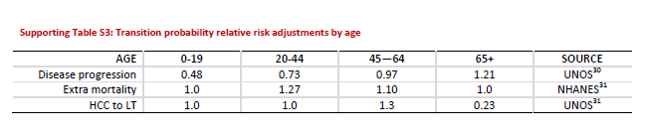

## UTILITIES COMPARISON

**Mahady SE, Wong G, Craig JC, George J. Pioglitazone and vitamin E for nonalcoholic steatohepatitis: A cost utility analysis. Hepatology. 2012;56:2172-2179.**

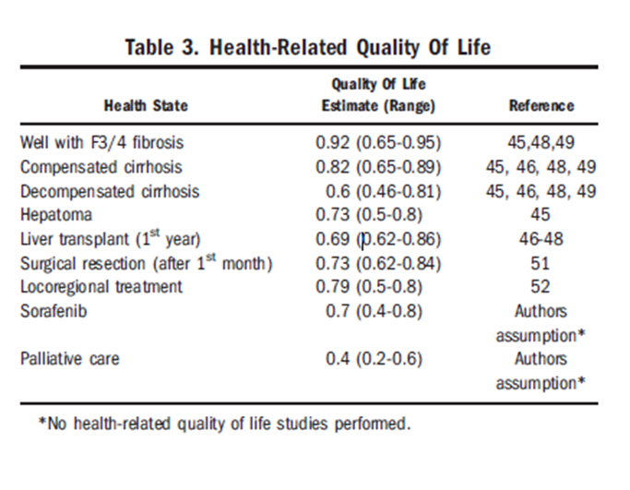

**Zhang E, Wartelle-Bladou C, Lepanto L, Lachaine J, Cloutier G, Tang A. Cost-utility analysis of nonalcoholic steatohepatitis screening. European radiology. 2015;25:3282-3294.**

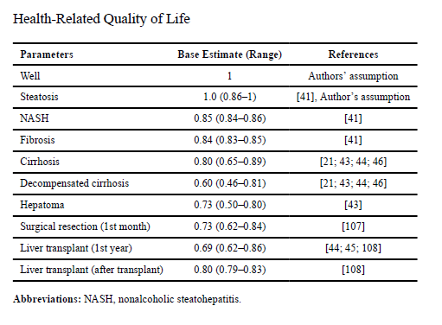

**Younossi ZM, Henry L, Stepanova M, et al. The Economic and Clinical Burden of Non-Alcoholic Fatty Liver Disease in the United States. Journal of Hepatology. 2015;2016;64:S502-S503.**

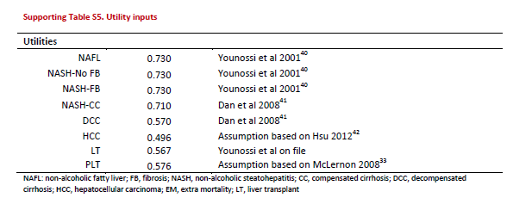

**Tapper EB, Sengupta N, Hunink MGM, Afdhal NH, Lai M. Cost-Effective Evaluation of Nonalcoholic Fatty Liver Disease With NAFLD Fibrosis Score and Vibration Controlled Transient Elastography. The American journal of gastroenterology. 2015;110:1298-1304.**

|  |  |  |  |  |  |
| --- | --- | --- | --- | --- | --- |
| Supplementary Table 3: Health State quality of life weights |  | |  |  |  |
| Health State | Estimate | | Range | | Reference |
| Nonalcoholic Fatty Liver Disease | 1 | * | |  | assumption |
| Nonalcoholic Steatohepatitis | 0.95 | 0.90 – 1.0 | | 23 | |
| **Well with Advanced Fibrosis** | **0.92** | **0.65 – 0.95** | | **52****,** **53** | |
| Compensated cirrhosis | 0.78 | 0.71 – 0.89 | | 23, 52-54 | |
| Decompensated cirrhosis | 0.6 | 0.46 – 0.71 | | 52-56 | |
| Liver transplant (1st year) | 0.69 | 0.55 – 0.78 | | 56 | |
| Liver transplant (2nd year) | 0.79 | 0.62 – 0.79 | | 23, 54, 56 | |
| Hepatocellular Carcinoma (HCC) | 0.65 | 0.52 – 0.78 | | 54 | |
| Decompensated cirrhosis and HCC | 0.57 | 0.46 – 0.68 | | 57 | |
| Palliative care | 0.40 | 0.32 – 0.48 | | 57 | |

|  |  |  |  |  |
| --- | --- | --- | --- | --- |
| Study name | **Tapper EB, Sengupta N, Hunink MGM, Afdhal NH, Lai M. Cost-Effective Evaluation of Nonalcoholic Fatty Liver Disease With NAFLD Fibrosis Score and Vibration Controlled Transient Elastography. The American journal of gastroenterology. 2015;110:1298-1304.** | **Younossi ZM, Henry L, Stepanova M, et al. The Economic and Clinical Burden of Non-Alcoholic Fatty Liver Disease in the United States. Journal of Hepatology. 2015;2016;64:S502-S503.** | **Zhang E, Wartelle-Bladou C, Lepanto L, Lachaine J, Cloutier G, Tang A. Cost-utility analysis of nonalcoholic steatohepatitis screening. European radiology. 2015;25:3282-3294.** | **Mahady SE, Wong G, Craig JC, George J. Pioglitazone and vitamin E for nonalcoholic steatohepatitis: A cost utility analysis. Hepatology. 2012;56:2172-2179.** |
| Well | 1 |  | 1 | 1 |
| NAFLD | 1 | 0.73 | 1.0 (0.86-1) Assumption |  |
| NASH F1 | 0.95 | 0.73 | 0.84 |  |
| NASH F2 | 0.95 | 0.73 | 0.84 |  |
| NASH F3 | 0.92 | 0.73 | 0.84 | 0.92 |
| NASH F4 | 0.78 | 0.71 | 0.80 | 0.82 |
| DCC | 0.6 | 0.57 | 0.60 | 0.60 |
| HCC | 0.65 | 0.49 | 0.73 | 0.73 |
| LT | 0.69 (first year)  0.79 (after transplant) | 0.567 | 0.69 (first year)  0.80 (after transplant) | 0.69 (first year) |

**Tapper et al clearly is strongest, per their methods in supplement**:

* Utilities are detailed in supplementary Table 3. Triangular distributions were employed for utilities with multiple estimates in the literature; otherwise for values without published ranges, a distribution of + 20% was assumed. **Only patient-derived state-utility estimates were only included, excluding estimates from expert opinion**. The utility state associated with NAFLD (bland steatosis) was assumed to be equivalent to the well-state (1.0) without a range. Post-transplant utility was divided into year one and > year 2. It was assumed to be constant for all years after 2.23-25 When a patient transitioned to a state with lower utility during a given stage, a one-time disutility equivalent to the difference between states was assessed. Liver biopsy was associated with a one-time disutility of 0.005 QALY.26 Added pill burden from vitamin E and specialist visits were associated with a marginal disutility of 0.001 QALY

## COSTS

**Tapper EB, Sengupta N, Hunink MGM, Afdhal NH, Lai M. Cost-Effective Evaluation of Nonalcoholic Fatty Liver Disease With NAFLD Fibrosis Score and Vibration Controlled Transient Elastography. The American journal of gastroenterology. 2015;110:1298-1304**

|  |  |  |  |  |
| --- | --- | --- | --- | --- |
| **Supplementary Table 2: Estimated Costs**  **in 2014 US dollars** |  |  |  |  |
|  | Estimate | Range | Reference | |
| **Annual Costs** |  |  |  | |
| Routine specialist care  (no therapy) | 244 | 90 – 537 | 38 | |
| **Compensated Cirrhosis** | **1,268** | **742 – 1,793** | 11, 38, 39 | |
| **Decompensated cirrhosis** | **16,263** | **13011 - 40198** | 11, 38, 39 | |
| Specialist Annual Visit | 249 | 199 – 299 | 40 | |
| Vitamin E | 70 | 70 - 164 | 41 | |
| Lifestyle modifications | 1,877 | 1502 – 2,252 | 42, 43 | |
| **Hepatocellular Carcinoma** |  |  |  | |
| First year of diagnosis | 41,460 | 29,141 – 51592 | 39, 44, 45 | |
| Localized | 42,645 | 38,380 – 46,910 | 39, 44, 45 | |
| Regional | 39,421 | 35,479 – 43,363 | 39, 44, 45 | |
| Distant | 33,064 | 29,758 – 41,580 | 39, 44, 45 | |
| Distant - Sorafenib | 80,117 | 64,094 – 96,141 | 25 | |
| Palliative care | 44,042 | 22,021 – 88083 | 46-48 | |
| **One Time Costs** |  |  |  | |
| Vibration-Controlled Transient-Elastography | 100 | 80 – 120 | 22 | |
| Liver Biopsy | **1,558** | **1,168 – 1,948** | 11 | |
| Liver resection | 40,156 | 20,078 – 80,311 | 46-48 | |
| Liver Transplant (First Year) | 318,157 | 247,679 – 318,157 | 36, 49 | |
| **Death from any cause** | **57,088** | **35,987 – 61,088** | 50, 51 | |

**🡪DEATH FROM ANY CAUSE CONVERSION**: $57,088 in 2014 dollars adjusted for medical inflation in 2018 dollars: **$62,317**

**Allen AM, Van Houten HK, Sangaralingham LR, Talwalkar JA, McCoy RG. Healthcare Cost and Utilization in Nonalcoholic Fatty Liver Disease: Real-World Data from a Large US Claims Database. Hepatology (Baltimore, Md.). 2018.**

**Data from 2010-2014: converted assuming dollars were valued in Dec 2014**

**Inflation calculator: https://data.bls.gov/cgi-bin/cpicalc.pl**

**Medical inflation: https://halfhill.com/inflation_js.html**

|  |  |  |  |  |
| --- | --- | --- | --- | --- |
| **Disease State** | **Costs PPPY** | **Incremental Costs PPPY** | **Inflation adjusted 2018 total costs** | **Medical Inflation adjusted cost (2017 dollars)** |
| control | $2,298 (IQR $681 - $6,580) |  | **$2,466** | **$2,509** |
| NAFLD new diagnosis | $7,804 (IQR $3,068-$18,688) | $5,506 | **$8,375** | **$8,519** |
| NAFLD long term | $3,789 (IQR $1,176-$10,539) | $1,491 | **$4,066** | **$4,136** |

Liver biopsies, imaging, and hospitalizations accounted for majority of costs

**[McAdam-Marx C, McGarry LJ, Hane CA, Biskupiak J, Deniz B, Brixner DI. All-cause and incremental per patient per year cost associated with chronic hepatitis C virus and associated liver complications in the United States: a managed care perspective. Journal of managed care pharmacy : JMCP. 2011;17:531.](F:\\Nima\\NAFLD and NASH\\Costs of HCV\\McAdam-Marx et al All-Cause and Incremental Per Patient Per Year Cost Associated with Chronic Hep C.pdf)**

**Data from 2001-2010: converted assuming dollars were valued in Dec 2010**

**Converted using** [**https://data.bls.gov/cgi-bin/cpicalc.pl**](https://data.bls.gov/cgi-bin/cpicalc.pl%20from%20Dec%202010)

**Medical Inflation: https://halfhill.com/inflation_js.html**

|  |  |  |  |  |
| --- | --- | --- | --- | --- |
| **Disease State** | **Median Total Costs PPPY** | **Incremental Costs PPPY** | **Inflation adjusted 2018 total costs** | **Medical Inflation adjusted cost (2017 dollars)** |
| HCV without Liver Disease | $14,916 | $5,873 | **$17,149** | **$18,254** |
| Compensated Cirrhosis | $16,925 | $5,348 | **$19,458** | **$20,712** |
| Decompensated Cirrhosis | $41,832 | $27,739 | **$48,094** | **$51,194** |
| HCC | $57,959 | $43,412 | **$66,635** | **$70,930** |
| All Liver Transplant | $113,710 | $94,030 | **$130,732** | **$139,158** |
| Liver Transplant First Year | $190,995 | $168,845 | **$219,586** | **$233,738** |
| Liver Transplant after First Year | $54,885 | $38,030 | **$63,101** | **$67,168** |
| All HCV | $19664 | $9,688 | **$22,608** | **$24,064** |

### **MODEL COST INPUTS**

|  |  |  |
| --- | --- | --- |
|  | **PPPY total** | **First year costs** |
| **No NAFLD** | $2,509 |  |
| **NAFLD F0** | $3,875 | $8,519 |
| **F1** | $3,925 |  |
| **F2** | $4,000 |  |
| **F3** | $4,500 |  |
| **F4** | $20,712 |  |
| **DCC** | $51,184 |  |
| **HCC** | $70,930 |  |
| **LT** | $67,168 | $233,738 |
| **death** |  | $62,317 |

* **NAFLD average for all states: $4,136**
  + Given the skewed distribution (more people in NAFLD than in F4), costs were approximated (i.e., I guessed)
    - NAFLD F0 prevalence: 84.3%
    - F1 prevalence: 7.7%
    - F2 prevalence: 4.1%
    - F3 prevalence: 2.4%
    - F4 prevalence: 1.5%
  + Average = $3,750 (0.843) + $3,875 (0.077) + $4,000 (0.041) + $4,500 (0.024) + $20,712 (0.015) = $4,042
    - Slightly short of goal 🡪 revise up
  + Average = $3,800 (0.843) + $3,875 (0.077) + $4,000 (0.041) + $4,500 (0.024) + $20,712 (0.015) = $4,084
    - Still slightly short of goal
  + Average = $3,875 (0.843) + $3,925 (0.077) + $4,000 (0.041) + $4,500 (0.024) + $20,712 (0.015) **= $4,151 – on target**
* **Probability a more mathematically rigorous way to do this (regression analysis)**

## TREATMENT COSTS

|  |  |  |  |  |  |
| --- | --- | --- | --- | --- | --- |
| **Drug & dose** | **Price ($) per dose** | **Resource** | **Year 1 Annualized $** | **Year 2 PPPY $** | **Year 3+ PPPY Cost** |
| Bariatric Surgery | $44,050 | Per *Makary et al, 2010* | $44,956 | $0 | $0 |
| Obeticholic Acid 5 mg/10 mg | $245.10/dose | LexiComp* | X 365 days = $89,461.50 | $89,461.50 | $89,461.50 |
| Obeticholic Acid 25 mg | Not priced, will index to available 10 mg dose |  |  |  |  |
| Pentoxifylline |  |  |  |  |  |
| Cenicriviroc |  |  |  |  |  |
| Intensive Lifestyle Intervention |  |  |  |  |  |

*I will look up in Micromedex/Redbook when I get access

**BARIATRIC SURGERY**

**Makary MA, Clark JM, Shore AD, et al. Medication Utilization and Annual Health Care Costs in Patients With Type 2 Diabetes Mellitus Before and After Bariatric Surgery. Archives of Surgery. 2010;145:726-731**

* Also used large administrative claims database (Comparable to NAFLD and AdvLD pricing studies
* Found a median price of $29,959 in claims from Jan 1, 2002 to December 31, 2005
  + Inflation adjusted: $38,360
  + Medical inflation adjusted: $**44,050**
* In the 3 years following surgery**, total annual health care costs per person increased by 9.7% ($616)** in year 1 but then decreased by 34.2% ($2179) in year 2 and by 70.5% ($4498) in year 3 compared with a preoperative annual cost of $6376 observed from 1 to 2 years before surgery.
  + Medical inflation adjusted: **$905.73**
* NOT NAFLD patients – cannot assume baseline costs are equal
* $44,050 + 906 =$44,956

**Keating CL, Dixon JB, Moodie ML, et al. Cost-Effectiveness of Surgically Induced Weight Loss for the Management of Type 2 Diabetes: Modeled Lifetime Analysis. Diabetes Care. 2009;32:567-574**..

* Cumulative probability of complication was estimated to be 17% every 10 years
* Assumed complication rates were independent and constant over time
* Costed with internal data

# FINAL INPUTS

* **US population distribution**:
  + US census: https://factfinder.census.gov/faces/tableservices/jsf/pages/productview.xhtml?src=bkmk
* **Prevalence**
  + **NAFLD prevalence** 
    - **Younossi ZM, Henry L, Stepanova M, et al. The Economic and Clinical Burden of Non-Alcoholic Fatty Liver Disease in the United States. Journal of Hepatology. 2015;2016;64:S502-S503**
    - 
  + **Age-related Risk Ratios**
    - **Younossi ZM, Henry L, Stepanova M, et al. The Economic and Clinical Burden of Non-Alcoholic Fatty Liver Disease in the United States. Journal of Hepatology. 2015;2016;64:S502-S503**
    - 
  + **F1 – F3 prevalence** 
    - **Estes C, Razavi H, Loomba R, Younossi Z, Sanyal AJ. Modeling the epidemic of nonalcoholic fatty liver disease demonstrates an exponential increase in burden of disease. Hepatology. 2018;67:123-133.**
    - **Stage Proportion of NAFLD**
    - **0 84.2%**
    - **1 7.7%**
    - **2 4.1%**
    - **3 2.4%**
    - **4 1.5%**
  + **Decompensate Cirrhosis Prevalence (OUT OF GENERAL POPULATION)**
    - **Zhang E, Wartelle-Bladou C, Lepanto L, Lachaine J, Cloutier G, Tang A. Cost-utility analysis of nonalcoholic steatohepatitis screening. European radiology. 2015;25:3282-3294.**
    - 
    - Cirrhosis = Compensated + Decompensated Cirrhosis
    - [number in cohort x prevalence in NASH cirrhosis] – prevalence of F4 = prevalence of DCC specifically??
      * Potential conflict because they are estimate derived from multiple sources
    - **Will just use raw proportion to estimate DCC for now**
  + **HCC prevalence** 
    - Used for calibration target by **Younossi ZM, Henry L, Stepanova M, et al. The Economic and Clinical Burden of Non-Alcoholic Fatty Liver Disease in the United States. Journal of Hepatology. 2015;2016;64:S502-S503**
    - **In NASH: 0.529%**
      * Citations: Younossi et al 20151, Starley et al 201023
        + **Younossi ZM, Koenig AB, Abdelatif D, Fazel Y, Henry L, Wymer M. Global epidemiology of non-alcoholic fatty liver disease-meta-analytic assessment of prevalence, incidence and outcomes. HEPATOLOGY 2016;64:73-84.**
        + **Starley BQ, Calcagno CJ, Harrison SA. Nonalcoholic fatty liver disease and hepatocellular carcinoma: a weighty connection. HEPATOLOGY 2010;51:1820-1832.**
  + **Liver transplant** 
    - **previous analysis of data from the Scientific Registry of Transplant Recipients (SRTR) reported that the proportion of patients with cirrhotic-stage NASH undergoing a liver transplant has increased from 0.1% or less in 1995–2000 to 3.5% in 2005, suggesting a modest increase in frequency of NASH as an indication for liver transplantation.**
    - **Charlton MR, Burns JM, Pedersen RA, Watt KD, Heimbach JK, Dierkhising RA. Frequency and Outcomes of Liver Transplantation for Nonalcoholic Steatohepatitis in the United States. Gastroenterology. 2011;141:1249-1253.**
    - **Originally reported Angulo P. Nonalcoholic fatty liver disease and liver transplantation. Liver Transpl 2006;12:523–534**
    - **Add F4 + DCC to get cirrhosis cohort**
    - **Multiply by Prevalence of Liver Transplant due to cirrhosis**
* **Incidence of New NAFLD**
  + 
  + **Gender-specific rates were averaged**
    - **Assumes equal distribution**
    - **Go back and calculate weighted averages**

|  |  |
| --- | --- |
| **Age bracket** | **Unweighted average rate** |
| 20-24 | 0.0405 |
| 25-29 | 0.0487 |
| 30-34 | 0.0571 |
| 35-39 | 0.0652 |
| 40-44 | 0.0728 |
| 45-49 | 0.0792 |
| 50-54 | 0.08535 |
| 55-59 | 0.0899 |
| 60-64 | 0.0922 |
| 65-69 | 0.0937 |
| 70-74 | 0.09465 |
| 75-79 | 0.0951 |

* + **=RATE not probability** 
    - **20-24:** Probability = 1 – e^(-0.0405 x 1 year) = **0.0396**
    - **25-29:** Probability = 1 – e^(-0.0487 x 1 year) = **0.04753**
    - **30-34:** Probability = 1 – e^(-0.0571 x 1 year) = **0.0555**
    - **35-39:** Probability = 1 – e^(-0.0652 x 1 year) = **0.0631**
    - **40-44:** Probability = 1 – e^(-0.0728 x 1 year) = **0.0702**
    - **45-49:** Probability = 1 – e^(-0.0792 x 1 year) = **0.0761**
    - **50-54:** Probability = 1 – e^(-0.0854 x 1 year) = **0.0818**
    - **55-59:** Probability = 1 – e^(-0.0899 x 1 year) = **0.0856**
    - **60-64:** Probability = 1 – e^(-0.0922 x 1 year) = **0.0881**
    - **65-69:** Probability = 1 – e^(-0.0937 x 1 year) = **0.0894**
    - **70-**74: Probability = 1 – e^(-0.0947 x 1 year) = **0.0904**
    - **75-**80: Probability = 1 – e^(-0.0951 x 1 year) = **0.0907**
* **Transition State Inputs**
  + RATE of remission to disease free
    - NAFLD F0🡪 no NAFLD
    - =19% per Younossi et al
    - Probability = 1 – e^(-0.19 x 1 year) = **0.17304**
  + **OTHERS AS STATED IN TRANSITION PROBABILITY TABLE**
* **COSTS**
  + 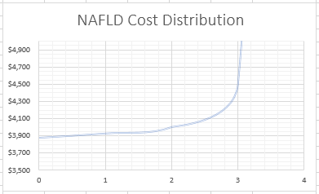
* **UTILITIES**

# ANALYSIS

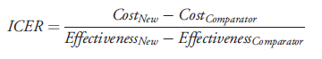

**Keating CL, Dixon JB, Moodie ML, et al. Cost-Effectiveness of Surgically Induced Weight Loss for the Management of Type 2 Diabetes: Modeled Lifetime Analysis. Diabetes Care. 2009;32:567-574**..

* Uncertainty analysis. The impact of model variable uncertainty on the ICER was tested. Values tested reflected worst-case scenarios (i.e., decreasing cost-effectiveness of surgical therapy) and are described in Tables 1 and 2. The impact of combinations of variables likely to be related were tested, including 1) combining all intervention costs in worst-case scenarios and 2) combining intervention effect and duration of diabetes remission in worst-case scenarios. Uncertainty in modeling assumptions was also tested, including 1) adding an additional LAGB surgical event to the lifetime intervention cost for each surgical patient (i.e., reflecting a routine LAGB replacement), 2) applying fixed health care treatment costs and utilities associated with type 2 diabetes (i.e., excluding the effects of disease duration and age), 3) applying type 2 diabetes mortality probabilities to all patients (i.e., assuming that the mortality probability of the population free of diabetes is not transferable to patients in type 2 diabetes remission), and 4) introducing a 0.03% probability of postoperative mortality for LAGB patients (i.e., superseding the actual zero mortality found in a trial with a probability reported by a systematic review [17**]). Threshold analysis was undertaken to identify the minimum duration of diabetes remission required to deem surgical therapy cost-effective, assuming a willingness to pay threshold of 50,000 AUD per QALY (18).**
* 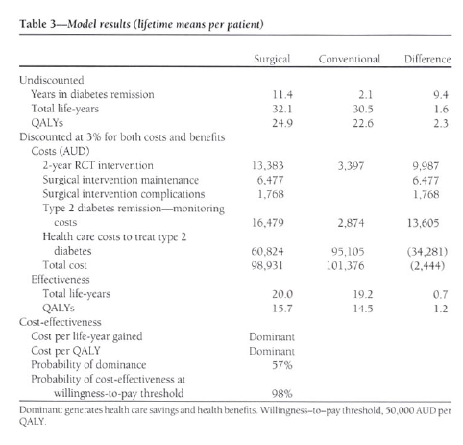

# WORKFLOW

1. Identify treatments that affect fibrosis regression (≥1 stage reduction in fibrosis scores) and summarize proportion of patients experiencing regression (> or = 1 stage reduction in score)
   1. Described baseline characteristics in each of these studies
2. Describe overall population and prevalences
   1. Find prevalence of fibrosis stage by age?? Or assume equal distribution across ages?
   2. =model assumption
3. Identify fibrosis progression rates between stages and to long term sequelae (cirrhosis (CC and DCC), HCC, liver transplant, and death)
   1. Alternatively, this can be extrapolated from the progression of “advanced fibrosis” (F 3-4)
4. Identify costs associated with fibrosis stages and long term sequelae
   1. Fibrosis stage specific costs available?
5. **Calculate average life years gained for a cohort of 10,000 patients** 
   1. **Identify % of population that is eligible for each treatment modality**
   2. **Conservatively assume that patients decreased by 1 stage in fibrosis score**
   3. **Assume that reduction was equally distributed across stages/presentations unless data is available to the contrary** 
      1. **Data from at least one trial in bariatric surgery suggests this is not the case (Taitano et al, described above)**
6. **Calculate costs associated with treatments (drug acquisition, monitoring costs, adverse event costs, health state costs)**
7. **Value QALY and subtract cost of treatments**
8. Present findings

**ONGOING CHALLENGES**

* **How to calculate mortality for Y1 separate from Y2 for Liver Transplant?**
  + **For now, I have just inputed Y2-onward probability of mortality**
* **How to distribute transition probabilities for treatment effects**
  + **In Tapper et al: *When high quality data from population-wide sources were available, beta distributions were used. When drawn from beta distributions, the ranges listed reflect + two standard deviations. When single center estimates or author assumptions were available, a triangular distribution was employed reflecting the published range or a range of + 20% when one estimate was available.***
* **Discount rates?**
* What are the limitations of comparisons in the absence of head-to-head trials?
  + Different populations with different comorbidities/severities of diseases
  + Different exclusion criteria
  + Differences in definitions of histological response (raw difference in NAS sought were possible), but still variability in resolution of NASH and fibrosis outcomes
* How are co-morbidities going to be modeled?
  + Separate transition state model needed for diabetes to assess QALY for A1C reductions